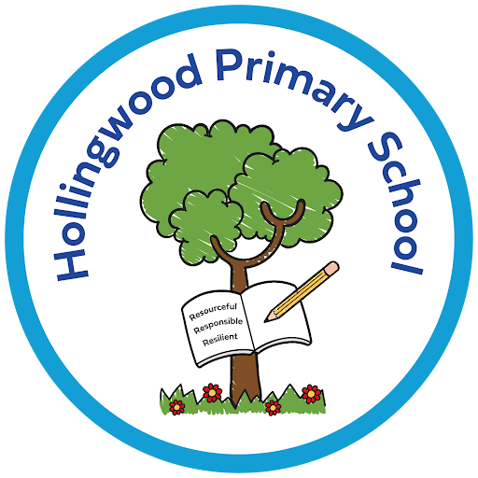
Art and Design at Hollingwood

Intent
At Hollingwood our Art and Design curriculum is designed to inspire creativity, nurture curiosity and develop critical thinking in all pupils. We aim to provide a rich and balanced art education that enables children to explore a wide range of artistic techniques, styles and media. Through a diverse and inclusive curriculum, we foster a genuine love of creativity and self‑expression, encouraging pupils to develop a lifelong appreciation for the arts.
We ensure that pupils experience a broad spectrum of art forms, including drawing, painting, mixed media, 3D form and sculpture. By engaging with varied artistic media, pupils build a strong visual vocabulary and gain an understanding of the significance of art within society.

Implementation
To bring our intent to life, we deliver an Art and Design curriculum that is carefully sequenced, progressive and responsive to the needs and interests of our pupils. Learning is structured so that children build on prior knowledge and skills, developing their artistic abilities year on year.
Pupils are given regular opportunities to experiment with different materials and techniques, encouraging them to take creative risks and express themselves with confidence and individuality. Lessons are practical, hands-on and focused on the creative process as well as the final outcome.
Throughout the school year, children also engage with additional art and design activities that enrich their learning beyond the core curriculum. These include workshops, collaborative projects, after school clubs and wider creative experiences that broaden their understanding of the arts.

Impact
At Hollingwood, our Art and Design curriculum enables pupils to develop a secure and coherent understanding of the key elements of art, including line, shape, form, tone, texture, pattern and colour. Through carefully planned learning, children gain confidence in applying these skills across a range of creative mediums.
Assessment, sketchbook monitoring and pupil voice are central to evaluating impact, ensuring that standards in Art remain high and consistent with other subject areas. Pupil voice provides valuable insight into how effectively children can express themselves, make creative choices and use appropriate artistic vocabulary.
Sketchbooks across all year groups demonstrate clear progression, experimentation and pride, reflecting each child’s journey as an artist. Pupils are encouraged to reflect on their work, respond to peers and engage with the work of a variety of artists. Artwork displayed throughout the school showcases their creativity, originality and growing technical skill.
By the time they leave Hollingwood, pupils have embedded a broad range of artistic skills, developed imagination and found a meaningful creative outlet that supports self‑expression, confidence and enjoyment.

