Art Overview Hollingwood Primary

Drawing | Painting | Printing (other art techniques) | Designing | Art Styles
Line  Colour  Pattern and Shape  Texture | Colour  Pattern  Composition | Texture  Line  Colour  Pattern  Composition | Explore ideas  Invent  Imagine  Problem solve | Y1 - Abstract  Y2 - Figurative, Geometric  Y3 - Figurative (portraits), Cubism, Pop Art  Y4 - Animal Art (Pokemon), Fantasy  Y5 - Landscapes, Silhouettes  Y6 - Watercolours, Pointillism (digital art)

 | Block 1 - Line and Tone | Block 2 - Texture and Pattern | Block 3 - Shape and Colour
Year 1 | Drawing  Art Elements: Line, pattern and shape, texture, colour.  Investigating types of lines.  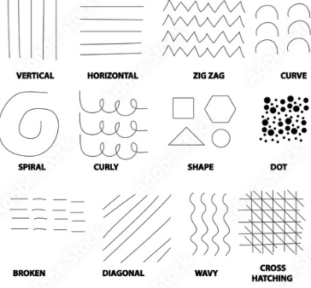  Using different media to create lines.  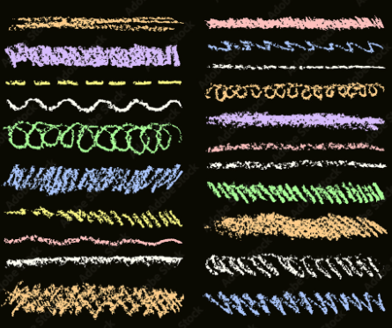  Investigating tone  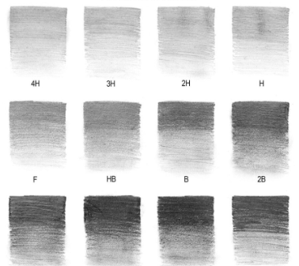  Painting  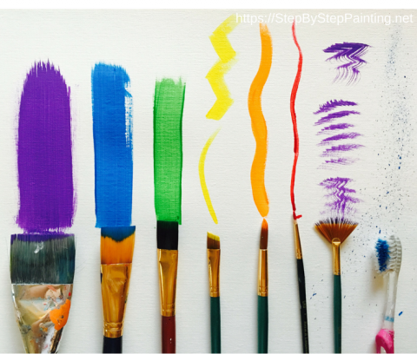  Art Elements: composition and pattern  Investigating types of brush strokes using different brushes.  Creating their own abstract piece.  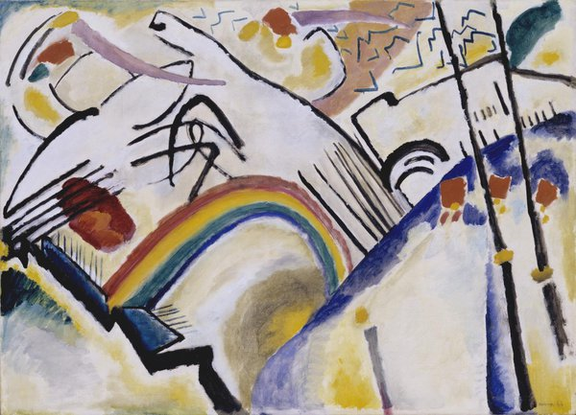  Art Style  Abstract Art  Artists  Jason Gathorne Hardy  Wassily Kandinsky | Drawing  Art Elements: line, pattern, texture and shape.  Drawing their own patterns.  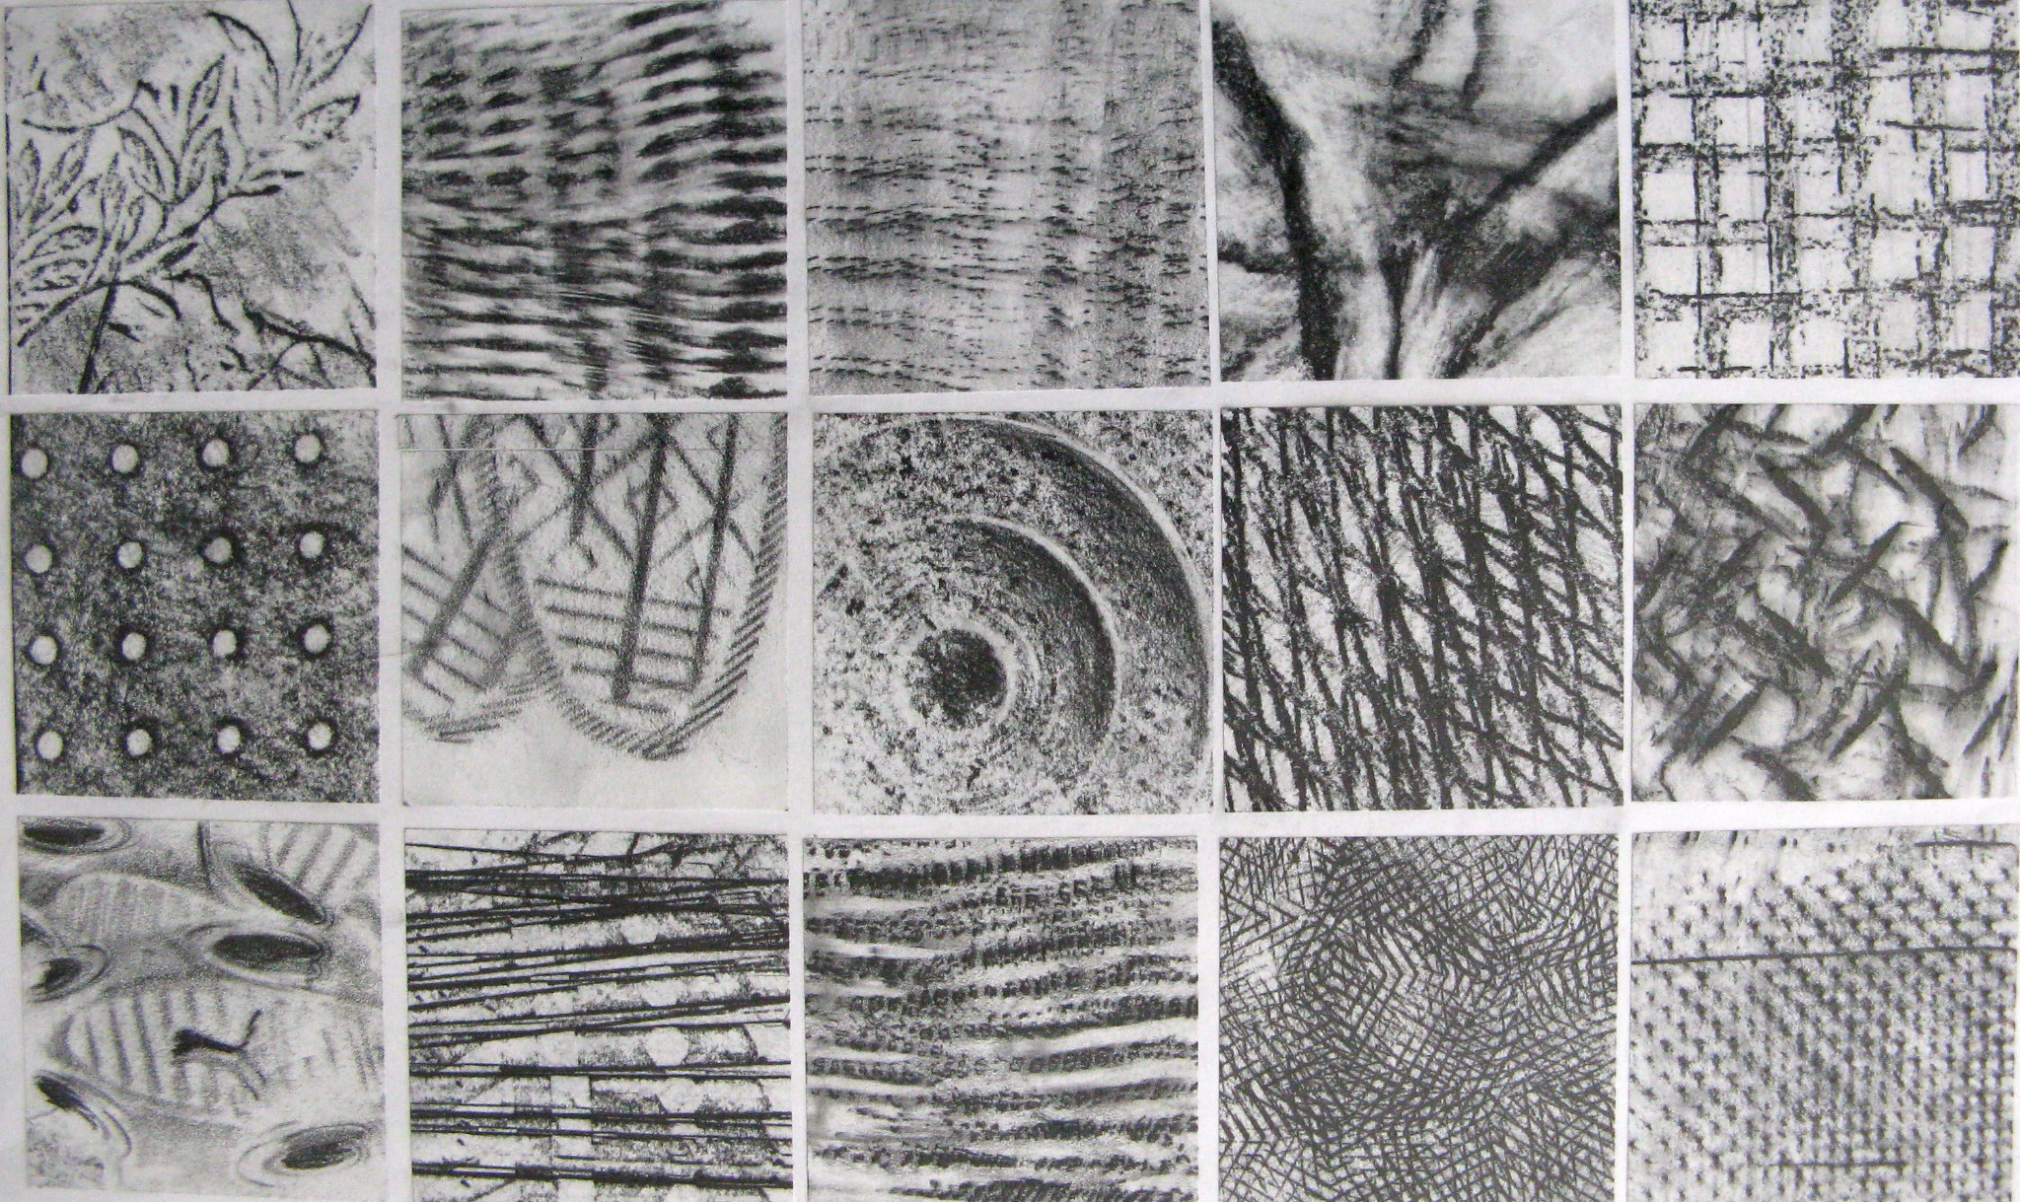  Painting  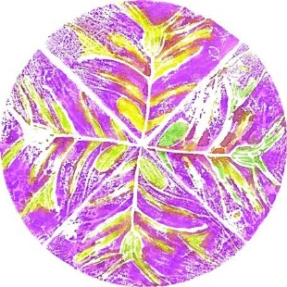  Art Elements: composition and pattern.  Deciding what colours/patterns/textures would look good for their work.  Printing  Art Elements: texture, line, colour.  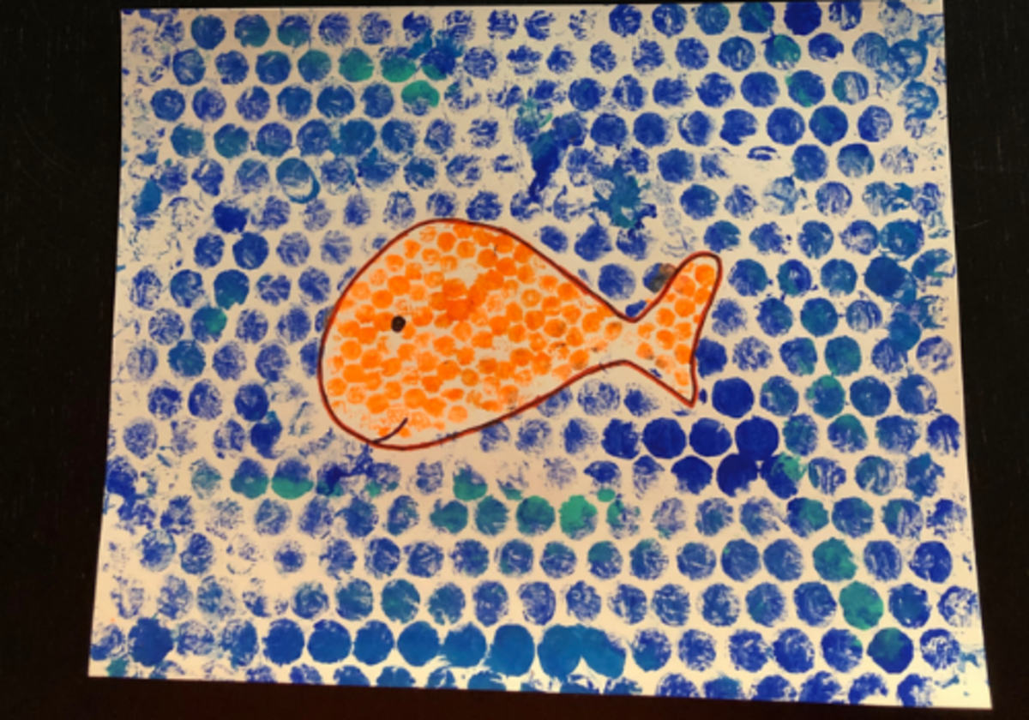  Creating textures using various media e.g bubble wrap,string etc  Art Style  Patterns  Artists  Van Gogh  Bisa Butler | Drawing  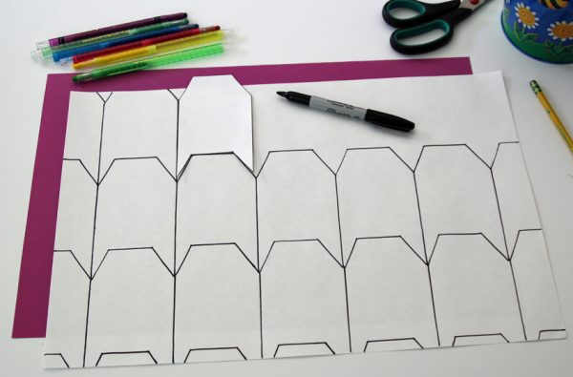  Art Elements: Line, pattern and shape, texture, colour.  Drawing lines to make shapes.  Painting  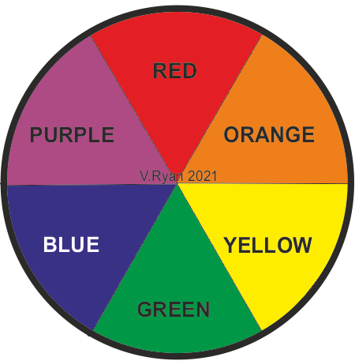  Art Elements: colour, composition and pattern.  Learning about primary and secondary colours. Colour mixing.  Printing  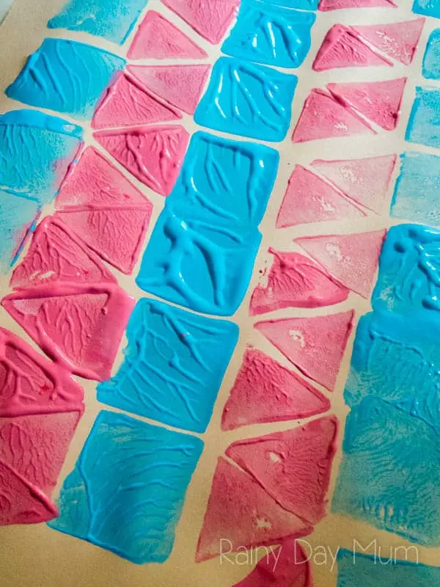  Art Elements: texture, line, colour.  Printing shapes in a specific way.  Art Style  Tessellation Art  Artists  M.C. Escher

 | Block 1 - Superheroes | Block 2 - Geometric Landscapes
Year 2 | Drawing  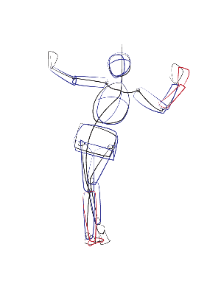  Art Elements: Line, pattern and shape.  Drawing Mickey Mouse, Horrid Henry,  Superman and their own superhero - own  figure drawing.  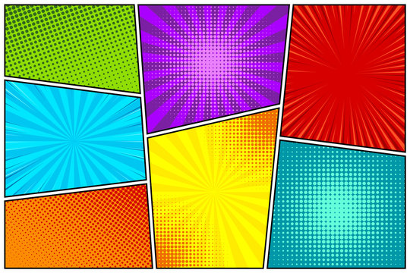  Painting  Art Elements: composition, pattern, colours.  Using complimentary colours to create backgrounds for their superhero (in comic book style).  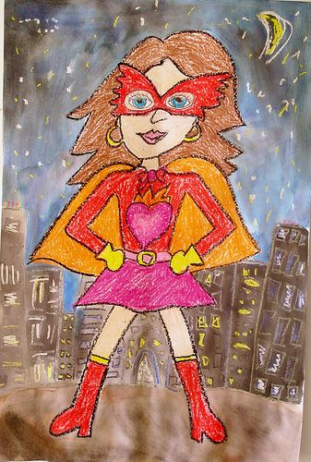  Designing  Elements- exploring ideas, imagining  Creating their own superhero.  Art Style  Figurative Art  Artists  Ub Iwerks (creator of Mickey Mouse  Tony Ross (Horrid Henry illustrator)  Sandra Equihua  Illustrator/animator of Cinderella(Once upon a world) book | Drawing  Art Elements: line, pattern,texture and shape.  Using shapes and lines to create a textured, geometric landscape.  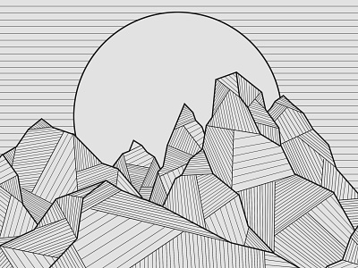  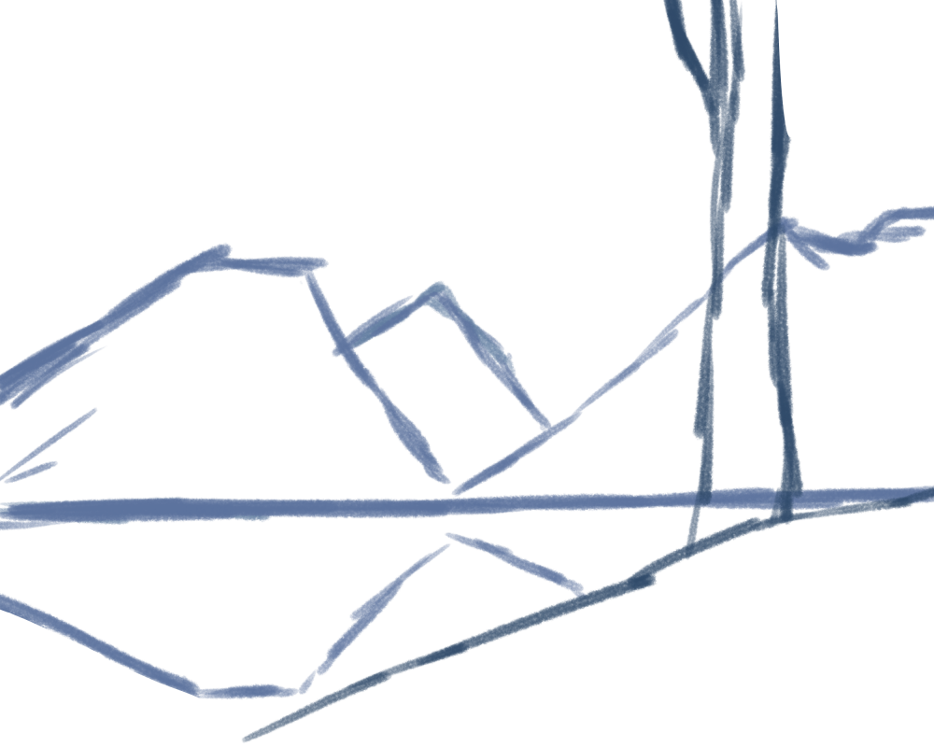  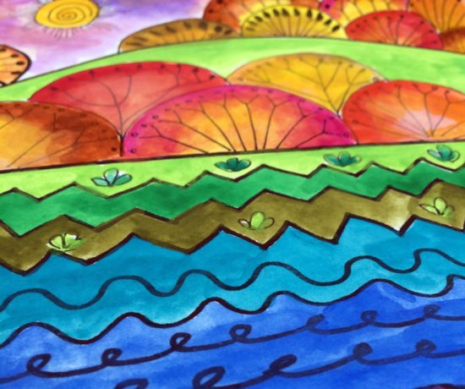  Painting  Art Elements: colour, composition  Deciding what colours would work well for the  different components of their landscape.  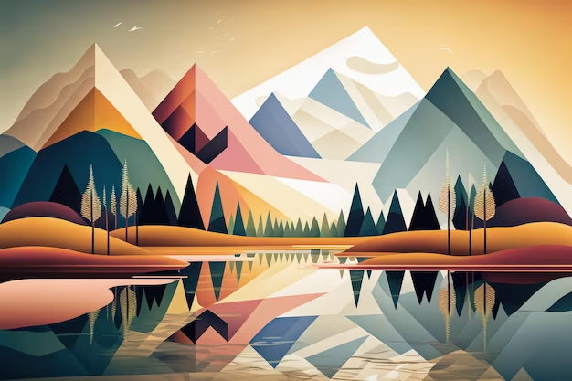  Designing  Elements- exploring ideas, imagining  Creating their own landscape from  imagination.  Art Style  Geometric Art  Artists  Elyse Dodge  Sherry Edmundson  David Hockney

 | Block 1 - Portraits | Block 2 - Cubism and Pop Art
Year 3 | Drawing  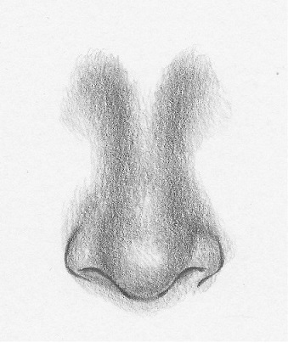  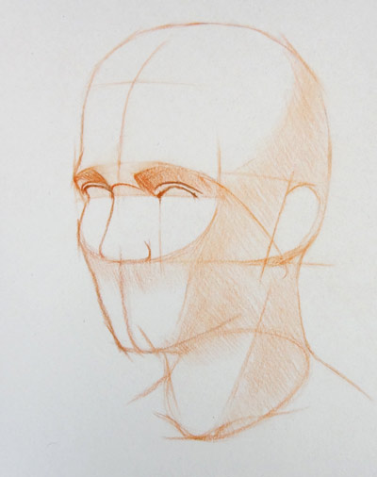  Art Elements: line, texture  Drawing features of the face. Learning to draw portraits with more accuracy.  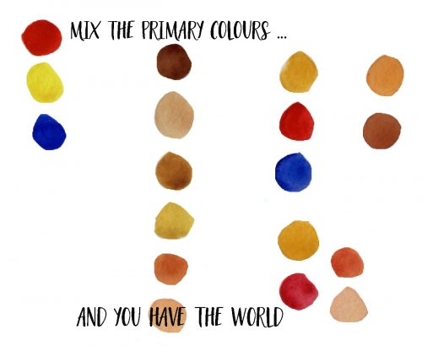  Painting  Art Elements: colour, composition  Learning how to mix different skin tones using primary colours.  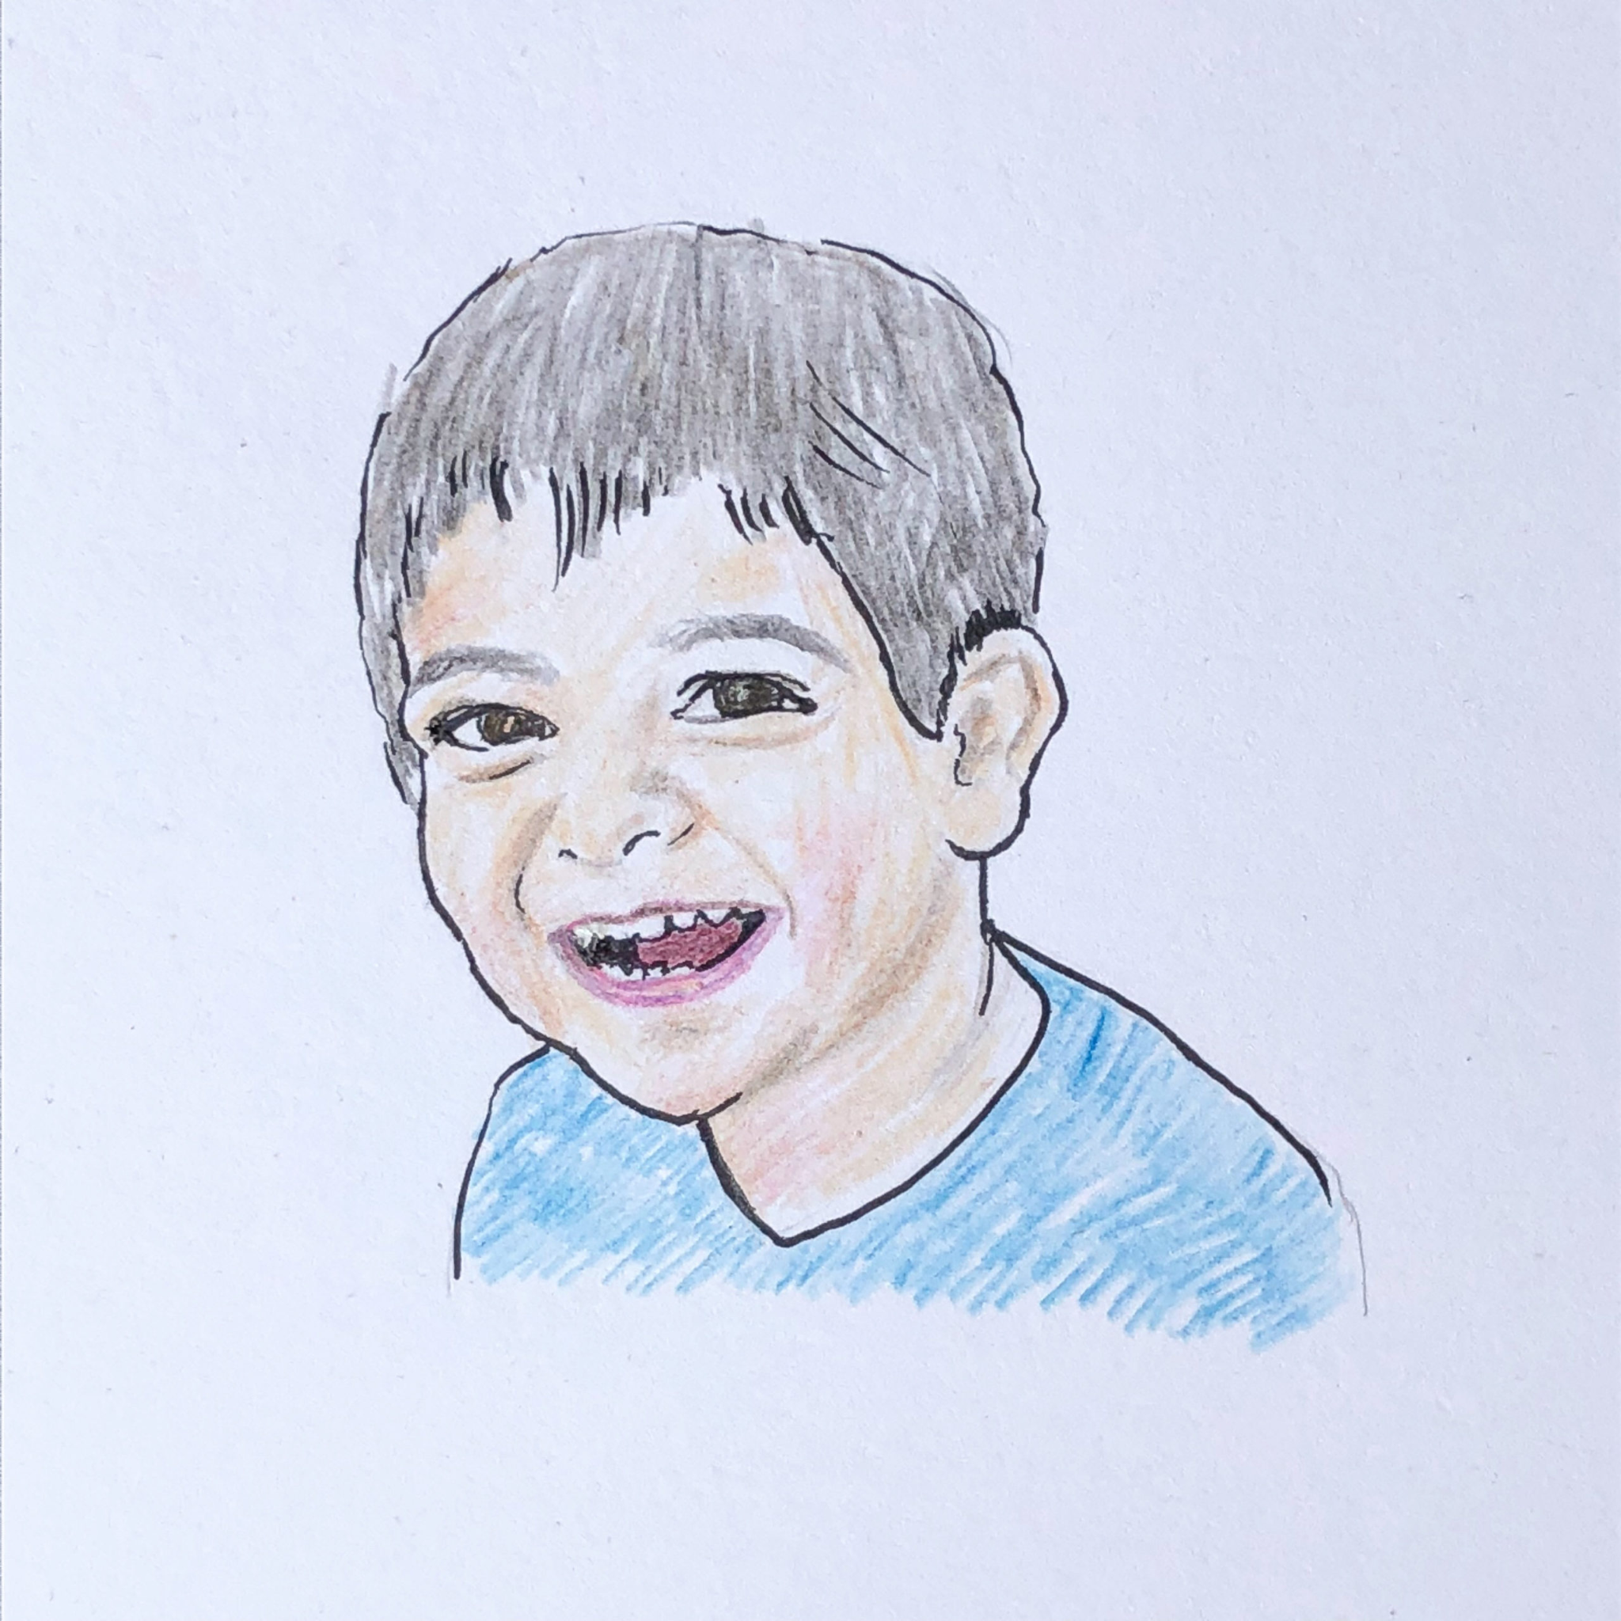    Designing  Elements - explore ideas  Drawing portraits in different ways for different purposes.  Art Style  Figurative - portraits  Artists  Toby Wiggins | Drawing  Art Elements: colour, pattern and shape  Drawing portraits of others/themselves using different art styles.  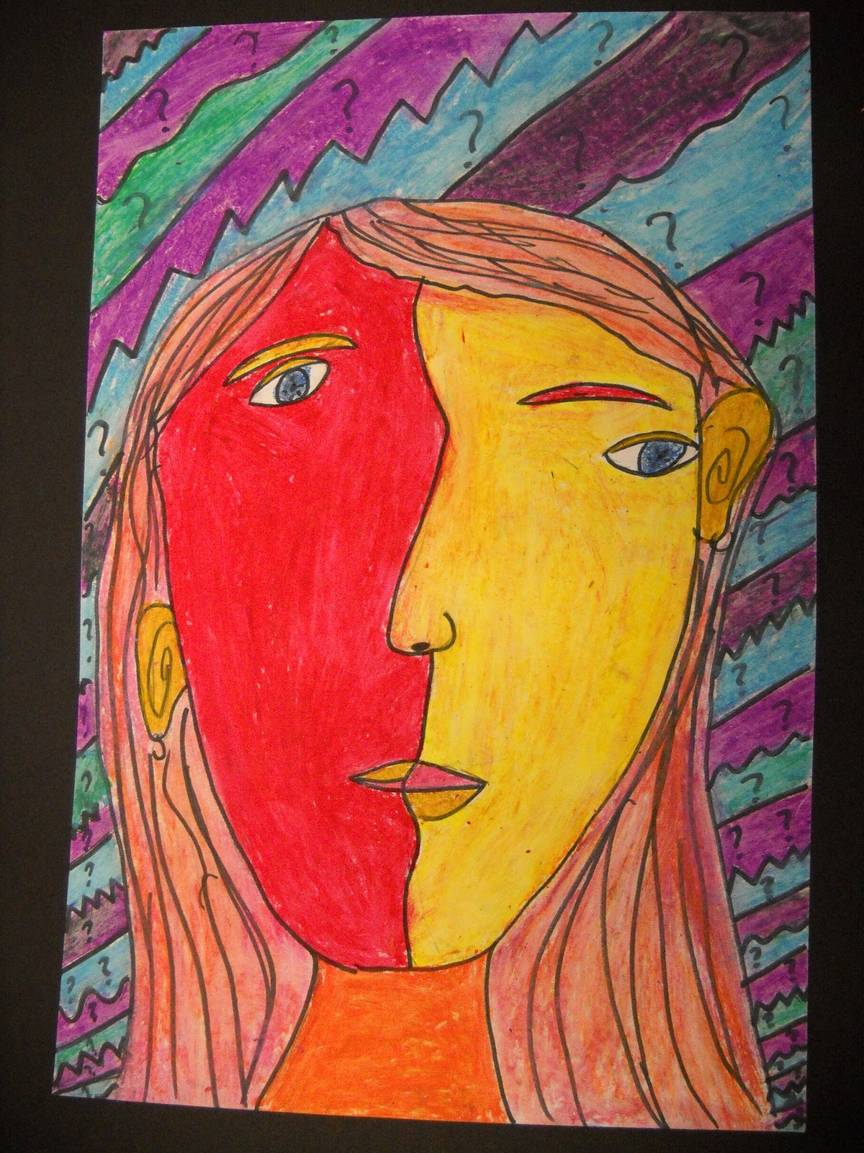  Painting  Art Elements: colour, pattern  Designing  Elements - imagine  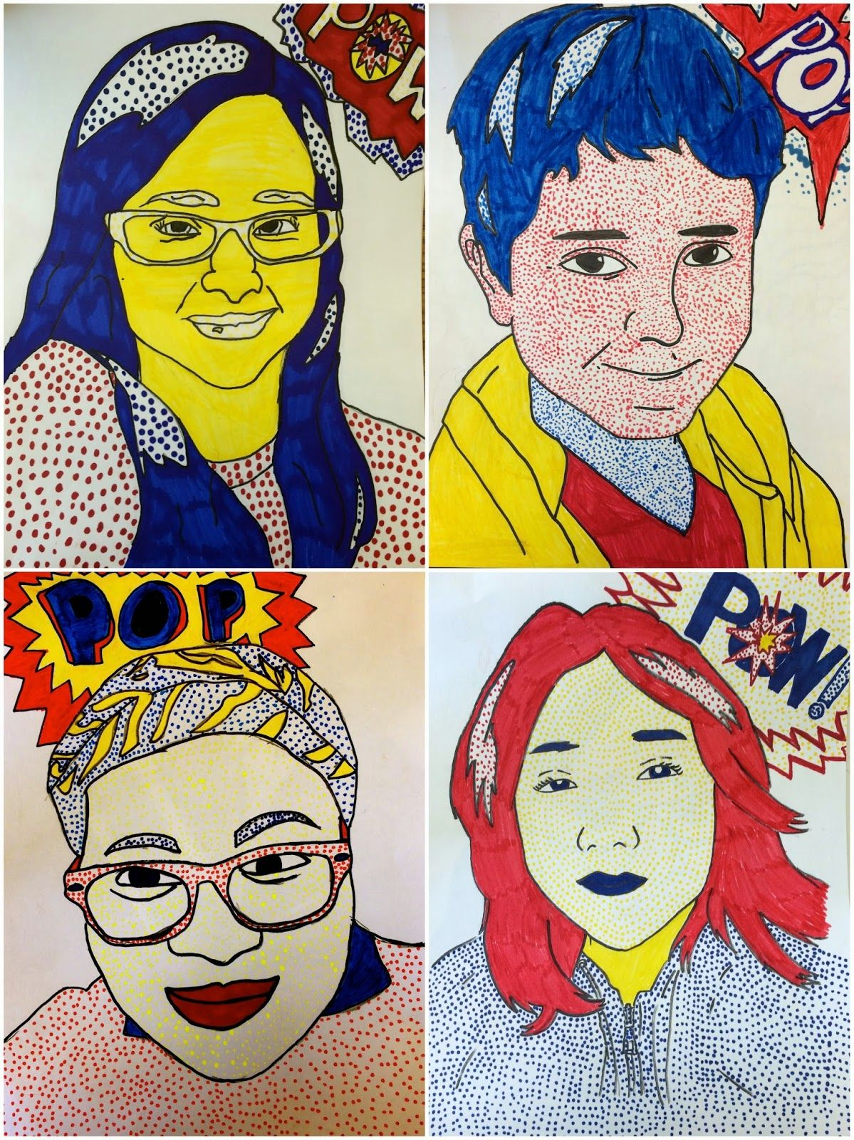  Art Style  Cubism, Pop Art  Artists  Romero Britton  Andy Warhol

 | Block 1 - Animals (2) | Block 2 - Mythical Creatures (1)
Year 4 | Drawing  Art Elements: Line, pattern and shape.  Draw Pokemon from tutorials (Art for kids)  Painting  Art Elements: colour and composition  Designing  Elements - explore ideas  Art Style  Animal art (Pokemon)  Artists  Ken Sugimori (Dave Pilkey) | Drawing  Art Elements: Line, colour, shape, and texture.  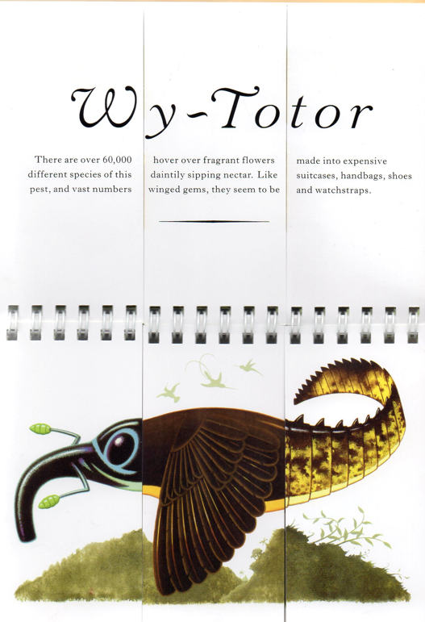  Draw own creature, by  amalgamating different parts  of other animals.  Painting  Art Elements: colour and  composition  Designing  Collage  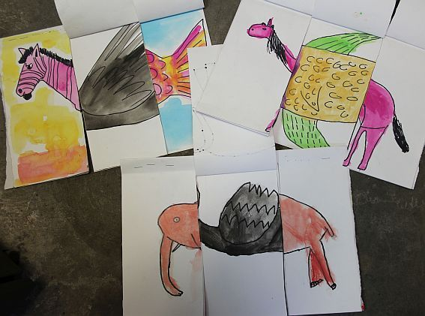  Elements - invent and imagine  Experimenting with a range of  materials and techniques including  painting to create texture, colour and  colour balance, invent a  mythical creature.  Art Style  Fantasy  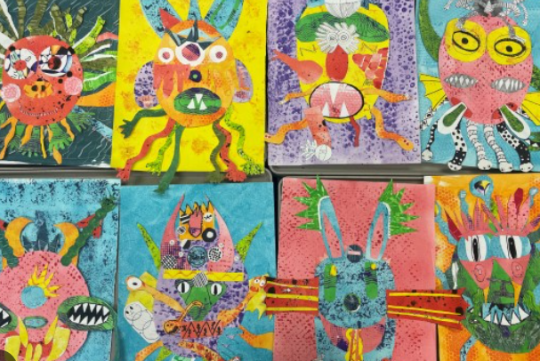  Artists  Sara Fanelli  Mark Todd  Tony Meeuswissen

 | Block 1 - Landscapes | Block 2 - Silhouettes
Year 5 | Drawing  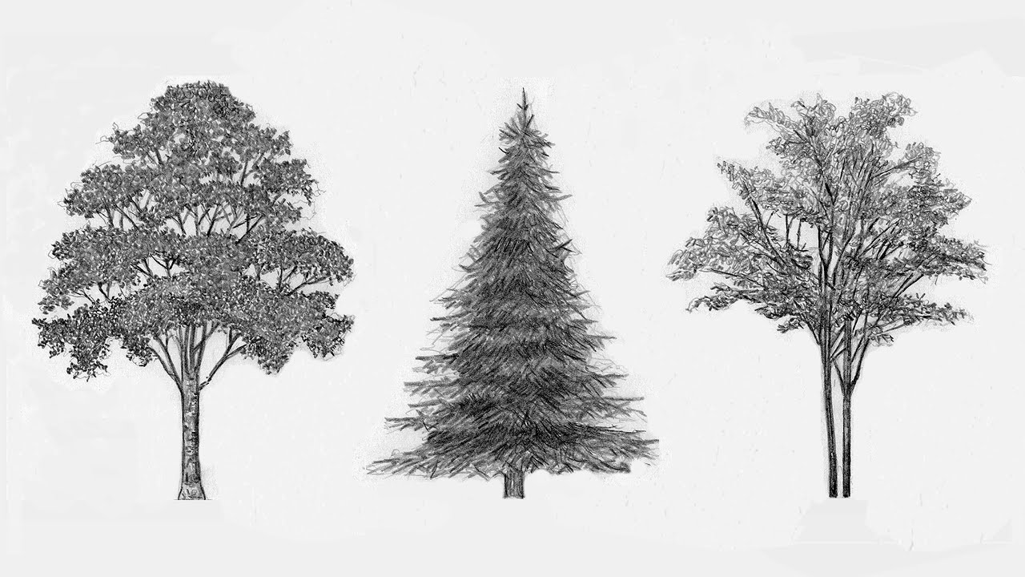  Art Elements: line, colour, shape, texture.  Drawing different features of a landscape in detail.  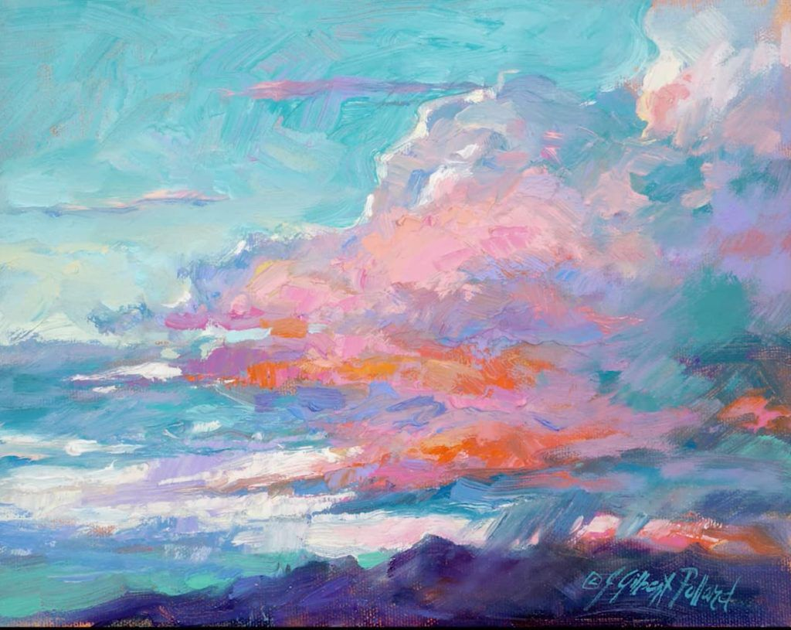  Painting  Art Elements: colour, pattern, composition.  Using colour to manipulate the mood/atmosphere of their painting.  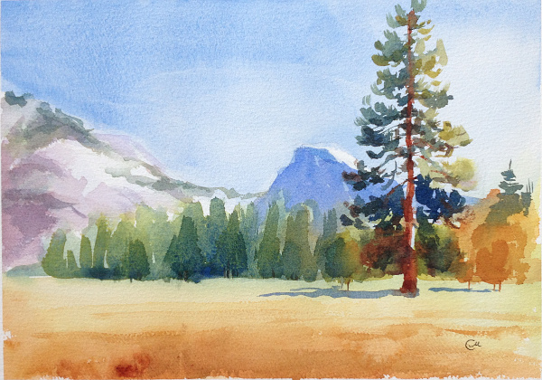  Designing  Elements - imagine  Creating their own landscape using their own imagination and inspiration from surroundings.  Art Style  Landscape  Artists  Etel Adnan  Stephen Wiltshire  David Hockney | Drawing  Art Elements: line, colour, shape, texture, pattern.  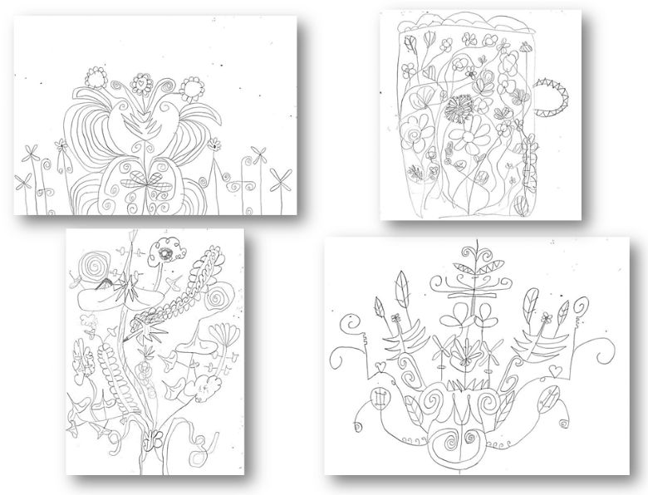  Drawing different features of William Morris’s repeat pattern wallpaper in detail.  Painting  Art Elements: colour, pattern, composition.  Printing  Art Elements: texture, line colour, pattern  Using their own printing blocks from  modelling clay, colour is used to  convey the dynamic of the print.  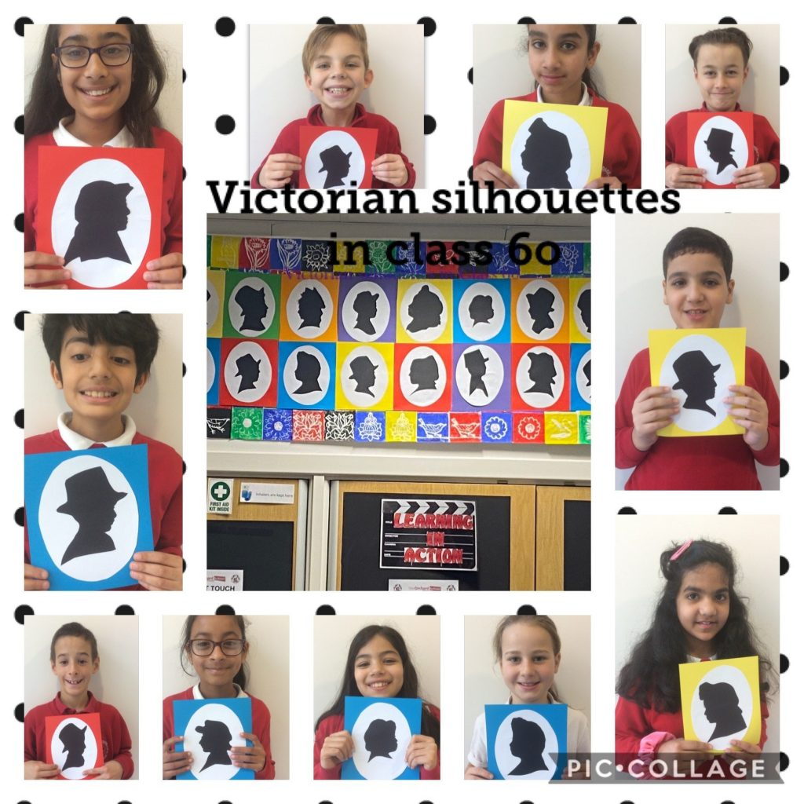  Designing  Elements - explore ideas.  Creating their own Victorian silhouette (linking to self-portraiture), with a William Morris-inspired background.  Art Style  Silhouettes  Artists  William Morris  Lindsay Phillip Butterfield  Walter Crane

 | Block 1 - Watercolours | Block 2 - Pointillism and Digital Art
Year 6 | 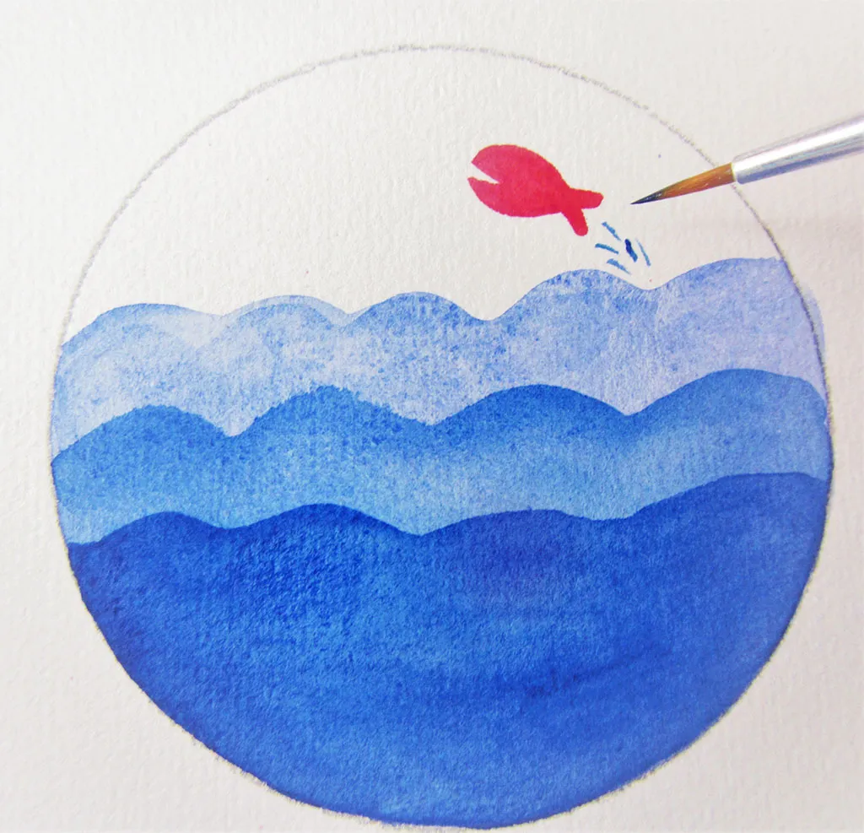  Drawing  Art Elements: line, colour, pattern and  shape  Painting  Art Elements: colour, pattern  Designing  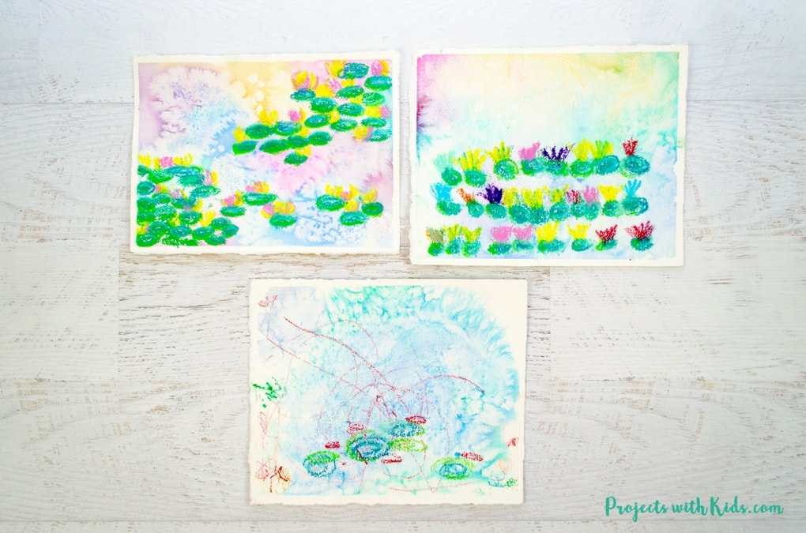  Elements - Explore ideas  Create a Monet water lilies  inspired painting.  Art Style  Watercolours  Artists  Claude Monet  JMW Turner | Drawing  Art Elements: colour, pattern, shape and texture  Painting  Art Elements: colour, composition  Designing  Elements - Explore ideas, imagine  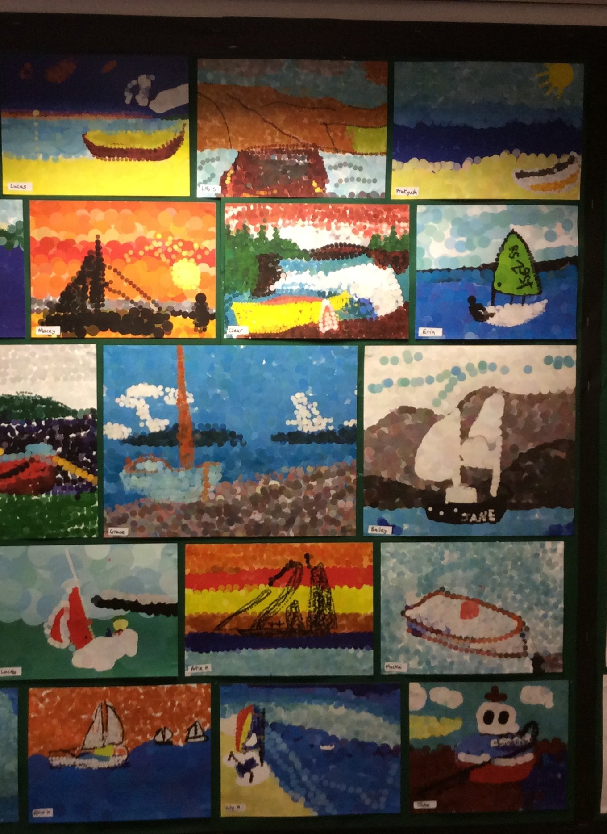  Using Purple Mash ‘2paint-a-picture’ and made using dots of pure colour create own landscape.  Art Style  Pointillism  Artists  Georges Seurat  Paul Signac

