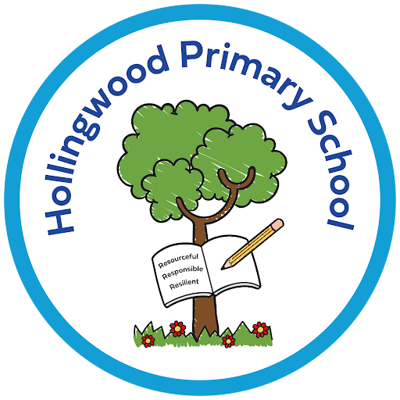
Spanish at Hollingwood

Intent
At Hollingwood, the Modern Foreign Languages curriculum is designed to ignite pupils’ curiosity about the wider world and to lay strong foundations for lifelong language learning. We believe that learning another language enriches pupils’ understanding of different cultures, deepens their appreciation of global diversity, and strengthens their ability to communicate with confidence and respect.
Our intent is to ensure that every child:
- Develops a genuine interest in languages and a positive attitude towards exploring how they work.
- Builds the essential knowledge and skills needed to understand and express simple ideas in another language, both orally and in writing.
- Recognises patterns, structures, and key grammatical features, enabling them to make connections across languages, including English.
- Gain the confidence to communicate, using accurate pronunciation and a growing bank of vocabulary.
- Appreciates cultural traditions and perspectives, developing empathy and an outward‑looking mindset.
- Is well prepared for further language study at secondary school through secure foundations in listening, speaking, reading, and writing.
Our MFL curriculum is ambitious, inclusive, and designed to ensure that all pupils—regardless of background or starting point—experience success and enjoyment as they learn to communicate in a new language.

Implementation
We deliver Spanish through a carefully sequenced curriculum that builds pupils’ linguistic knowledge and cultural understanding progressively from Year 3 to Year 6. Our approach ensures that pupils revisit and deepen key vocabulary, grammar, and phonics so that learning becomes secure and transferable.
Our implementation is characterised by:

A structured, cumulative curriculum
- Spanish is taught weekly throughout KS2 by staff who model accurate pronunciation and enthusiasm for language learning.
- Units are sequenced to introduce core vocabulary and grammatical structures before moving to more complex language.
- Prior learning is revisited regularly through retrieval practice, ensuring knowledge is retained and built upon.

A strong focus on phonics, vocabulary, and grammar
- Pupils learn key Spanish phonemes early, enabling them to decode new words confidently.
- Vocabulary is introduced in meaningful contexts and practised through games, songs, stories, and short conversations.
- Grammar is taught explicitly but accessibly, helping pupils understand how language works and how to manipulate it independently.

Developing the four key skills
Listening: Pupils hear authentic Spanish through teacher modelling, audio resources, and simple dialogues.
Speaking: Children practise speaking in pairs, groups, and whole‑class activities, building confidence and accurate pronunciation.
Reading: Pupils read familiar words, phrases, and short texts, gradually increasing complexity.
Writing: Children write simple sentences and short paragraphs using modelled structures and scaffolded support.

Cultural understanding woven throughout
Pupils learn about Spanish‑speaking countries, traditions, festivals, and daily life, helping them appreciate global diversity.
Cultural content is integrated into lessons so that language learning feels purposeful and connected to real people and places.

Inclusive practice
Lessons are designed so that all pupils can succeed, with visual support, repetition, modelling, and opportunities for overlearning.
More confident linguists are challenged through extended tasks, independent sentence creation, and deeper grammatical reasoning.

Impact
Our Spanish curriculum aims to ensure that pupils leave Key Stage 2 as confident, curious, and capable language learners who are well prepared for secondary study.
We measure impact through:

Growing linguistic confidence
Pupils can express simple ideas in Spanish, ask and answer questions, and engage in short conversations.
They demonstrate increasing accuracy in pronunciation, intonation, and spelling.

Secure knowledge of vocabulary, phonics, and grammar
Children recall key vocabulary and structures and apply them in new contexts.
They recognise patterns in Spanish and make links to English and other languages.

At Hollingwood, we already have children that are bilingual and experienced at communicating in a range of different languages, so we seek to build on this capital with our Spanish learning. Pupils enjoy learning Spanish and show curiosity about other cultures. They develop resilience, confidence, and a willingness to ‘have a go’—key attributes for future language success.

Readiness for Key Stage 3
By the end of Year 6, pupils have a strong foundation in Spanish that enables a smooth transition to secondary languages.
They understand what it means to be a language learner and have the skills to continue building their proficiency.

