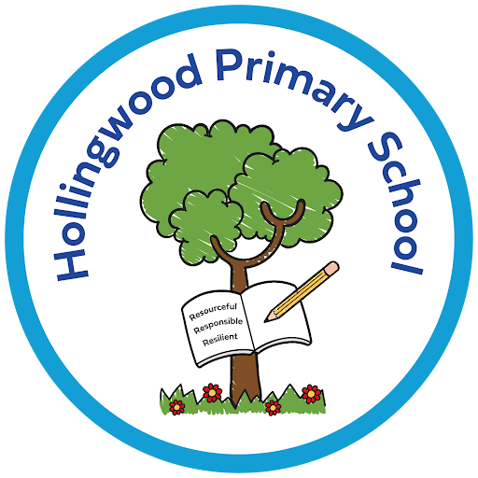
Music at Hollingwood Primary School

Intent

At Hollingwood Primary School, we aim to provide an outstanding music education that instills a lifelong love and appreciation for music. We believe music is a powerful tool for enhancing creativity, promoting personal expression, and developing important skills such as teamwork, communication, and self-confidence. Our intent is to ensure that all pupils have equal access to a high-quality music curriculum, regardless of their background or musical ability.

Implementation

Our music curriculum is structured to provide a broad and balanced education in line with the National Curriculum and the National Plan for Music Education. It is carefully sequenced, ensuring clear progression and depth of knowledge, whilst allowing flexibility for individual creativity and exploration. It incorporates a blend of musical disciplines, including performance, composition, listening, and appraisal, catering to the diverse needs and interests of our pupils.

Through whole-class instrumental teaching, pupils have the opportunity to learn an instrument with specialist support from Bradford Music and Arts Service. Singing is central to our music provision, with assemblies, choir rehearsals and performances helping pupils develop vocal skills and self-expression. Partnerships with musicians and local arts organisations further enrich learning through performances, concerts and wider musical experiences.

Impact

Our music provision consistently leads to good progress and attainment for our pupils. Through regular formative assessment and formative feedback, we gauge the development of their knowledge and skills, enabling us to provide personalised support where needed. Pupils demonstrate a deepening understanding of musical concepts, techniques, and styles, as well as the ability to express themselves with increased confidence through musical performance and composition.
Through music, pupils develop confidence, creativity and important life skills such as perseverance, collaboration and self-discipline. Our music provision helps children become culturally aware individuals who appreciate a wide range of musical traditions, genres and cultures. By participating in performances, festivals and community events, pupils build pride, belonging and a strong sense of community spirit. Our high-quality music curriculum provides children with rich cultural experiences and a lifelong enjoyment of music.

