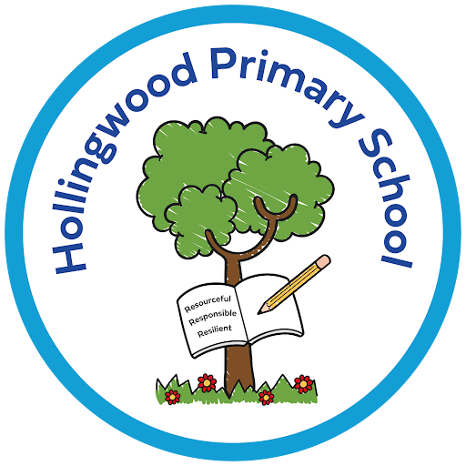
PSHRE at Hollingwood

Intent
At Hollingwood, PSHRE (Personal, Social, Health and Relationships Education) aims to develop confident, respectful and responsible individuals who are prepared for life in modern Britain. Our curriculum equips children with the knowledge, understanding and skills needed to manage relationships, maintain physical and mental wellbeing, and make informed decisions. We are committed to delivering a curriculum which is broad, balanced and relevant to the needs of our children, ensuring that every child receives high quality PSHRE education that reflects the values of our school community and wider society.

Implementation
PSHRE is delivered through a structured and progressive curriculum that is taught across all year groups. Our curriculum is designed and sequenced to meet the needs of our children pupils at different stages of their development. We use a combination of discrete lessons, cross curricular links, assemblies, outside agencies and enrichment activities to deliver a curriculum that covers a wide range of themes.
A key part of our PSHRE provision is The Story Project, which supports pupils in exploring identity, belonging, empathy and resilience through storytelling and shared experiences. This project allows pupils to reflect on their own stories and understand the experiences of others, helping them develop compassion, confidence and a stronger sense of community. Pol-Ed lessons are also used to support contextualised learning.
Teachers use a range of strategies to ensure learning is engaging and meaningful:
- Discussion and reflection
- Scenario-based learning
- Role play and problem-solving
- Collaborative activities
- Cross-curricular links
A safe and supportive classroom environment is established so children feel comfortable sharing ideas and discussing sensitive topics.
Impact
The impact of our PSHRE curriculum is that pupils leave Hollingwood with the knowledge, skills and confidence to navigate the challenges of life. Pupils will have a greater awareness and understanding of their own well being and mental health and that of others. Pupils are empowered to problem solve and make informed decisions, manage risks effectively, self-regulate and resolve conflict. As a result, pupils grow into thoughtful, resilient individuals who understand themselves, respect others and feel empowered to contribute positively to our school community and wider society.

