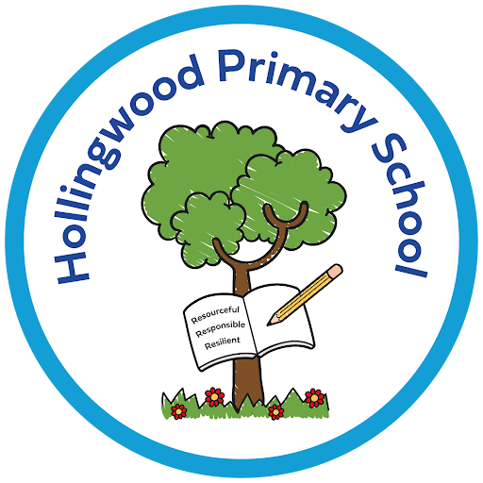
Reading at Hollingwood

Intent
At Hollingwood, we believe reading is a fundamental life skill that enables children to access the full curriculum and to thrive beyond school. Our intent is to develop fluent, confident readers who understand and enjoy a wide range of texts. We aim to build cultural capital through high-quality literature, strengthen vocabulary across the curriculum, and ensure all children keep up with the reading journey. This includes securing strong foundations in systematic synthetic phonics and reading fluency, so every child can decode, read accurately, and comprehend with increasing independence.

Implementation

Whole-Class Reading
- Reading is taught as a whole-class subject from Year 1 to Year 6.
- Children engage with ambitious, carefully chosen texts (fiction and non-fiction) that develop vocabulary, fluency and comprehension.
- Teachers are encouraged to link some texts to wider curriculum themes to deepen understanding and engagement.

Systematic Synthetic Phonics (Little Wandle)
- Little Wandle Letters and Sounds Revised is taught daily from Early Years, providing a consistent, rigorous approach to phonics.
- Lessons are fast-paced, structured and engaging, with clear routines and opportunities for practice and application.
- Children who need additional support receive immediate, targeted keep-up sessions to ensure they keep up rather than catch up.
- The expectation is that children complete the programme by the end of Year 2.
- Children who still need phonics beyond Year 2 continue Little Wandle keep-up sessions in Year 3 and, if required, Year 4.
- Children are thoroughly prepared for the Phonics Screening Check through high-quality teaching, regular review and ongoing assessment.

Reading Practice and Decodable Books
- In Early Years and Key Stage One, children read fully decodable books matched precisely to their current phonics knowledge.
- Children take home a reading practice book to develop fluency, vocabulary and comprehension, as well as a book to share for pleasure.
- In Key Stage Two, children take home appropriately levelled books and may also borrow from their class library.
- The school library is open to all pupils to encourage wider reading.
- From Year 2 onwards, and particularly in Key Stage Two, we use the Little Wandle Fluency programme to strengthen accuracy, prosody and reading stamina.
- Fluency sessions support children who need additional practice to become confident, expressive readers.
- Our Raving Readers reward system celebrates regular reading at home. Children receive awards at multiples of twenty-five reads and may wear their own clothes the following school day.
- Reading enjoyment is promoted through events such as World Book Day, Bradford Literacy Festival, Bedtime Read, Hollingwood Reading Café, Pyjamarama and author visits.
- Vocabulary expectations are embedded across the curriculum.
- Vocabulary from core texts is explicitly taught, revisited and applied to support understanding and writing.

Impact
Children become fluent, confident readers with a rich vocabulary, using reading to support learning across the curriculum. They achieve well in assessments, meet expected standards in EYFS and phonics, and complete the Little Wandle programme by the end of Year 2, with continued support where needed. A genuine love of reading is fostered, with initiatives like Raving Readers encouraging regular reading at home and broad, enthusiastic reading habits.

