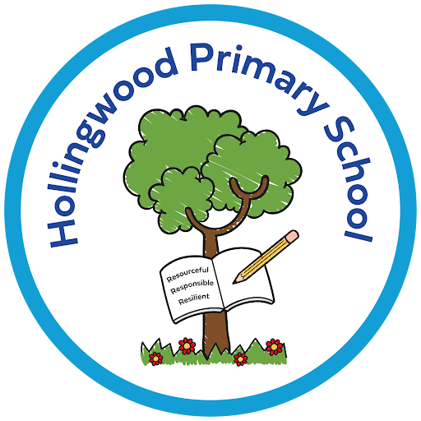
Writing at Hollingwood

Intent

We want every child at our school to see themselves as a writer. Our writing curriculum is designed to develop confident, fluent and imaginative writers who can communicate clearly for a wide range of purposes and audiences. Children learn to:

- Build strong foundations in spelling, handwriting and sentence construction.
- Use grammar and vocabulary purposefully to shape meaning.
- Draw inspiration from high‑quality literature across a wide range of genres.
- Understand writing as a process that involves planning, drafting, editing and improving.
- Write for real and meaningful audiences, developing pride and ownership in their work.
- Develop stamina, independence and a secure authorial voice as they move through school.

Our curriculum is carefully sequenced so that knowledge builds year on year, ensuring that all children—including those with SEND—are supported and challenged to achieve their full potential.

Implementation

Writing is taught through a consistent, whole‑school approach that blends modelling, explicit teaching of skills and opportunities for independent application.

Each unit of work is planned around a high‑quality text. These texts expose children to ambitious vocabulary, varied sentence structures and diverse voices. They provide the context for grammar, inspire ideas and give children clear models of effective writing.

Across all year groups, writing follows a structured cycle:

Immersion and reading
Children explore the core text through discussion, drama, vocabulary work and close reading. This builds understanding and generates ideas for writing.

Skills development
Grammar, punctuation and vocabulary are taught explicitly and always in context. Children practise new skills through short, focused writing tasks.

Modelled and shared writing
Teachers demonstrate the writing process, showing children how to construct sentences, organise ideas and make deliberate language choices. Shared writing allows children to contribute and learn collaboratively.

Independent writing
Children apply what they have learned in extended pieces of writing across a range of genres, including narrative, explanation, diary, persuasion, poetry and non‑fiction.

Editing and redrafting
Children learn how to evaluate and improve their work, developing accuracy, clarity and control.

Progression and coherence
Skills build progressively from EYFS to Year 6:
- Early Years: oral rehearsal, simple sentences, phonics‑based spelling.
- Key Stage 1: sentence types, basic punctuation, descriptive language.
- Lower Key Stage 2: paragraphing, cohesion, subordination, apostrophes.
- Upper Key Stage 2: complex clauses, varied sentence structures, advanced punctuation and authorial control.

Inclusive practice
All children are supported to succeed through:
- Scaffolded planning formats
- Sentence stems and vocabulary banks
- Visual prompts and guided groups
- Carefully structured challenge for higher‑attaining children

Handwriting, spelling and vocabulary
Handwriting and spelling are taught regularly and systematically. Vocabulary is developed through reading, discussion and modelled writing, ensuring children have the language they need to express themselves effectively.

Impact

By the time children leave Hollingwood, they are confident, capable writers who can communicate clearly, creatively and with purpose.
Children develop a love of writing, take pride in their work, and use grammar and vocabulary with confidence and purpose. They make clear progress in both transcription and composition, leaving them well prepared for the demands of writing at Secondary School.

