Hollingwood Primary School Personal Development Map Year 2
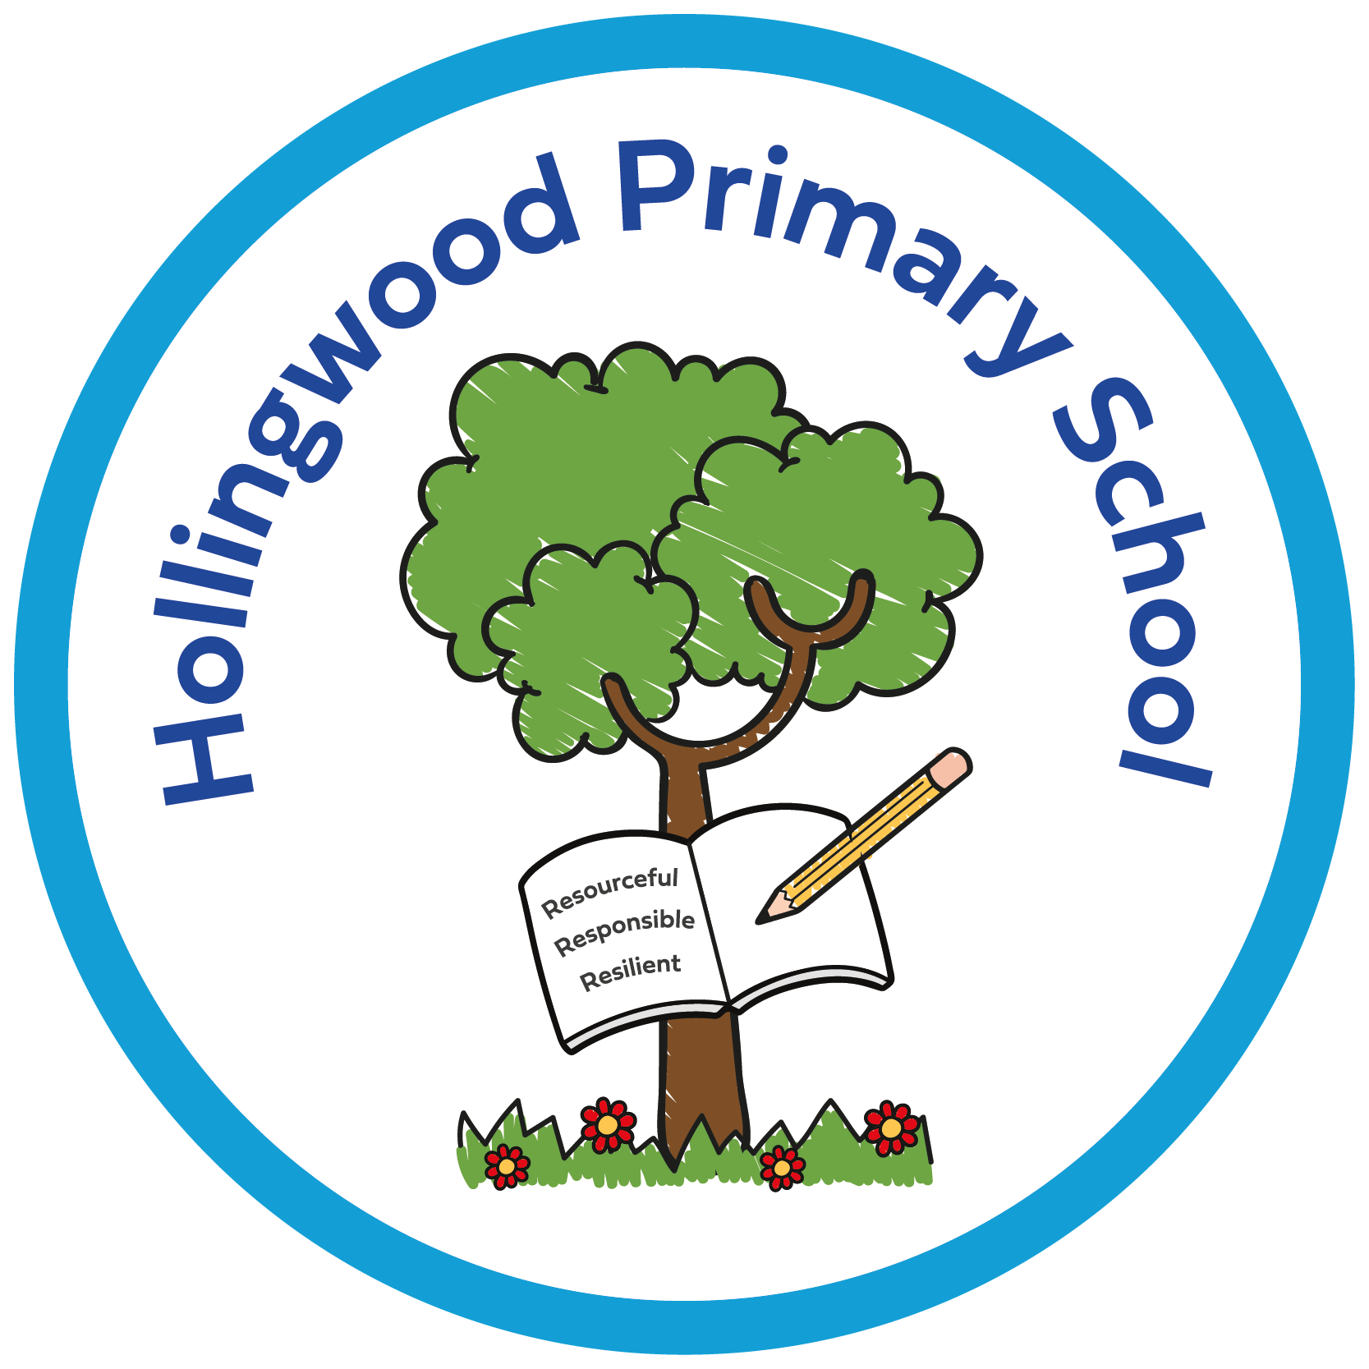  Year 2 | Autumn 1 | Autumn 2 | Spring 1 | Spring 2 | Summer 1 | Summer 2
Curriculum | Story project - The Girl Who Never Makes Mistakes - perseverance and self belief  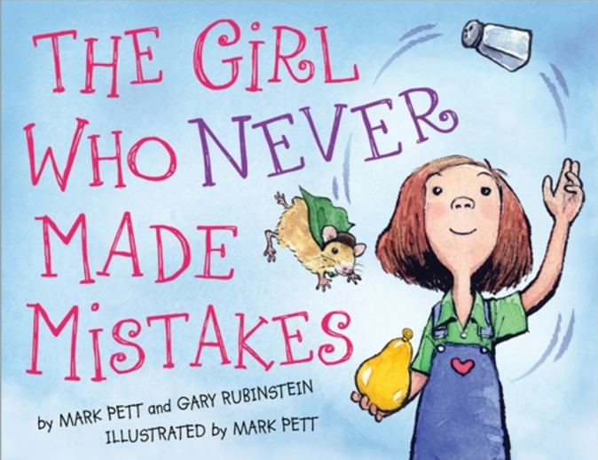  World of Work Day  World Mental Health Day  Assemblies - New Beginnings, Good Work, Black History Month, Halloween and Harvest, Celebration  Enrich days - Quidditch competition.  Newsround | Story project - Ravi’s Roar - dealing with big emotions  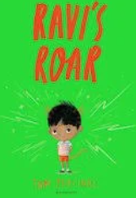  Anti-bullying Week  Odd socks day  Positive Noticing day  Pol Ed lesson - Relationships / How are we the same / different?  Assemblies - Good Work and Human Rights, Celebration  Whole Class Reading - Anti-bullying week.  Theatre company performance.  Newsround | Story project - Chicken Clicking - online safety  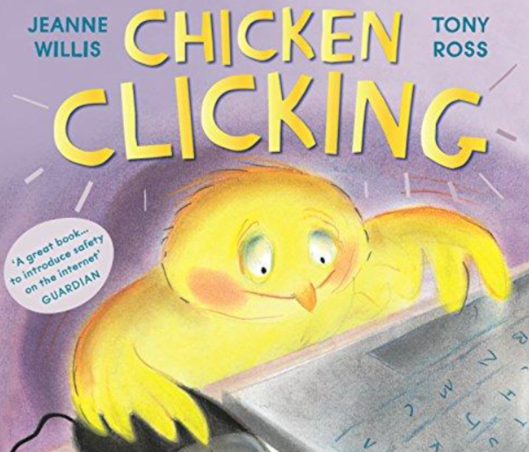  Pol Ed - What is the Internet? What are the risks of online gaming?  Children’s Mental Health Week.  Safer Internet Day.  Assemblies - Good Work, Celebration  Newsround  Forest School | Story project - Aliens Love Underpants - secrets and body parts    Pol Ed - What are private body parts?  Assemblies - Good Work, Eid and Easter week, Celebration  Number Day  Newsround | Story project - The Girl At The Front Of The Class - Refugees and Rights  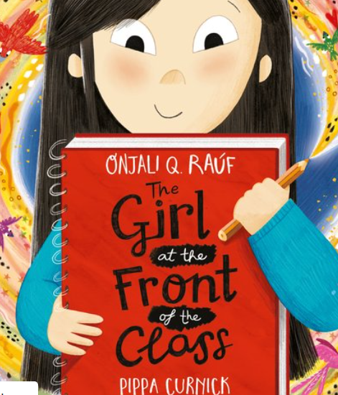  Pol Ed - Relationships - How can I work with other people?  Visit a Mosque  Assemblies - Good Work, Celebration  Newsround | Story project - Grandad’s Camper - Grief and Loss, LGBTQ+  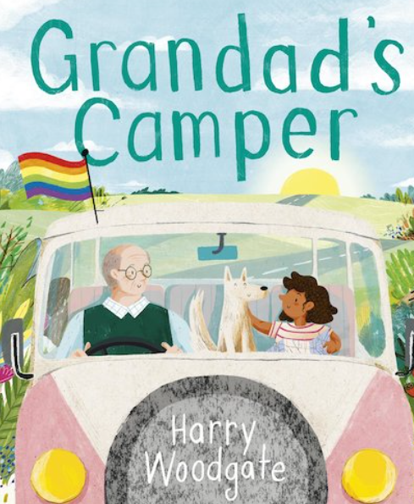  Pol Ed - What is a family? How can I cope with change?  Filey trip  Assemblies - Good Work, Celebration  Newsround
Environment | Reading nooks and break out spaces.  Sensory room  OPAL  Technology - Chromebooks  Forest School  Library  Allotment  Care Club

Family Partnership | Parents invited in for a Good Work assembly.  PTA recruitment meeting.  Harvest Festival - donations to the foodbank.  Library  Phonics parent information session. | PTA bake sale.  Rocksteady Concert.  KS2 Christmas Concert.  Spanish Breakfast.  Parents invited in for a Good Work assembly.  Parents' evening.  Library  Money morning.  Christmas Card Competition Award | MHST parent workshop - Kindness at home.  Ash Class - Class assembly.  Parents invited in for a Good Work assembly.  Parent online safety workshops  Library  DT afternoon | Parents invited in for a Good Work assembly.  Rocksteady Concert.  World Book Day  Book Bus  Whole School Art Day  Library | Whole School Art Day - showcase at the end of the day.  PTA Eid Mela  Hawaii morning.  Parents' evening.  Parents invited in for a Good Work assembly.  Birch Class - Class assembly.  Library  Eid Card Competition Award | Sports Day.  Open evening.  Parents invited in for a Good Work assembly.  Rocksteady Concert.  Library
Pupil Voice | Eco council  Digital leaders  School council  Seat-y workshop - train seat design for city of culture 2025.  Litter pick  I wish my teacher knew… | Eco council  Digital leaders  School council  Litter pick  I wish my teacher knew… | Eco council  Digital leaders  School council  Litter pick  I wish my teacher knew… | Eco council  Digital leaders  School council  Litter pick  I wish my teacher knew… | Eco council  Digital leaders  School council  Litter pick  NSPCC virtual assembly.  I wish my teacher knew… | Eco council  Digital leaders  School council - Rota Kids.  Litter pick  HollingWorld Cup Event.  I wish my teacher knew…
Culture | Walking to School - WOW  Pastoral work - KD  Positive noticing.  Relationships  Staff voice  Story Project Pilot - part of the expert school panel. Now going national.  Goldsmiths and the National Literacy Trust.  Rewards - Raving Readers and attendance awards (bowling)  Living Well  Early Help  Outside agencies.

