Hollingwood Primary School Personal Development Map Year 3
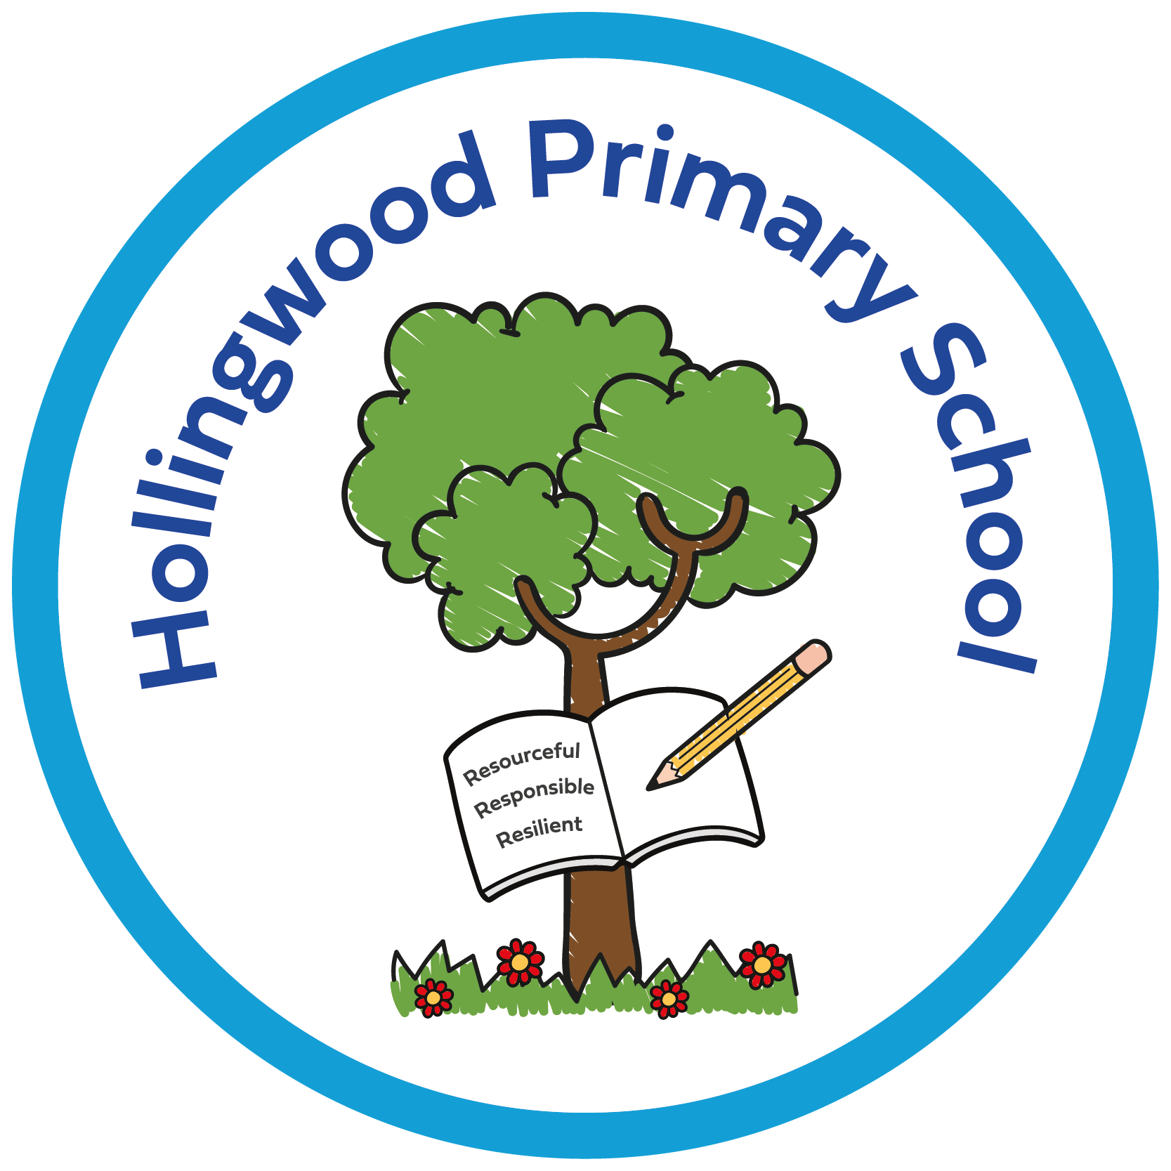  Year 4 | Autumn 1 | Autumn 2 | Spring 1 | Spring 2 | Summer 1 | Summer 2
Curriculum | Story project - On A Magical Do Nothing Day -understanding the importance of spending time outdoors and connecting with nature.  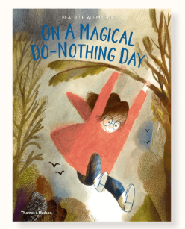  World of Work Day  World Mental Health Day  Assemblies - New Beginnings, Good Work, Black History Month, Halloween and Harvest.  Enrich days - Quidditch competition.  Newsround | Story project - Ruby’s Worry- Understanding how to deal with anxiety.  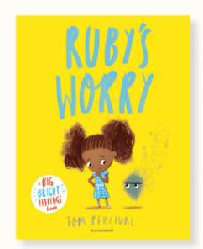  Pol-Ed - Keeping safe - How can I share my worries?  Charlotte's Web Day Anti-bullying Week  Odd socks day  Positive Noticing day  Assemblies - Good Work and Human Rights..  Whole Class Reading - Anti-bullying week.  Theatre company performance.  Friendship Workshop- Ellen  Newsround | Story project -It’s A No Money Day- understanding the importance of money and poverty.  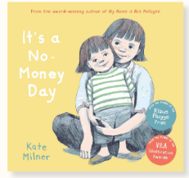  Children’s Mental Health Week.  Safer Internet Day.  Assemblies - Good Work.  Newsround  Religious visit to St Johns | Story project - Faruq and the Wiri Wiri- understanding balanced lifestyle.  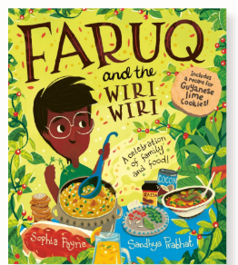  Assemblies - Good Work, Eid and Easter week.  Number Day  Newsround  Cliffe Castle  World Book Day  Art Day  Book Bus | Story project - The Hundred Dresses- understanding bullying.  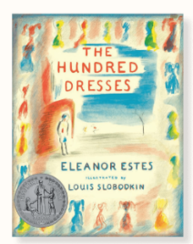  Pol-Ed Relationships - What do we mean by consent in friendships?  Pol-Ed Relationships - what can we do when friendships go wrong?  Thornton Hall Country Park.  Bradford City Football stadium- Goldsmiths  DT Afternoon  Spelling Bee  Assemblies - Good Work  Newsround | Story project - Ossiri and The Bala Mengro- understanding different communities and growth mindset.  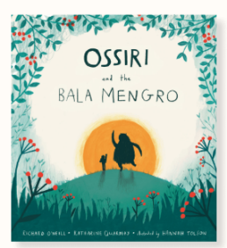  Pol-EdRelationships - What is bullying?  Pol-Ed Well-being - What am I good at?  Cross country  Assemblies - Good Work  Newsround  Bradford Stories Bus- Goldsmiths  Road Safety- pedestrian training  Forest School  Show and Tell Assembly Pine and Rowan
Environment | Reading nooks and break out spaces.  Sensory room  OPAL  Technology - Chromebooks  Forest School  Library  Allotment  Care Club

Family Partnership | Parents invited in for a Good Work assembly.  PTA recruitment meeting.  Harvest Festival - donations to the foodbank.  Library | PTA bake sale.  Rocksteady Concert.  KS2 Christmas Concert.  Parents invited in for a Good Work assembly.  Parents' evening.  Library  Christmas Card Competition Award  Charlotte’s Web Day | Parents invited in for a Good Work assembly.  Parent online safety workshops  Library | Parents invited in for a Good Work assembly.  Rocksteady Concert.  World Book Day  Book Bus  Whole School Art Day  Library | Whole School Art Day - showcase at the end of the day.  PTA Eid Mela  Parents' evening.  Parents invited in for a Good Work assembly.  Library  DT afternoon  Eid Card Competition Award | Sports Day.  Open evening.  Parents invited in for a Good Work assembly.  Rocksteady Concert.  Library  Rowan and Pine class assembly.
Pupil Voice | Eco council  Digital leaders  School council  Seat-y workshop - train seat design for city of culture 2025.  Litter pick  Librarians  Play buddies  OPAL leaders  I wish my teacher knew… | Eco council  Digital leaders  School council  Litter pick  Librarians  Play buddies  OPAL leaders  I wish my teacher knew… | Eco council  Digital leaders  School council  Litter pick  Librarians  Play buddies  OPAL leaders  I wish my teacher knew… | Eco council  Digital leaders  School council  Litter pick  Librarians  Play buddies  OPAL leaders  I wish my teacher knew… | Eco council  Digital leaders  School council  Litter pick  Librarians  Play buddies  OPAL leaders  NSPCC virtual assembly.  I wish my teacher knew… | Eco council  Digital leaders  School council - Rota Kids.  Litter pick  Librarians  Play buddies  OPAL leaders  HollingWorld Cup Event.  I wish my teacher knew…
Culture | Walking to School - WOW  Pastoral work - KD  Positive noticing.  Relationships  Staff voice  Story Project Pilot - part of the expert school panel. Now going national.  Goldsmiths and the National Literacy Trust.  Rewards - Raving Readers and attendance awards (bowling)  Living Well  Early Help  Outside agencies.

