Hollingwood Primary School Personal Development Map Year 4
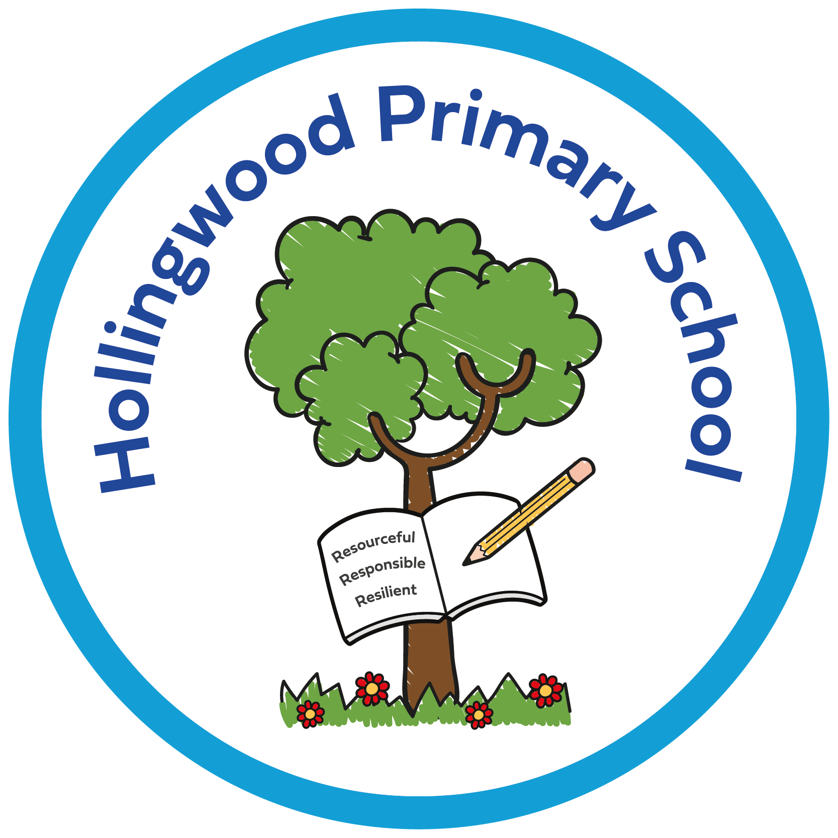  Year 4 | Autumn 1 | Autumn 2 | Spring 1 | Spring 2 | Summer 1 | Summer 2
Curriculum | Story project - The Grand Hotel of Feelings - understanding feelings.  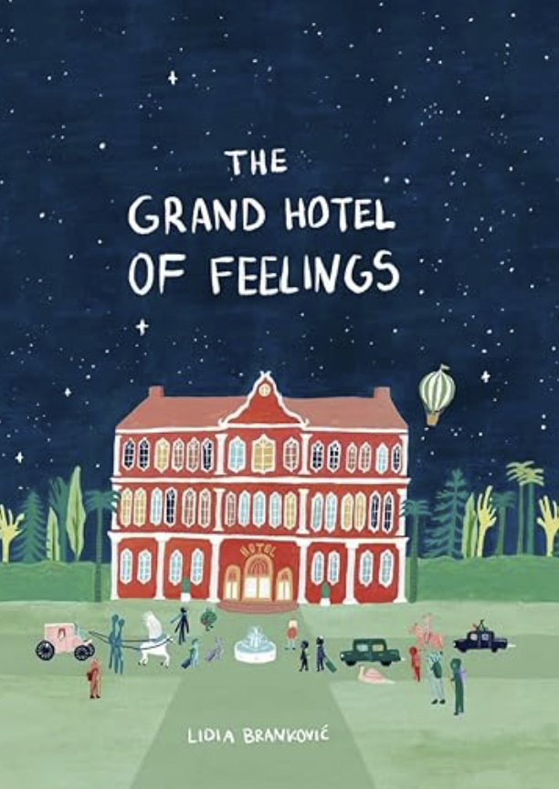  Pol Ed lessons - Winter water safety  RE - being part of a community.  World of Work Day  World Mental Health Day  Assemblies - New Beginnings, Good Work, Black History Month, Halloween and Harvest.  Enrich days - Quidditch competition.  Cornets  Newsround | Story project - Penguin Pig - Online safety.  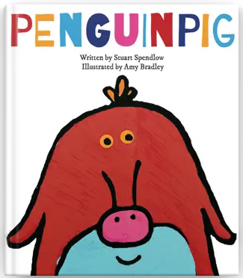  Anti-bullying Week  Odd socks day  Positive Noticing day  Pol Ed lesson - Keeping safe, who do I encounter?  Assemblies - Good Work and Human Rights.  Local area walk in science.  Whole Class Reading - Anti-bullying week.  Theatre company performance.  Cornets  Newsround | Story project - This Moose Belongs to Me - Friendship.  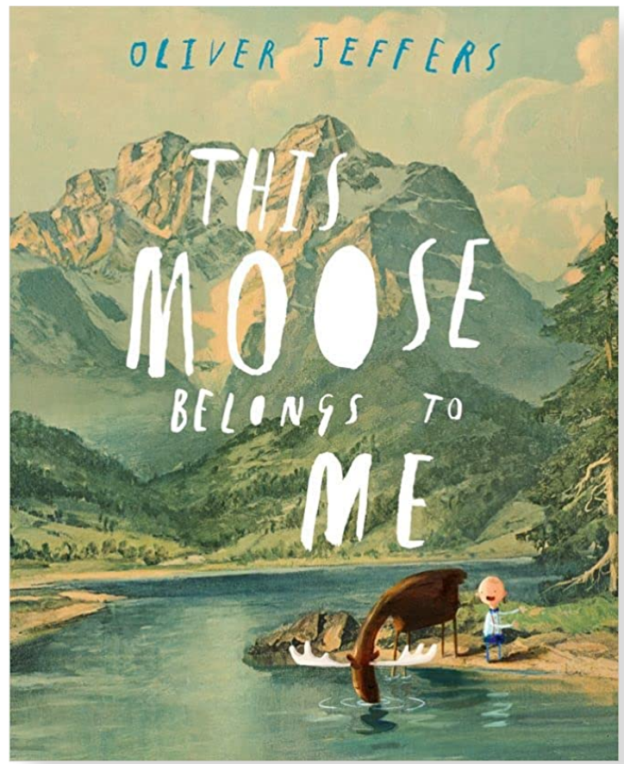  Pol Ed - What makes a healthy friendship?  Children’s Mental Health Week.  Safer Internet Day.  Assemblies - Good Work.  Cornets  Newsround  Forest School | Story project - The Proudest Blue - Cultural heritage and strategies for dealing with bullying.  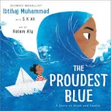  Computing-internet.  Pol Ed - Relationships - What is discrimination?  Assemblies - Good Work, Eid and Easter week.  Number Day  Learning to play Cornets  Newsround | Story project - The Tunnel - Peer pressure and risks.  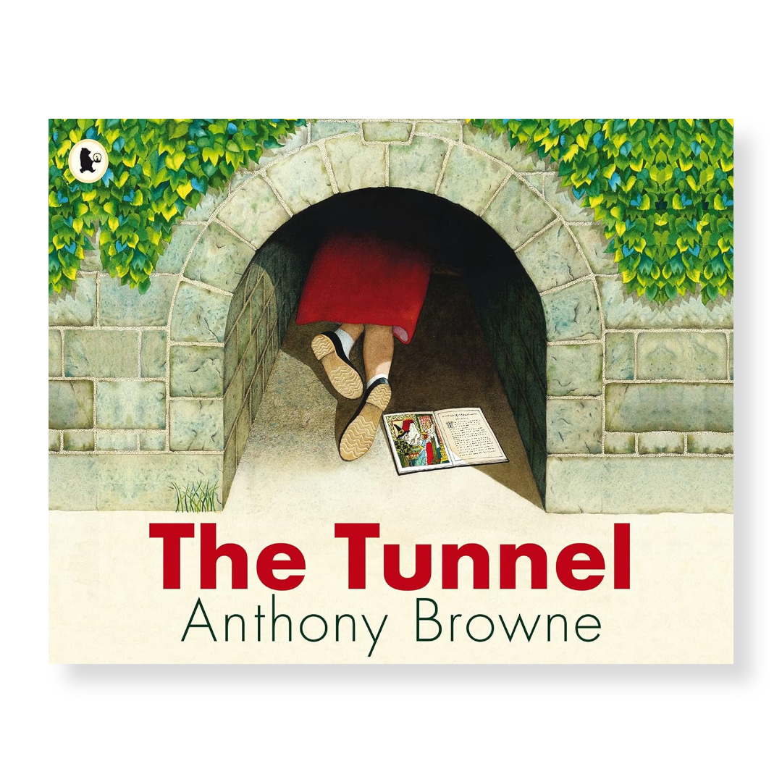  Pol Ed - Relationships - What is peer influence?  Keeping Safe - What is first aid?  Chester Zoo school trip.  Visit a Gurdwara.  Assemblies - Good Work  Dixon Kings Concert  Learning to play Cornets  Prime VR day  Newsround | Story project - Mama Miti - risks from the sun, role models and wellbeing-  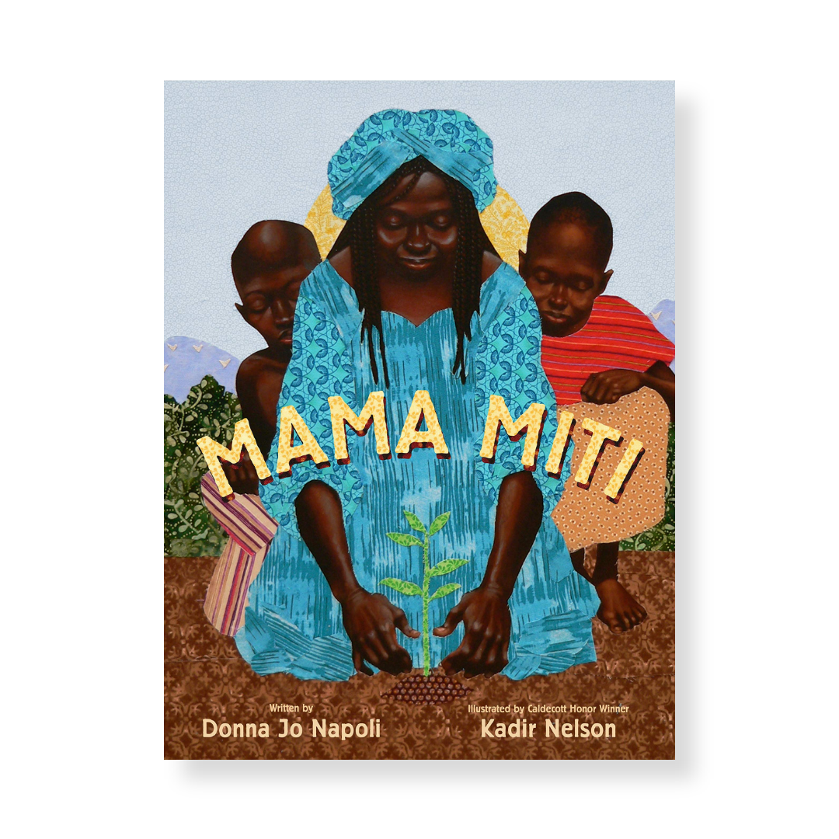  Cross country.  Assemblies - Good Work  Music Service Concert  Learning to play Cornets  Newsround
Environment | Reading nooks and break out spaces.  Sensory room  OPAL  Technology - Chromebooks  Forest School  Library  Allotment  Care Club

Family Partnership | Parents invited in for a Good Work assembly.  PTA recruitment meeting.  Harvest Festival - donations to the foodbank.  Library | PTA bake sale.  Rocksteady Concert.  KS2 Christmas Concert.  Spanish Breakfast.  Parents invited in for a Good Work assembly.  Parents' evening.  Library  Christmas Card Competition Award | MHST parent workshop - Kindness at home.  Ash Class - Class assembly.  Parents invited in for a Good Work assembly.  Parent online safety workshops  Library | Parents invited in for a Good Work assembly.  Rocksteady Concert.  World Book Day  Book Bus  Whole School Art Day  Library | Whole School Art Day - showcase at the end of the day.  PTA Eid Mela  Hawaii morning.  Parents' evening.  Parents invited in for a Good Work assembly.  Birch Class - Class assembly.  Library  Eid Card Competition Award | Sports Day.  Open evening.  Parents invited in for a Good Work assembly.  Rocksteady Concert.  Library
Pupil Voice | Eco council  Digital leaders  School council  Seat-y workshop - train seat design for city of culture 2025.  Litter pick  Librarians  Play buddies  OPAL leaders  I wish my teacher knew… | Eco council  Digital leaders  School council  Litter pick  Librarians  Play buddies  OPAL leaders  I wish my teacher knew… | Eco council  Digital leaders  School council  Litter pick  Librarians  Play buddies  OPAL leaders  I wish my teacher knew… | Eco council  Digital leaders  School council  Litter pick  Librarians  Play buddies  OPAL leaders  I wish my teacher knew… | Eco council  Digital leaders  School council  Litter pick  Librarians  Play buddies  OPAL leaders  NSPCC virtual assembly.  I wish my teacher knew… | Eco council  Digital leaders  School council - Rota Kids.  Litter pick  Librarians  Play buddies  OPAL leaders  HollingWorld Cup Event.  I wish my teacher knew…
Culture | Walking to School - WOW  Pastoral work - KD  Positive noticing.  Relationships  Staff voice  Story Project Pilot - part of the expert school panel. Now going national.  Goldsmiths and the National Literacy Trust.  Rewards - Raving Readers and attendance awards (bowling)  Living Well  Early Help  Outside agencies.

