Hollingwood Primary School Personal Development Map Year 5
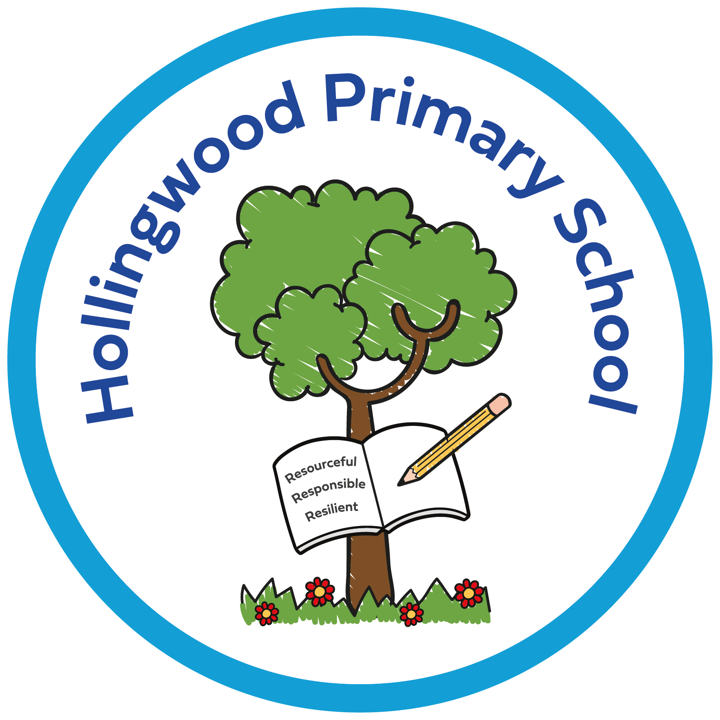  Year 5 | Autumn 1 | Autumn 2 | Spring 1 | Spring 2 | Summer 1 | Summer 2
Curriculum | Story project - The boy who grew flowers - Bullying  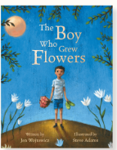  Pol-Ed Relationships - How do words have power?  World of Work Day  World Mental Health Day  Assemblies - New Beginnings, Good Work, Black History Month, Halloween and Harvest.  Enrich days - Quidditch competition.  Art Day  Newsround  Bradford Beck  China morning - Parent Day | Story project - The colour Thief- Mental health.  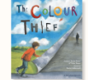  Pol-Ed Understanding the law - How do rules help our community?  Anti-bullying Week  Odd socks day  Positive Noticing day  Assemblies - Good Work and Human Rights.  Whole Class Reading - Anti-bullying week.  Theatre company performance.  Fire safety talk  Newsround | Story project - Ada’s Violin - Self-esteem and goals.  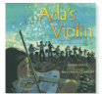  Children’s Mental Health Week.  Safer Internet Day.  Assemblies - Good Work.  Alhambra  MHST workshop  Newsround | Story project - Mum and dad glue - Affirmation and separation.  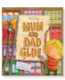  Computing-internet.  Assemblies - Good Work, Eid and Easter week.  Number Day  Newsround  Art Morning - Tony Bullock  World Book Day  Art day | Story project -  Ritu weds Chandni - Cultural celebrations  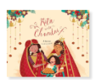  Pol-Ed Relationships - Why are our special people important?  Pol-Ed Well being - What is my personal identity?  Knife crime session  MHST workshop  Assemblies - Good Work  Virtual Reality workshop  Newsround | Story project - Pizza Face - Puberty    Pol-Ed Relationships - What are my personal boundaries?  Pol-Ed Well-being - How might puberty impact the way I feel?  Cross country  Assemblies - Good Work  Salts Mill  Newsround  MHST workshop  Puberty talk  Road Safety assembly  Bradford music concert
Environment | Reading nooks and break out spaces.  Sensory room  OPAL  Technology - Chromebooks  Forest School  Library  Allotment  Care Club

Family Partnership | Parents invited in for a Good Work assembly.  PTA recruitment meeting.  Harvest Festival - donations to the foodbank.  Library | PTA bake sale.  Rocksteady Concert.  KS2 Christmas Concert.  Parents invited in for a Good Work assembly.  Parents' evening.  Library  Christmas Card Competition Award  Beech class assembly. | Parents invited in for a Good Work assembly.  Parent online safety workshops  Library  Chestnut- Whole class assembly  Family partnership -Online safety session for parent | Parents invited in for a Good Work assembly.  Rocksteady Concert.  World Book Day  Book Bus  Whole School Art Day  Library | Whole School Art Day - showcase at the end of the day.  PTA Eid Mela  Parents' evening.  Parents invited in for a Good Work assembly.  Eid Card Competition Award | Sports Day.  Open evening.  Parents invited in for a Good Work assembly.  Rocksteady Concert.  Library  Making smoothies with parents.
Pupil Voice | Eco council  Digital leaders  School council  Litter pick  Librarians  Play buddies  OPAL leaders  I wish my teacher knew… | Eco council  Digital leaders  School council  Litter pick  Librarians  Play buddies  OPAL leaders  I wish my teacher knew… | Eco council  Digital leaders  School council  Litter pick  Librarians  Play buddies  OPAL leaders  I wish my teacher knew… | Eco council  Digital leaders  School council  Litter pick  Librarians  Play buddies  OPAL leaders  I wish my teacher knew… | Eco council  Digital leaders  School council  Litter pick  Librarians  Play buddies  OPAL leaders  NSPCC virtual assembly.  I wish my teacher knew… | Eco council  Digital leaders  School council - Rota Kids.  Litter pick  Librarians  Play buddies  OPAL leaders  HollingWorld Cup Event.  I wish my teacher knew…
Culture | Walking to School - WOW  Pastoral work - KD  Positive noticing.  Relationships  Staff voice  Story Project Pilot - part of the expert school panel. Now going national.  Goldsmiths and the National Literacy Trust.  Rewards - Raving Readers and attendance awards (bowling)  Living Well  Early Help  Outside agencies.

