Hollingwood Primary School Personal Development Map Year 6
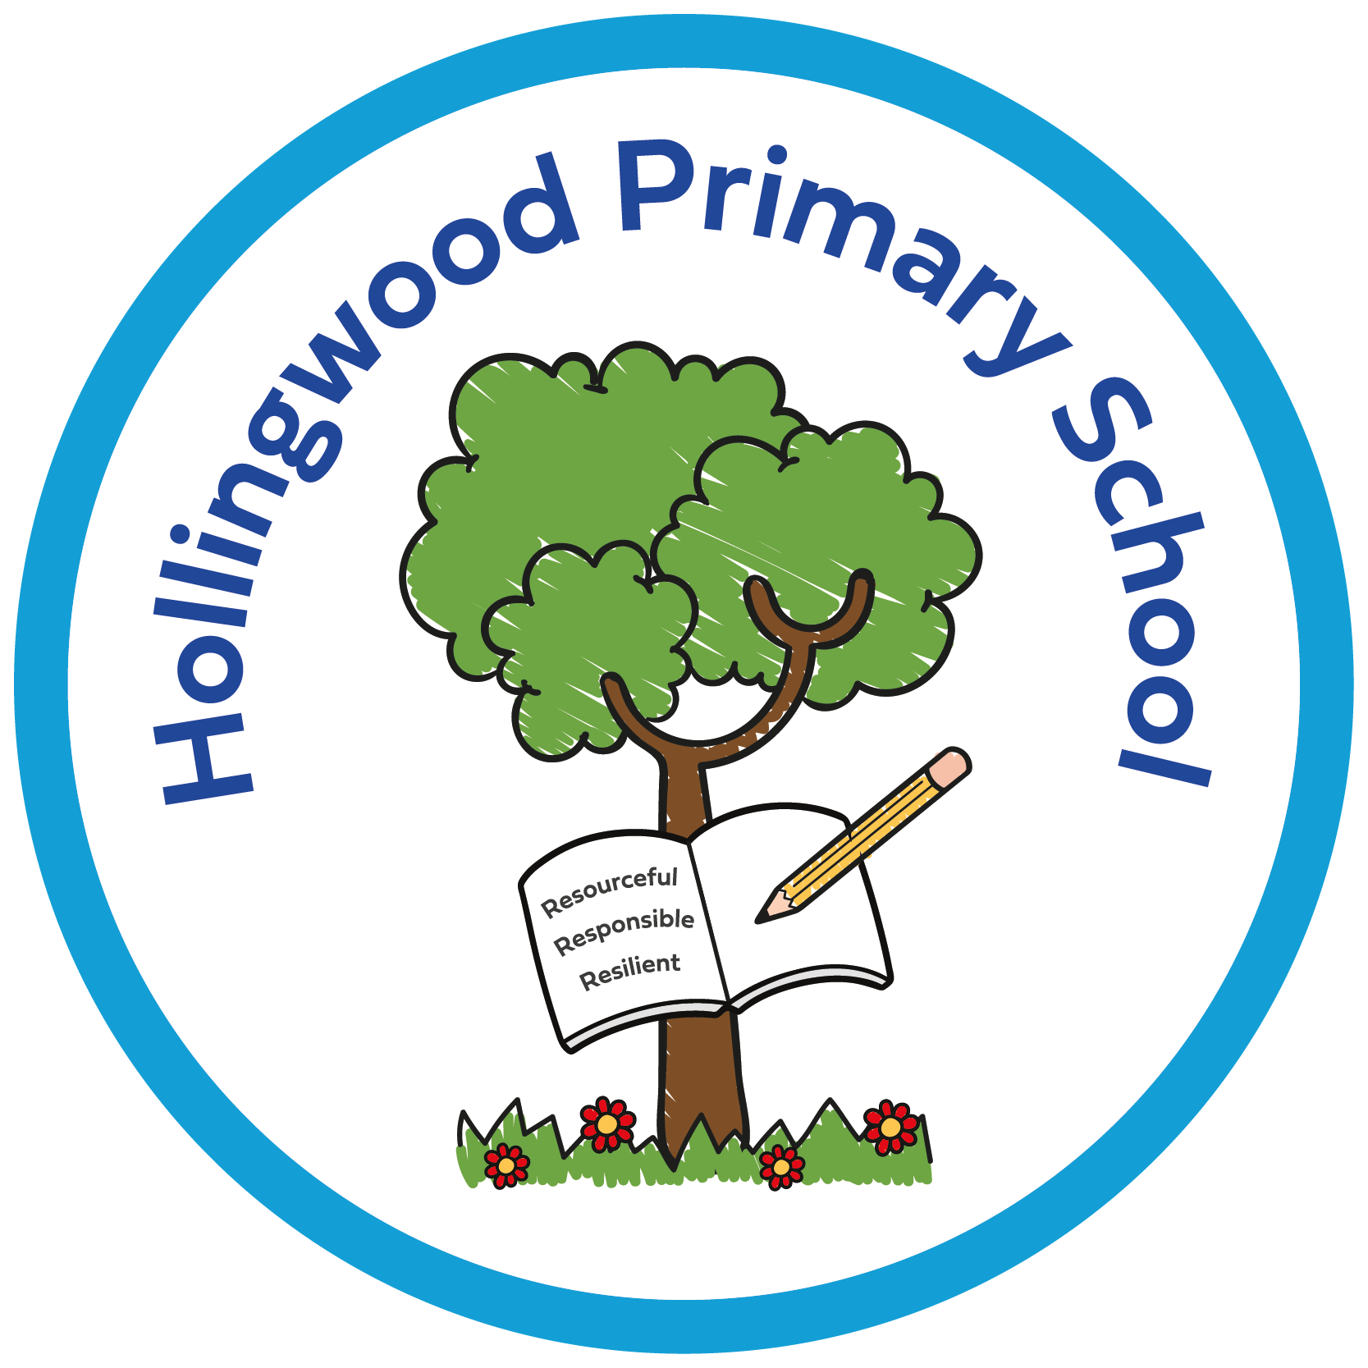  Year 4 | Autumn 1 | Autumn 2 | Spring 1 | Spring 2 | Summer 1 | Summer 2
Curriculum | Story project - Aaron Slater Illustrator by Andrea Beaty  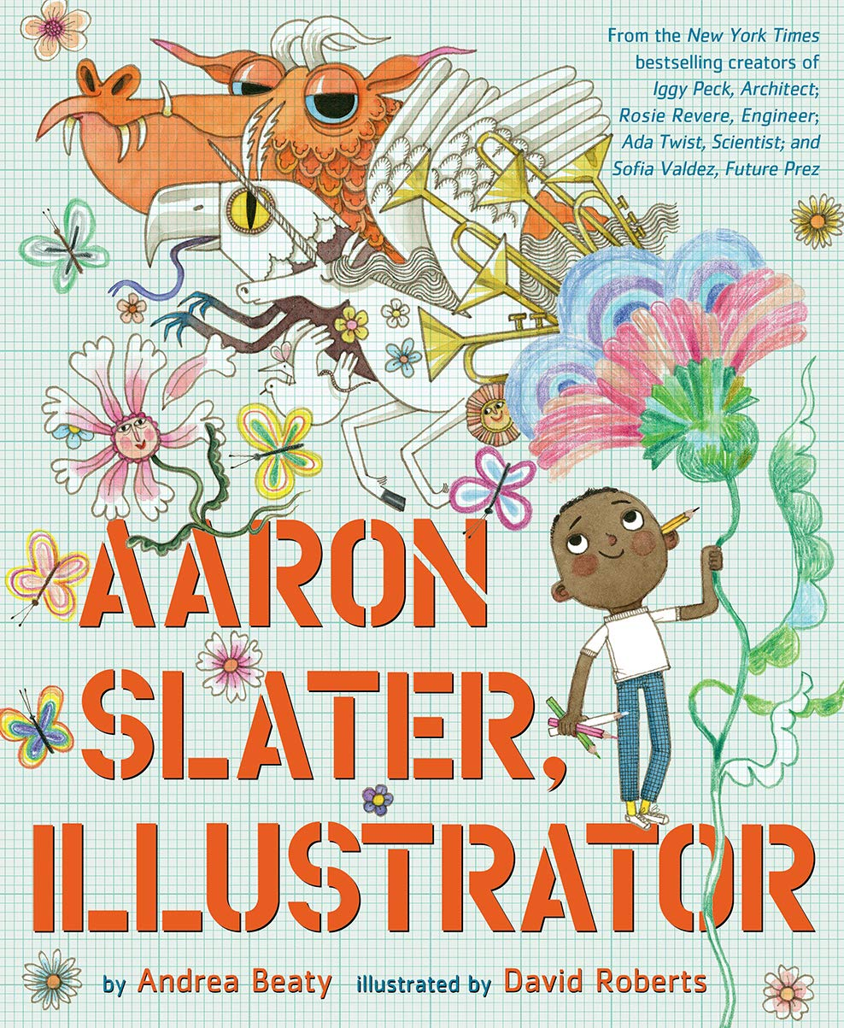  Pol Ed Lessons - Keeping Safe: Halloween - Trick or treat  Odsal Blue Watch - Bonfire Safety Talk  World of Work Day  World Mental Health Day  Assemblies - New Beginnings, Good Work, Black History Month, Halloween and Harvest.  Enrich days - Quidditch competition  Art afternoon - Bradford heritage  Newsround  Year 6 Boys Football Tournament  Year 6 Girls Football Tournament | Story project - Little People Big Dreams: Marcus Rashford by Maria Isabel Sanchez Vegara  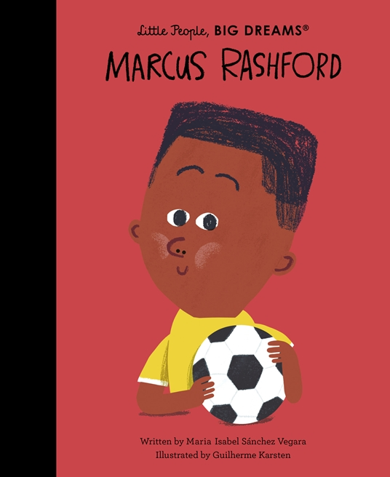  Pol Ed Lessons - Relationships: How can we be allies against racism?  Odsal Red Watch - Fire Safety Talk  Anti-Bullying Week  Odd Socks Day  Positive Noticing Day  Assemblies - Good Work and Human Rights.  Whole Class Reading -  Anti-Bullying Week.  Theatre company performance.  Bikeability  Newsround | Story project - Little People Big Dreams: Mary Earps by Maria Isabel Sanchez Vegara  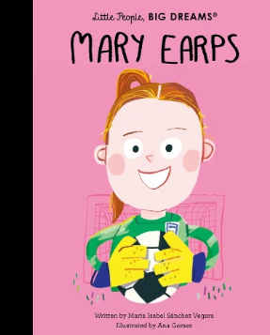  Pol Ed Lessons - Wellbeing: What does adulthood look like?  Children’s Mental Health Week.  Safer Internet Day.  Assemblies - Good Work.  Dodgeball Tournament  Newsround | Story project - Sunny Side Up by Jennifer and Matthew Holm  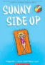  Pol Ed Lessons - Understanding the Law: What does the law say about legal drugs?; What is the issue with addiction (vaping / smoking)?  Computing-internet.  Assemblies - Good Work, Eid and Easter week.  Number Day  Learning to play Cornets  Newsround  World Book Day  Whole School Art Day | Story project - On the Tip of a Wave by Joanna Ho  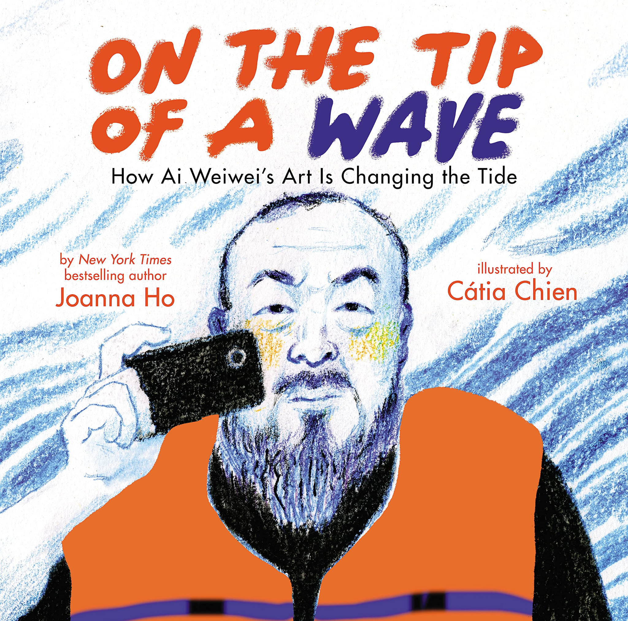  Keeping Safe - What is first aid?  Assemblies - Good Work  Newsround  Prime VR Day  MHST Worry Workshop  West Yorkshire Police: Knife Crime Awareness Session | Story project - Finding My Voice Aoife Dooley  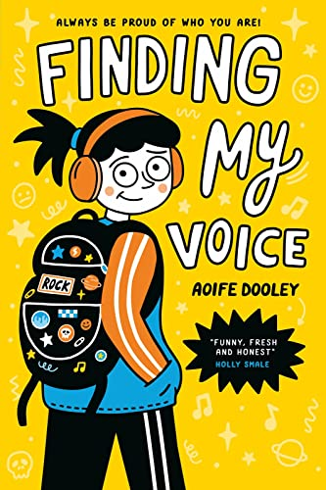  Pol Ed Lessons - Relationships: How can I get ready for secondary relationships?  Wellbeing: How can I manage moving to high school positively?  Cross country  Assemblies - Good Work  Newsround  Alhambra: Terrible Tudors  Road Safety Session  Robinwood Residential  Bradford Music Concert  Year 6 Transition Webinar  Brackenhill Transition Event  MHST - Prepare to Change  Rounders Festival  Escape Room
Environment | Reading nooks and break out spaces  Sensory room  OPAL  Technology - Chromebooks  Forest School  Library  Allotment  Care Club

Family Partnership | Parents invited in for a Good Work assembly  PTA recruitment meeting  Harvest Festival - donations to the foodbank  Library | PTA bake sale  Rocksteady Concert  KS2 Christmas Concert  Parents invited in for a Good Work assembly  Parents' evening  Library  Christmas Card Competition Award | Parents invited in for a Good Work assembly  Online Safety Session - Parents  Library | Parents invited in for a Good Work assembly.  Rocksteady Concert.  MHST - Parent-Pupil Workshop: Take Notice  Whole School Art Day  Book Bus  Library | Whole School Art Day - showcase at the end of the day  PTA Eid Mela  Parents' evening  Oak Class Assembly  Good Work assembly  Library  Eid Card Competition Award | Sports Day  Open evening  Parents invited in for a Good Work assembly  Rocksteady Concert  Year 6 Performance  Year 6 Leavers’ Party  Year 6 Graduation  RE Parent Langar  Library
Pupil Voice | Eco council  Digital leaders  School council  Librarians  Play buddies  OPAL leaders  Litter pick  I wish my teacher knew… | Eco council  Digital leaders  School council  Librarians  Play buddies  OPAL leaders  Litter pick  I wish my teacher knew… | Eco council  Digital leaders  School council  Librarians  Play buddies  OPAL leaders  Litter pick  I wish my teacher knew… | Eco council  Digital leaders  School council  Librarians  Play buddies  OPAL leaders  Litter pick  I wish my teacher knew… | Eco council  Digital leaders  School council  Librarians  Play buddies  OPAL leaders  Litter pick  NSPCC virtual assembly.  I wish my teacher knew… | Eco council  Digital leaders  School council  Librarians  Play buddies  OPAL leaders  Rota Kids  Litter pick  HollingWorld Cup Event.  I wish my teacher knew…
Culture | Pastoral work - KD  Positive noticing.  Relationships  Staff voice  Story Project Pilot - part of the expert school panel. Now going national.  Goldsmiths and the National Literacy Trust  Raving Readers  Living Well  Early Help  Outside agencies  Walking to School - WOW

