
Hollingwood Primary School Long Term Plan – Year 1
This is a working document and subject to updating and change

HT1 | HT2 | HT3 | HT4 | HT5 |  |  |  | HT6
English
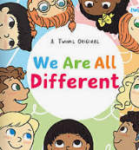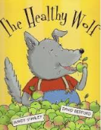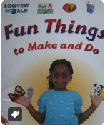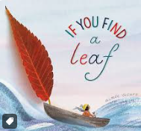  We are all different - Twinkl - Description genre  The Healthy Wolf - Mandy Stanley and David Bedford - Fiction genre  Fun things to make and do - Discovery - Instruction genre  If you find a leaf - Aimee Sicuro - Recount genre  *Write recognisable letters, most of which are correctly formed.  *Say out loud what they are going to write about.  *Join clauses using ‘and’  *Leave spaces between their words. | 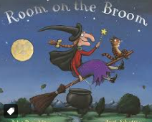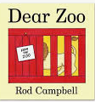  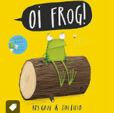  Room on the broom - Julia Donaldson- Fiction genre  Dear Zoo - Rod Campbell - Description genre  Oi frog! Kes Gray and Jim  Field - Poetry genre  Aliens love Panta Claus - Claire Freedman and Ben Cort - Instruction genre  *Consider what they are going to write before beginning.  * Plan what they are going to write about.  *Leave spaces between words  * Begin to punctuate sentences using a capital letter and a full stop, question mark or exclamation. | 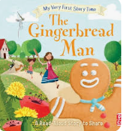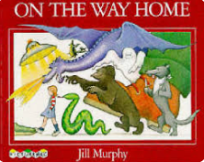  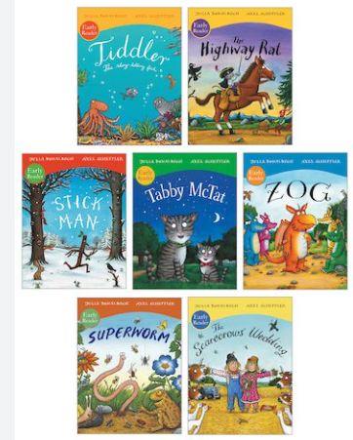  The Gingerbread Man - Traditional tale - Fiction genre  A variety of Julia Donaldson books - Recount  On the way home - Jill Murphy -Description genre  *To spell some common exception words.  *Use phonics to spell new words.  *Leave spaces between words.  *Re read my writing to check that it makes sense. | 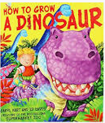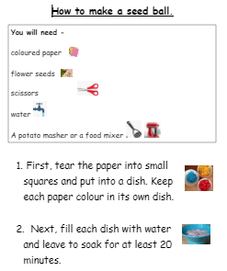  How to grow a dinosaur - Caryl Hart and Ed Eaves - Fiction genre  How to make a seed ball - Teacher made text - Instruction genre  Amazing animal homes - Chris Packham -Description genre  *Compose a sentence orally before writing it  *Use the joining word ‘and’  *Use capital letters and full stops  *Read aloud their writing clearly enough to be heard by their peers and the teacher. | 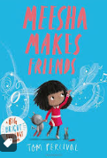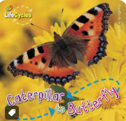  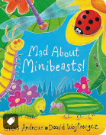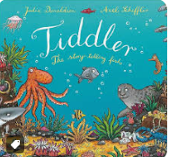  Meesha makes friends - Tom Percival - Fiction genre  Lifecycles -Caterpillar and Butterflies - non fiction text - Recount  Mad about Mini beasts - Giles Andreae - Poetry genre  Tiddler - Julia Donaldson - Fiction genre  *Learn to appreciate rhymes and poems, and to recite some by heart  *Speak audibly and fluently with an increasing command of Standard English  * Participate in presentations and performances  * Gain, maintain and monitor the interest of the listener(s) |  |  |  | 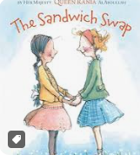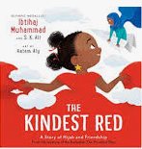  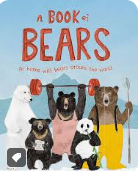  The sandwich swap - Queen Rania Al Abdullah - Instruction genre  The Kindest Red - Ibtihaj Muhammed - Recount  A book of Bears - Katie Viggers - Description  *Sequence sentences to form short narratives.  *Re-read what they have written to check that it makes sense. leaving spaces between words  *Use joining words and joining sentences using and  *Begin to punctuate sentences using a capital letter and a full stop, question mark or exclamation
Maths
Place Value  of numbers within 10.  *sort and count objects  *Represent objects  *Recognise numbers as words  *count on from any number  *1more/1less  *count backwards from 10.  *ordering numbers  *comparing numbers  *Using a number line.  Addition and Subtraction within 10.  *part whole models  *writing number sentences  *fact families  *number bonds within 10  *number bonds to 10  *addition  *subtraction | Addition and Subtraction within 10.  *part whole models  *writing number sentences  *fact families  *number bonds within 10  *number bonds to 10  *addition  *subtraction  Geometry - shape  *Recognising and sorting 2d shapes  *Recognising and sorting 3d shapes  *Patterns with 2d and 3d shapes | Place Value within 20  *count within 20  *understand 10  *understand 11,12,13, 14,15,16,17,18,19 and 20.  *1 more and 1 less  *number line to 20  *comparing and ordering numbers to 20  Addition and Subtraction within 20.  *add by counting on within 20  *finding and making number bonds to 20  *doubles and near doubles  *subtraction by counting back and finding the difference.  *Related facts  *missing number problems | Place Value within 50  *counting from 20 to 50  *exploring numbers 20,30,40 and 50  *groups of 10  *groups of tens and ones  *partitioning into groups of tens and ones  *number line to 50  *1more/1less  length and height  *compare length and height  *measure length using objects  *measure length in cms.  Mass and Volume  *heavier and lighter  *measure mass  *compare mass  *full and empty  *compare volume  *measure capacity  *compare capacity | Multiplication and division  *Counting in multiples of 2,5 and 10.  *recognising and adding equal groups  *make arrays  *make doubles  *make equal groups by grouping and sharing.  Fractions  *recognising and finding half of a shape and quantity.  *recognising and finding a quarter of a shape and quantity.  Geometry  *Position and direction  *Using language (left, right, front, back, full turn, half turn, quarter turn, 3 quarter turn)  *ordinal numbers |  |  |  | Place Value within 100  *count from 50 to 100  *tens to 100  *partitioning tens and ones  *number line to 100  *1more/1less  *comparing numbers  Measurement - money  *unitising  *recognising coins  *recognising notes  *count in coins  Measurement - time  *before and after  *days of the week  *months of the year  *seconds, minutes and hours  *tell the time to the hour  *tell the time to the half hour.
Science
Science - Human bodies/senses. |  |  | Science - Animals (sorting into groups) | Science - Plants |  |  |  | Science - Materials
History

 |  | History - Toys |  |  |  |  |  | History - The Great Fire of London
Geography

 | Geography - The world and my school |  |  | Geography - Our local park
Art
Art - Monochromatic | Art - Chromatic | Art - Chromatic |  | Art - Sculpture
DT
DT - Fruit Salad |  | DT - Puppets | DT - Puppets |  |  |  |  | DT - lunchboxes
Computing
 |  | Learning to log in | Learning to use Purple Mash | Purple Mash |  |  |  | .Purple Mash
RE
Why are festivals important? | Which books and stories are important?  What does it mean to belong to a community of belief?  How and why do we care for others?
PSHE
The Story Project - Peace at last  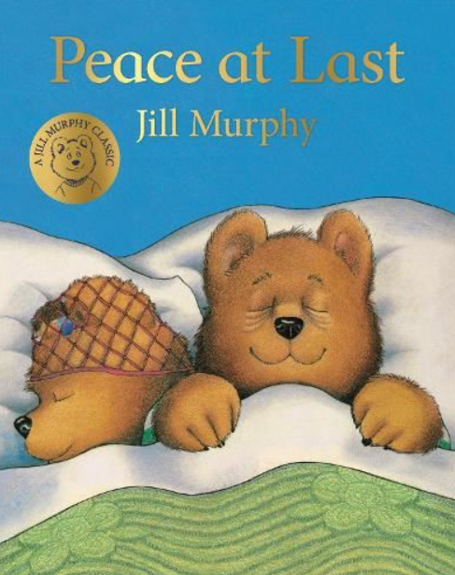 | The Story Project - Morris the mankiest monster  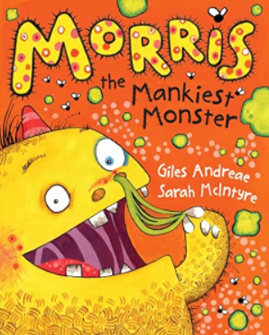 | The Story Project - Look up!  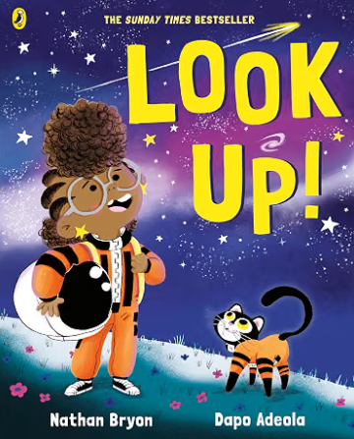 | The Story Project - Angry Arthur  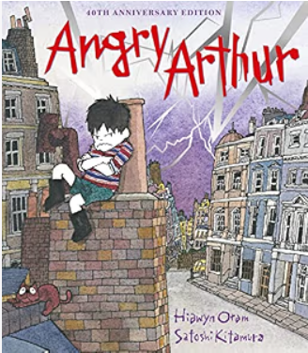 | The Story Project - Mama Car  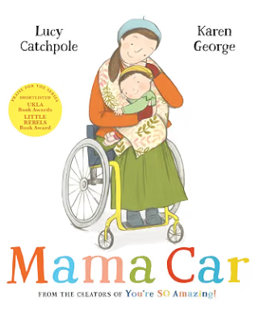 |  |  | The Story Project - The friendship bench  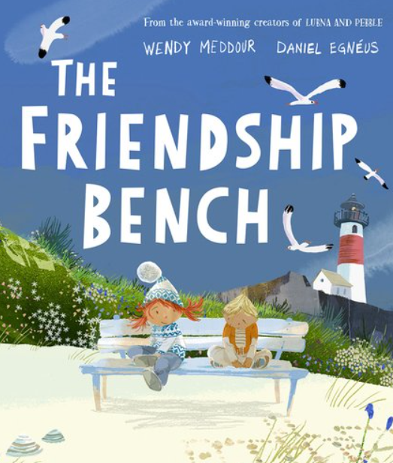
Music
Keeping the pulse - My favourite things | Tempo - Snail and the mouse | Dynamics - Seaside | Sound patterns - Fairytales | Pitch - Superheroes |  |  |  | Musical symbols - Under the sea
PE
icommunicate - Playtime  Fundamentals - Balancing and travelling | iexercise - Jungle  Fundamentals - Rolling and dribbling a ball | Dance - Toys/Great fire of London  Fundamentals - Balancing while moving | icommunicate - Ball crazy  icreate - Funfair | ipractise - Machines  Fundamentals - Throwing and catching |  |  |  | ithink - Wildwest  Fundamentals - Dodging and evading opponents

