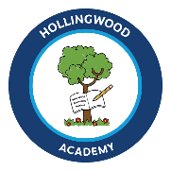
Hollingwood Primary School Long Term Plan – Year 2
This is a working document and subject to updating and change

HT1 | HT2 | HT3 | HT4 | HT5 | HT6
English
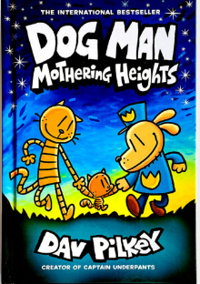  Dogman Mothering Heights by Dav Pilkey  Genre - Writing to entertain  Grammatical features-  1. Capital letters and full stops.  2. Adjectives.  3. Nouns  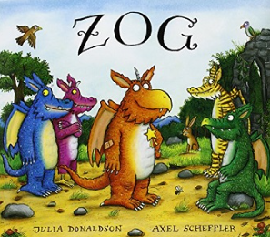  ZOG by Julia Donaldson  Genre- Narrative  Grammatical features-  1. Capital letters and full stops.  2. Adjectives.  3.Time connectives. | 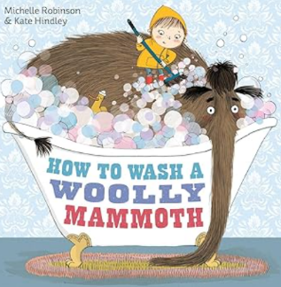  How to wash a Woolly Mammoth by Michelle Robinson  Genre- Instructions  Grammatical features-  1. Verbs  2. Adverbs  3. Expanded noun phrases  4. Adverbs of time to sequence events  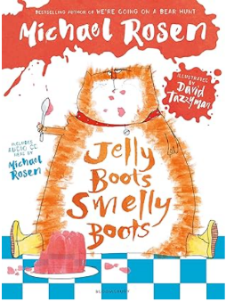  Jelly Boots Smelly Boots by Michael Rosen  Genre- Poetry  Grammatical Features-  1. Rhyming words  2. Recognising recurring literary language.  Writing poetry | 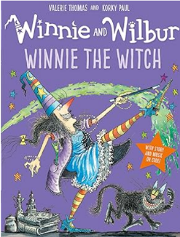  Winnie the Witch by Valerie Thomas  Genre-Writing to entertain (narrative)  Grammatical features  1. Expanded noun phrases.  2. Retelling the story  3. Past tense  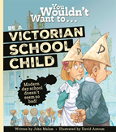  You wouldn’t want to be a Victorian school child by John Malam  Genre- Writing to inform/Setting description  Grammatical features-  1.Present tense  2.Rhetorical questions  3.Contractions  4.Suffix endings | 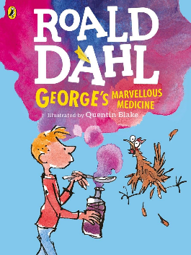  George’s Marvellous Medicine by Roald Dahl  Genre- Writing to entertain (character description)  Grammatical features-  1.Present tense and progressive present tense.  2.Sentence types.  3.Singular possessive apostrophe  4.Onomatopoeia | 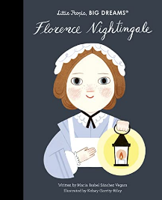  Florence Nightingale – Little people big dreams  Genre- Diary entry  Grammatical features-  1.Past tense  2.Subordination  3.Commas in a list  4.Personal pronouns  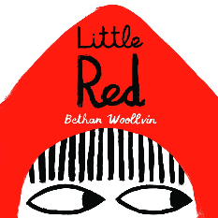  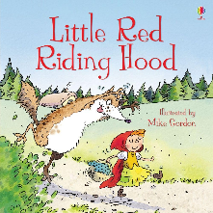  Little Red Riding Hood by Brothers Grimm  Genre- Writing to entertain  Grammatical features-  1.Exclamation sentences  2.Commas in a list  3.Sentence types  4.Past tense  Little Red by Bethan Woolvin  Genre- Writing to inform (narrative)  Grammatical features-  1.Exclamation sentences  2.Re-telling the story/ sequencing  3.Sentence types  4.Past tense | 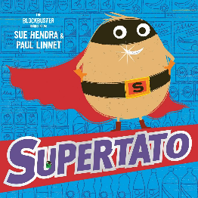  Supertato by Sue Hendra  Genre- Writing to inform (Narrative)  Grammatical features-  1.Past tense and progressive past tense.  2.Expanded noun phrases.  3.Adverbs  4.Contractions  Filey Recount
Maths
Place Value  Place Value of numbers within 100. Counting in 2s, 5s and 10s.  Addition and Subtraction  Adding and Subtracting two 2-digit numbers crossing 10. | Addition and Subtraction  Adding and Subtracting two 2-digit numbers crossing 10.  Shape  Counting sides and vertices on 2D shapes. Counting faces, edges and vertices on 3D shapes. | Money  Count, compare and calculate with Money (Pounds and Pence). Find change.  Multiplication and Division  The 2-times table, The 5 times-table, the 10 times-table. | Multiplication and Division  The 2-times table, The 5 times-table, the 10 times-table.  Dividing by 2, 5 and 10.  Length and Height  Measure in centimetres and metres and compare and order lengths and heights.  Mass, Capacity and Temperature  Measure in grams, kilograms, millilitres, litres. Compare mass. Compare Volume and Capacity. | Fractions  Recognise and find a half, a quarter, a third and three quarters. Recognise Unit and Non-Unit Fractions.  Time  O’clock, half past, quarter to, quarter past. Tell the time to and past the hour to 5 minutes. | Statistics  Make tally charts, tables and block diagrams. Draw and interpret pictograms with a key of 1-1 and 2,5,10.  Position and Direction  Describe position, movement and turns.
Science
Animals including Humans  Growth, Survival, Keeping Healthy. | Living things and habitats  Local habitats, World habitats, Microhabitats. Food chains. | Materials  Testing the suitability and changing the shape of different materials. |  | Plants  Exploring how plants and seeds grow.
History

Hospitals and Healthcare |  |  | Victorian Seaside
Geography

 | My Local Area and Luxor |  |  | Weather and Climate
Art
 | Drawing  Understanding Tone and Texture  Non-Chromatic Art |  |  |  | Painting and mixed media  Life in colour  Chromatic Art
DT
 |  |  | Bendy Bags |  | Healthy Dips and Dippers
MFL

Computing
Typing Skills | Spreadsheets and Pictograms | Making Music | Creating Pictures | Coding | IT Around Us
RE
How is new life is welcomed? |  | How can we make good choices? |  | How and why do some people pray?
PSHE/RHE
The Girl who never made mistakes by Mark Pett and Gary Rubinstein.  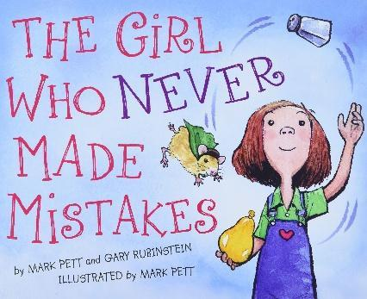  I can explain why mistakes help my learning.  I can tell you how I have learnt from my mistakes.  I can tell you how respecting myself and being kind to myself can help me to be happy.  I can tell you what the word perseverance means.  I can tell you what helps me to persevere. | Ravi’s Roar by Tom Percival  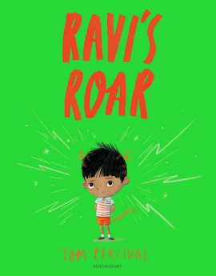  I can explain that it is ok to feel all emotions  I can explain why it is important to reflect on how I manage my emotions  I can tell you what strategies help me to calm down  I can tell you what is fair/unfair, right/wrong and kind/unkind  I can tell you why it is good that people are different. | Chicken Clicking by Jeanne Willis Aliens Love Underpants by Claire  and Tony Ross Freedman  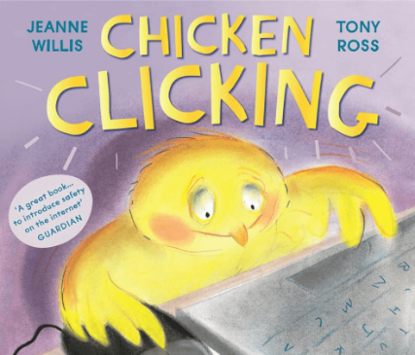  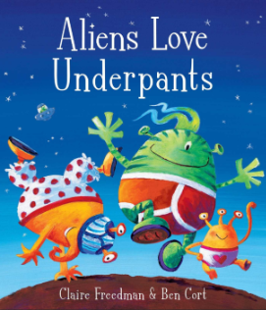  I can tell you the benefits of going online.  I can tell you how to recognise the  dangers of being online.  I can tell you the rules and principles for  keeping safe online.  I can tell you how to report problems I have  online.  I can tell you the value of the things that I buy. |  | The Girl at the Front of the Class by Onjali Q Rauf  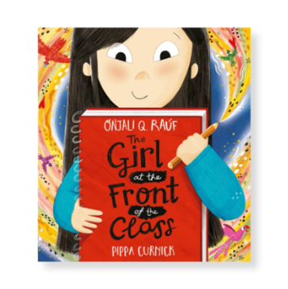  I can tell you what a refugee is.  I can tell you what human rights are.  I can tell you how I understand the needs of others.  I can tell you how I support others.  I can tell you some strategies for deciding if someone is trustworthy. |  | Grandad’s Camper by Harry Woodgate  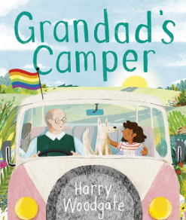  I can tell you some of the feelings  associated with times of loss and change  I can tell you some strategies I have for  dealing with times of change and loss.  I can tell you about some of the different  relationships I have with people in my  family and why they are important.
Music
I can tell you what type of physical contact is acceptable/ comfortable/ unacceptable/ uncomfortable and how to respond if I am uncomfortable
I can tell you what I can do if I feel unsafe in variety of situations.
.
Call and Response | Instruments | Singing | Contrasting Dynamics | Structure | Pitch
PE
Fundamental Skills  Invasion Games  Striking and Fielding | Workout World - Balancing/Pilates  Fundamental Skills – Throwing and Catching | Dance – Animals  Fundamental Skills – Ball games | Skill Showdown – Racket skills | Sporting best – Agility | Dodgeball  Bat and Racquet Skills

