
Hollingwood Primary School Long Term Plan – Year 3
This is a working document and subject to updating and change

HT1 | HT2 | HT3 | HT4 |  | HT5 |  | HT6
English (8 weeks) (7 weeks) (6 weeks) (5 weeks) (7 Weeks)
If I Were Prime Minister by Trygve Skaug and Ella Okstad  Genre - Writing to persuade - monologue and vlog  Grammatical features-  - Expanded noun phrases  - Subordination  - Suffix endings  - Apostrophe for contraction/ commas in a list  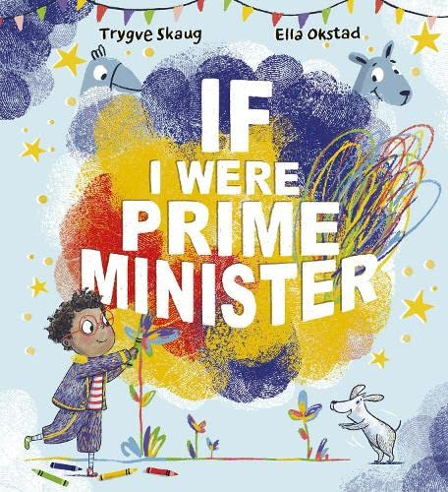  The Day the Crayons Quit By Drew Daywalt  Genre- Diary entry  Grammatical features-  - Paragraphs  - Tense- past progressive  - Sentence types  - Subordination  - Homophones - their/ they’re/ there  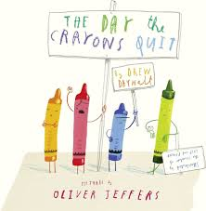 | Genre- Narrative - story (new animal to the barn)  Grammatical features-  - Conjunctions  - Adverbs  - Speech  - Similes  - Synonyms  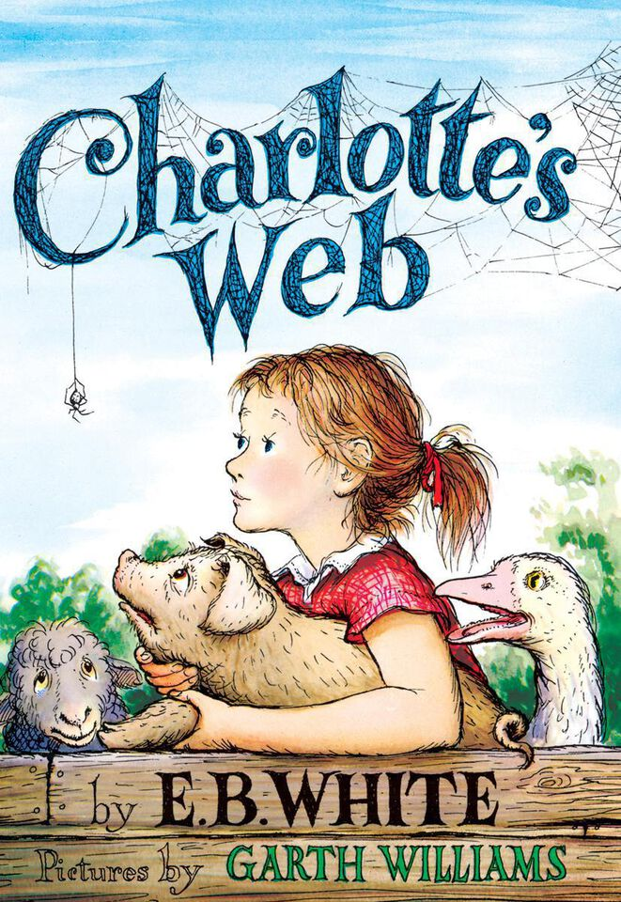  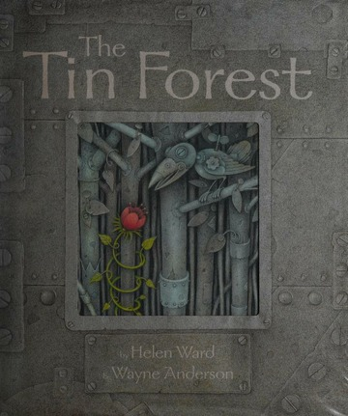  The Tin Forest by Helen Ward  Genre- Character description  - Similes  - Paragraphs  - Adverbs  - Prepositions  - Determiners a/an | Quick Let’s Get Out Of Here by Michael Rosen (poetry)  - Structure  - Adjectives  - Tense  - Synonyms/ antonyms  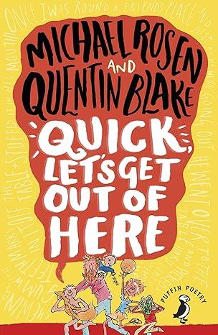  So You Think You’ve Got It Bad? By Chaise Straithe (Explanation)  Genre- Explanation text  - Present perfect tense  - Adverbs  - Apostrophe for possession (inc plurals)  - Subordination  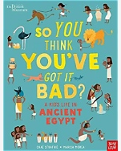 | The Football School Encyclopedia by Alex Bellos (letter)  - Conjunctions  - Present perfect tense  - Modal Verbs  - Prepositions  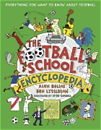 |  | The Boy Who Grew Dragons By Andy Shepherd  (Character description)  Genre- Character description  - Expanded noun phrases  - Similes  - Present perfect tense  - Adverbs  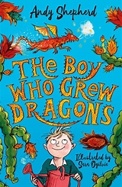  The Wild Robot by Peter Brown  Genre- Narrative  Grammatical features-  - Direct speech  - Synonyms/ antonyms  - Past tense  - Metaphors  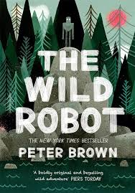 |  | Diary of A Big Bad Wolf by Ben Miller (Book review)  Genre- Character description  1.Expanded noun phrases  2. Adverbs  3.Pronouns  4.Present tense  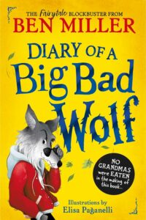
Maths
Place value - numbers up to 1000  Addition and subtraction - up to 3 digit numbers - no exchange. | Multiplication and division A - times-tables (up to 8x times-tables).  Multiplication and division A - multiply and divide a 2-digit number by a 1-digit number (with/without exchange). | Length and perimeter  Fractions | Mass and capacity  Fractions |  | Money  Time |  | Shape  Statistics
Science
Animals including Humans -  Skeletons  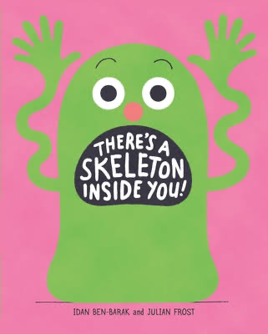 | Rocks  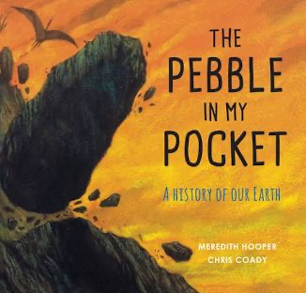 |  | 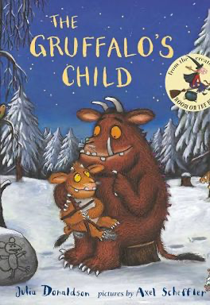  Light |  | Forces  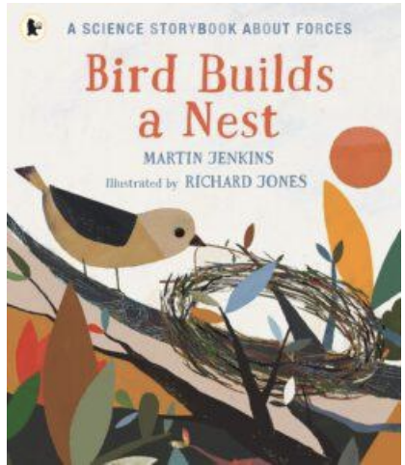 |  | Plants  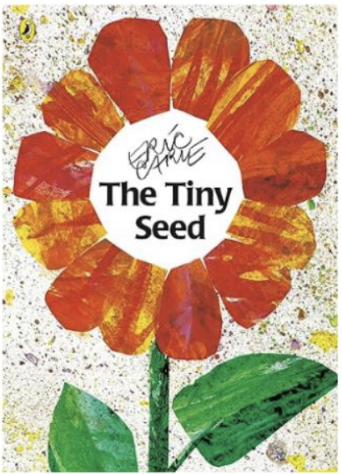
History

 | Stone Age to the Iron Age  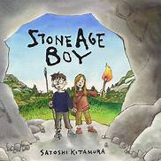 |  | 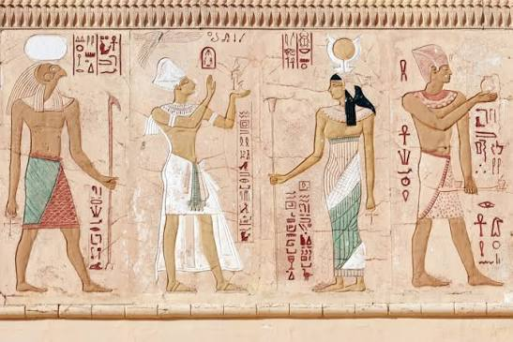  Egyptians
Geography

  United Kingdom |  |  | Land Use  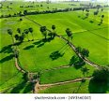
Art
 | Mono-chromatic |  |  |  | Chromatic
DT
Moving monsters |  |  |  |  | Photo frames |  | Sandwiches
MFL - kapow

Spanish greetings with puppets | Spanish numbers and ages | Shapes and colours in Spanish | Classroom objects in Spanish |  | Where do you live in Spain? |  | Journey to Latin America
Computing
 | Touch typing | Coding |  |  |  |  | Branching databases  Connecting computers
RE
Spirituality |  | Jews and Stories |  |  | Modern celebrations
PSHE/RHE
On A Magical Do-Nothing Day - by Beatrice Alemagna  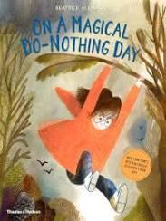  Children will learn how nature supports wellbeing, respect the rights of living things, balance online and offline activities, stay safe outdoors and use strategies to manage disappointment. | Ruby’s Worry – by Tom Percival  Children will learn about worries and how to get help, recognise signs of worry, use self-care strategies and know what to do if they feel unsafe or unhappy.  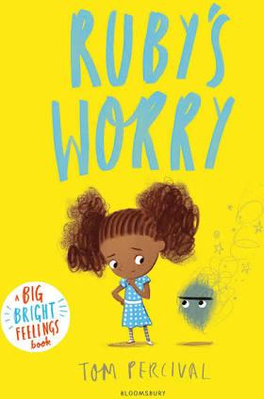 | It’s A No Money Day – by Kate Milner  Children will learn how people spend, save, or borrow money, how money affects emotions, and ways to keep money and possessions safe.  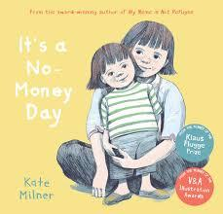 |  | Faruq and the Wiri Wiri – by Sophia Payne  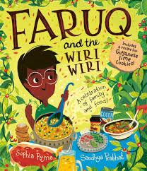  Pupils will explore how food and drink support a balanced lifestyle, ways to make healthy choices, and what can influence their goals and dreams for the future. | The Hundred Dresses – by Eleanor Estes  Pupils will learn about the qualities of good friendships, how to manage problems, the impact of bullying and cyberbullying, the role of bystanders, and ways to improve friendships.  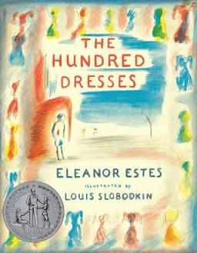 | Ossiri and The Bala Mengro by Richard O'Neill and Katharine Quarmby  Pupils will learn how community participation and music support wellbeing, why perseverance is important, how to manage challenges in their work, and how to give constructive support to others.  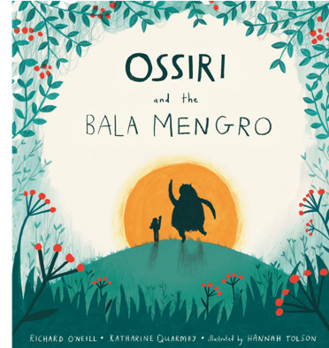
Music- kapow
Mountains and melodies: steps and leaps. | Reading rhythms: patterns and layers. | Inspired by India: Musical improvisations. | Music technology: intro |  | Reggae rhythms: playing in a band |  | Baroque meets pop: building harmony
PE- imoves
Football  Dribbling, passing, and receiving  Shielding the ball  Basic defending  Understanding positions  Cricket  Striking with control  Bowling with accuracy  Fielding techniques  Working as a batting/fielding unit | Gym  Balances, rolls, and controlled jumps  Linking actions smoothly  Using apparatus safely  Creating sequences  Basketball  Dribbling with control  Passing under pressure  Shooting technique  Basic team tactics | Dance  Using motifs and formations  Developing group choreography  Using dynamics and timing  Performing with expression  Circuit training  Improving stamina, strength, agility  Completing timed stations  Understanding fitness components  Tracking progress | Handball  Passing under pressure  Intercepting and defending  Shooting on the move  Applying tactics  Badminton  Serving consistently  Forehand/backhand shots  Simple rallies  Court awareness |  | Outdoor & adventurous  Orienteering with increasing independence  Multi‑step problem solving  Team communication  Evaluating strategies  Athletics 1  Running with technique  Throwing for distance  Jumping for height/distance  Measuring and improving performance |  | Dodgeball  Tactical positioning  Quick reactions  Catching under pressure  Coordinated team play  Rounders  Bowling accurately  Batting with control  Fielding effectively  Understanding game rules and roles

