
Hollingwood Primary School Long Term Plan – Year 4
This is a working document and subject to updating and change

HT1 | HT2 | HT3 | HT4 | HT5 |  | HT6
English
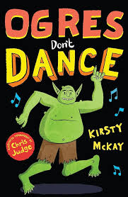  Ogres Don’t Dance by Kirsty McKay  Narrative writing  Writing with capital letters and full stops.  Apostrophes for contraction.  Using question marks.  Identifying nouns, verbs and adjectives.  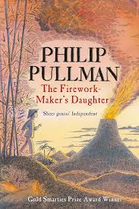  ]  The Firework Maker’s Daughter by Philip Pullman  Descriptive writing  Expanded noun phrases.  Simile sentences (Alan Peat)  Personification.  Fronted adverbials. | 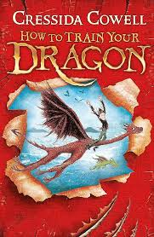  How to Train a Dragon by Cressida Cowell.  Non Chronological Report.  Statements.  Questions.  Subheadings.  BOYS sentences (Alan Peat).  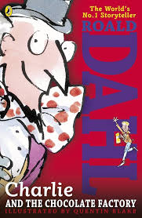  Charlie and the Chocolate Factory by Roald Dahl  Persuasive letter.  3ed sentences (Alan Peat)  Fronted adverbials.  Commas in lists.  Commands. | 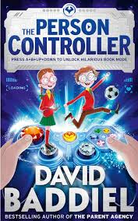  The Person Controller by David Baddiel.  Narrative writing.  Synonyms for said.  Imperative verbs  -ed openers.  Questions and statements. | 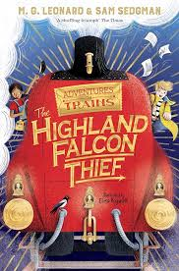  The Highland Falcon Thief by M. G Leonard and Sam Sedgman.  Explanation text.  Subordinating conjunctions.  As -ly sentences (Alan Peat)  Apostrophes for contractions.  Apostrophes for possession.  Short sentences (Alan Peat). | 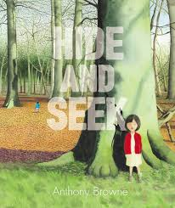  Hide and Seek by Anthony Browne.  Description writing.  Prepositional phrases.  Fronted adverbials.  Personification.  Verb person sentences (Alan Peat).  The Person Controller by David Baddiel.  Advert  Determiners (new skill)  Persuasive language techniques.  Rhetorical questions. |  |   In the Forest by Anthony Browne.  Poetry.  Onomatopoeia  Similes and metaphors  Past progressive tense.
Maths
Place Value - numbers up to 10,000.  Addition and Subtraction - up to 4 digit numbers with exchange. | Area - counting squares.  Multiplication and Division - times tables. | Multiplication and Division - multiply by 10 and 100.  Length and Perimeter | Fractions  Decimals | Decimals  Money  Time |  | Shapes  Statistics  Position and direction
Science
Animals including Humans - digestive system. | Living things and habitats - classification. | Electricity | States of Matter |  |  | Sound
History

 |  | Ancient Greece | Romans
Geography

My region and the South Aegean |  |  |  | Locality Unit - Halifax
Art
Non - chromatic |  |  |  |  |  | Chromatic
DT
 | DT Parent workshop - Bookmarks | Night Lights |  |  |  | Levers and linkages
MFL - Spanish

Introductions and counting | Shapes and colours | Classroom objects. | Where do you live? | Pets |  | Special Celebrations
Computing
 | Spreadsheets and logos | Animation and the internet |  |  |  | Purple Mash Coding  .
RE
Community | Five Pillars of Islam |  |  | Sikh Guru
PSHE/RHE
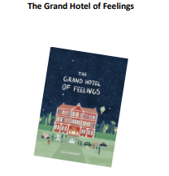  I can tell you a range of feelings words and can explain when I have felt these feelings. I can tell you why it is important to listen to our emotions. I can describe examples of how people experience more than one feeling at a time I can explain how my feelings might change as I grow up. I can tell you what I could do if my feelings are too big to handle myself. |   I can tell you the risks of making friends online I can tell you why it is important to treat people online the same as you treat people in person I can tell you some strategies for managing online bullying I can tell you how to critically consider sources of information I can tell you how information and data is shared and used online. |   I can tell you how friends should treat each other. I can politely say ‘no’ when I don’t want to do something. I can explain that friendships have ups and downs. I can tell you some ways I can repair a damaged friendship. I can explain how rules and laws protect me and others. |   I can tell you about my cultural heritage. I can tell you about ways my family and friends support me. I can tell you how I show respect to people who have different beliefs to me. I can tell you about some of the different types of bullying (including online bullying) and I can tell you some strategies to resist this and to get help. I can tell you about the impact of bullying on mental wellbeing. | 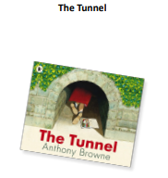  I can tell you what a dare is and how dares make people feel. I can use a 5-point scale to tell you how risky something is. I can tell you what peer pressure is and how to resist anything that is dangerous, unhealthy, and uncomfortable or wrong. I can tell you how taking risks can be a positive thing and how this can build up my resilience. I can tell you what I should do in an emergency situation. |  |   I can tell you about safe and unsafe exposure to the sun and how to reduce the risk of sun damage. I can tell you how serving others can improve my own wellbeing. I can tell you what a role model is and who my role models are. I can tell you about something I am passionate about. I can tell you how to show respect for different languages and the benefits of speaking different languages.
Music
Body and tuned percussion (Rainforests) | Rock and Roll | Changes in pitch, tempo and dynamic (Rivers). | Haiku music and performance (Hanami festival). | Samba and carnival sounds (South America) |  | Adapting and transposing motifs (Romans)
PE
Football  Passing under pressure  Combination play  Defensive positioning  Using width and depth  Cricket  Bowling variations  Tactical batting  Fielding as a unit  Decision‑making | Gym  Counterbalances and partner work  Complex rolls  Apparatus sequences  Fluency and control  Basketball  Shooting under pressure  Defensive strategies  Fast‑break play  Team communication | Dance - The Romans and Ancient Greece  Canon, unison, formations  Group choreography  Using contrasting dynamics  Evaluating performance  Circuit training  Progressive fitness challenges  Understanding aerobic/anaerobic work  Improving technique  Monitoring improvement | Handball  Advanced passing  Tactical defending  Creating overloads  Shooting from different angles  Badminton  Forehand/backhand development  Net play  Tactical shot selection  Sustained rallies | Outdoor & adventurous  Advanced orienteering  Leadership in teams  Strategic planning  Evaluating route choices  Athletics  Sprint starts and pacing  Improving throwing technique  Long jump/triple jump basics  Performance analysis |  | Dodgeball  Strategic team roles  Reading opponents  Coordinated attacks  Defensive formations  Rounders  Advanced batting  Tactical fielding  Game management  Officiating basics

