
Hollingwood Primary School Long Term Plan – Year 5
This is a working document and subject to updating and change

HT1 | HT2 | HT3 | HT4 | HT5 |  | HT6
English
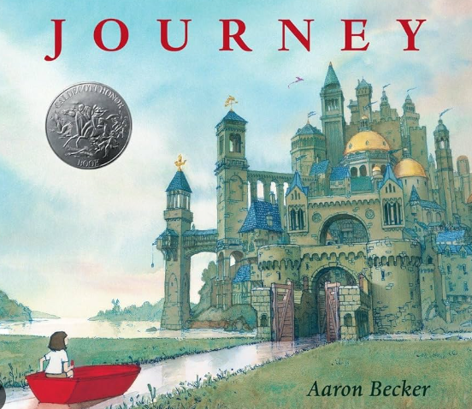  Journey - Aaron Becker  The Lion, the Witch and the Wardrobe - CS Lewis  Setting description  - Ing ed sentences  - Fronted adverbials  - Subordinate clauses / complex sentences  - Similes  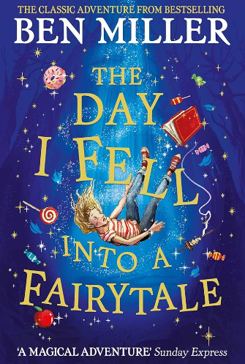  The Day I Fell Into A Fairytale - Ben Miller  Narrative - Twisted fairytales  - Fronted adverbials / what is a sentence?  - Action as if sentences  - Prepositional phrases  - Commas for clarity | 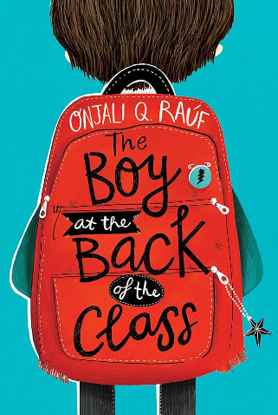  The Boy at the Back of the Class - Omjali Q Rauf  Persuasive letter  - Outside (inside) sentences  - Relative clauses  - Parenthesis  - Ed ed ed sentences | 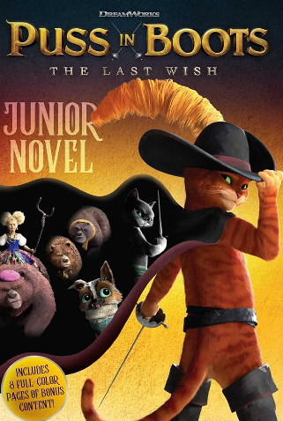  Puss in Boots - The Last Wish  Narrative - retell story with different character  - Expanded noun phrases  - Speech to advance action  - Action as if sentences  - Metaphors  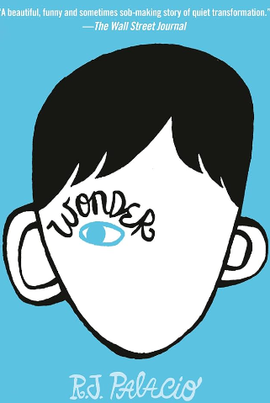  Wonder - Ed Palacio  Explanation - how can we beat bullying?  - Passive voice  - Cause and effect conjunctions  - Adverbial phrases  - Relative pronouns with ,, - - ( ) punctuation | 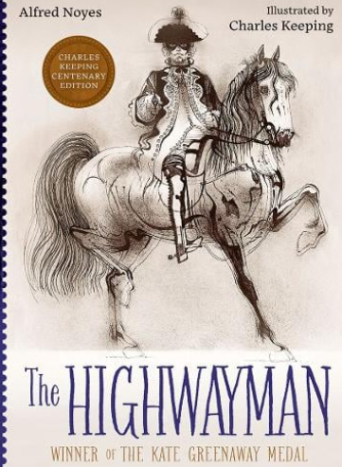  The Highwayman - Alfred Noyes  News report  - Adverbial phrases  - Modal verbs  - Rhetorical questions  - Speech punctuation | 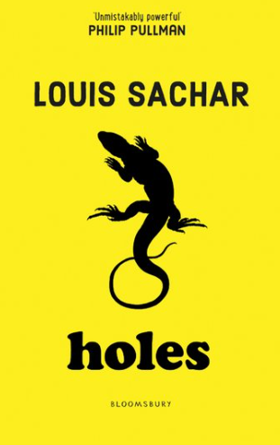  Holes - Louis Sachar  Argument  - Determiners  - Phrases and clauses  - Modal verbs  - Relative clauses |  |   Safiyyah’s War - Hiba Noor Khan  Poetry, description
Maths
Place Value: Numbers to 1000000  Addition and Subtraction: Add & subtract numbers with more than 4 digits | Multiplication and Division A: Multiples, factors, prime numbers, square numbers, cube numbers, multiplying & dividing by 10, 100 or 1000  Fractions A: Convert between improper and mixed number fractions, add & subtract fractions with same denominators including improper and mixed number fractions | Multiplication and Division B: Multiply up to 4 digit numbers by 2 digit numbers, divide up to a 4 digit number by a 1 digit number  Fractions B: Multiply unit fractions, non-unit fractions & mixed number fractions by an integer, calculate fractions of amounts | Decimals & percentages: Round & order decimals with up to 3 decimal places, know fraction, decimal and percentage equivalents  Perimeter & Area: Calculate perimeter of rectangles, rectilinear shapes & polygons, calculate the area of rectangles & compound shapes  Statistics: Read & interpret line graphs, tables & timetables | Shape: Classify, estimate and measure angles, calculate missing angles on a straight line and about a point, recognise and name regular & irregular polygons, recognise and name 3D shapes  Position & direction: Read & plot coordinates, translate shapes, recognise lines of symmetry, reflect shapes in horizontal & vertical lines |  | Decimals: Add & subtract decimals with same number of & different numbers of decimal places, multiply & divide decimals  Negative numbers: Understand, compare & order negative numbers  Converting units. Converting metric units of measure, converting metric & imperial units, converting units of time & calculate with timetables  Volume: Compare & estimate volume & capacity
Science
Living things and their habitats. | Properties of materials and changes of state  - separating materials  - reversible and irreversible changes |  | Animals including humans - life cycles | Earth and Space |  | Forces
History

 |  | Anglo Saxons and Vikings |  | Ancient Maya
Geography

 | Brazil   |  |  |  |  | Biomes and Ecosystems.
Art
Monochromatic |  |  | Chromatic
DT
 |  |  | Lavender bags | Marble Run |  | Smoothies
MFL

Describing family and friends in Spanish | Spanish portraits | Sports in Spanish | Spanish food and drink | A trip across Spain |  | Saving South America
Computing
Vector drawing |  | Sharing information  Databases |  | Coding  Physical computing |  | .
RE
What values do people live by? | Why do some people go on pilgrimage? |  | What do Christians believe about old and new covenants? |  |  | Should we forgive others?
PSHE
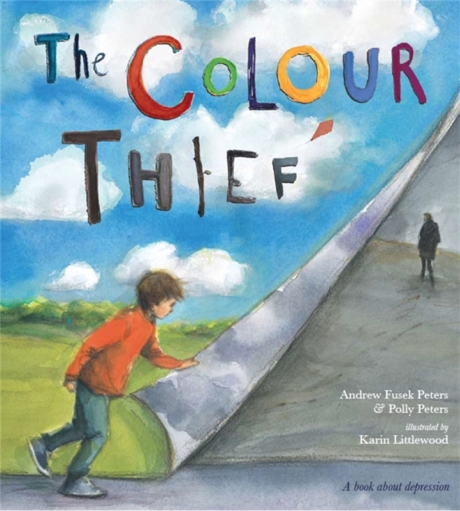  Mental health and well being | 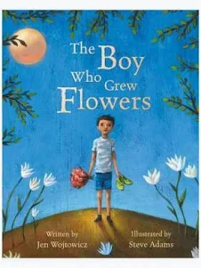  Body image, bullying, physical disabilities and self esteem. | 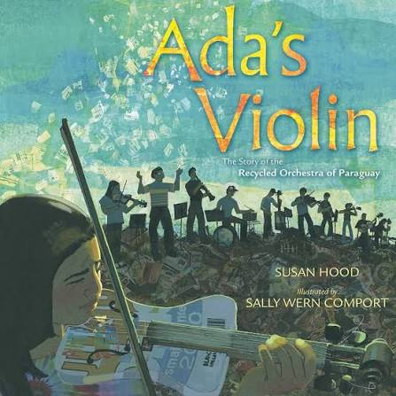  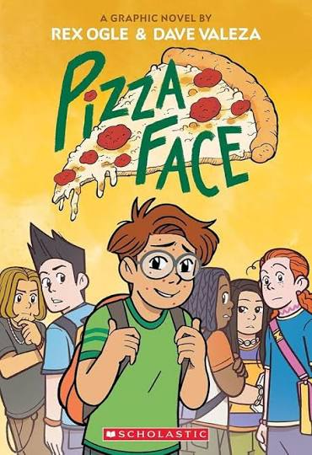  Environment, goals, gratitude, self esteem. Puberty. |  |   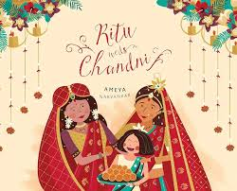  Cultural celebrations Divorce, separation
Music
Music in nature: chords and melodies. | Three chord pop: Playing in a band. | West African rhythms: create, play, perform. | Musical technology: podcasts and jingles. | Stage and song: telling stories through music. |  | Samba sounds: rhythm and grooves.
PE
Cricket  Football | Gymnastics  Basketball | Dance: The Vikings and Aztecs  Circuit Training | Badminton  Handball | Outdoor & Adventurous  Athletics |  | Dodgeball  Rounders

