
Hollingwood Primary School Long Term Plan – Year 6
This is a working document and subject to updating and change

HT1 | HT2 | HT3 | HT4 | HT5 |  | HT6
English
Little Badman and the Invasion of the Killer Aunties  Expanded noun phrases  Adverbials  Co-ordinating conjunctions  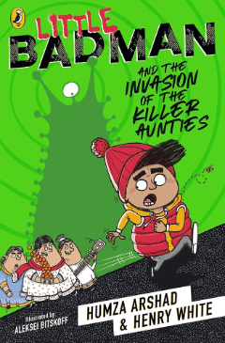  Description of Little Badman’s personality - how it changes throughout the story. | Windrush Child  Subordinating conjunctions  Parenthesis  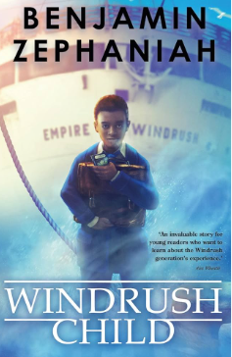  Diary entry from Leonard’s perspective | The Ultimate Guide to Mario and Nintendo - 2024 Edition  De: de sentences  Present perfect tense  Apostrophes for singular possession  Apostrophes for plural possession    Non-chronological report | Who Let the Gods Out  Inverted commas - dialogue  Similes and metaphors  Relative clauses  Subordinate clauses  Narrative from Mr Boil’s perspective  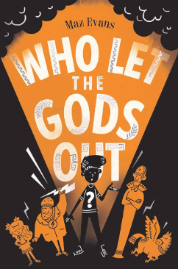 | Wonka  Modal verbs  Expanded noun phrases  Formal language  Prepositions  Description of chocolate  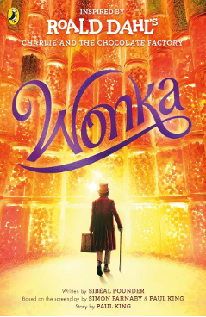  Formal letter to persuade |  | The Final Year  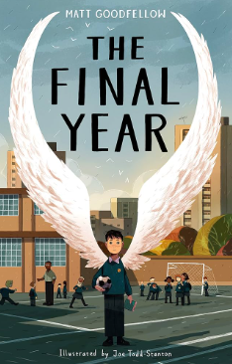  Discussion - Should SATs be abolished?
Maths
Number - Place Value  Numbers to 1,000,000; rounding integers and negative numbers  Number - Addition, subtraction, multiplication & division  Addition & subtraction of 7 digit numbers  Number - Fractions  Equivalent fractions; comparing & ordering fractions; adding & subtracting simple fractions | Number - Fractions A  Multiplying & dividing fractions; fractions of amounts  Number - Fractions B  Multiplying & dividing fractions and mixed numbers; fractions of amounts  Number - Converting Units  Metric measures; converting measures | Number - Ratio  Ratio & fractions; scale drawings, scale factors; ratio & proportion  Number - Algebra  Form expression; substitution; formulae; form equations  Number - Decimals  Place value within 1; rounding decimals; add & subtract decimals; multiply & divide decimals | Number - Fractions, Decimals & Percentages  Equivalents; fractions to percentages; ordering FDP; percentages of amount  Measurement - Area, Perimeter & Volume  Area, perimeter & volume of shapes  Statistics  Line graphs; dual bar charts; read & interpreting pie charts; the mean | Geometry (Shape)  Measuring & classifying angles; calculating angles, vertically opposite angles, angles in different shapes, nets  Geometry (Position & Direction)  Four quadrants; co-ordinates; translation; reflection
Science
Animals (Including Humans)  Digestive & Circulatory System | Living Things  Classification |  | Evolution & Inheritance  Adaptation | Electricity |  | Light
History

 |  | World War 2 | Early Islamic Civilisation
Geography
 | UK Depth Study |  |  | Sustainability
Art
Monochromatic |  |  | Chromatic
DT
 |  |  |  | Wheels and axels |  | Alarming Vehicles
MFL

Unit 1: Clothes in Spanish | Unit 2: School life in Spanish | Unit 3: Household tasks in Spanish | Unit 4: Shopping in Spain | Unit 5: Free time in Spain |  | Unit 6: Maya city treasure hunt
Computing
Communication & 3D Modelling |  | Programming | Coding - physical | Coding & Spreadsheets
RE
 | Hindu Beliefs about God |  | Sikh Commitment  Jewish Festivals
PSHE
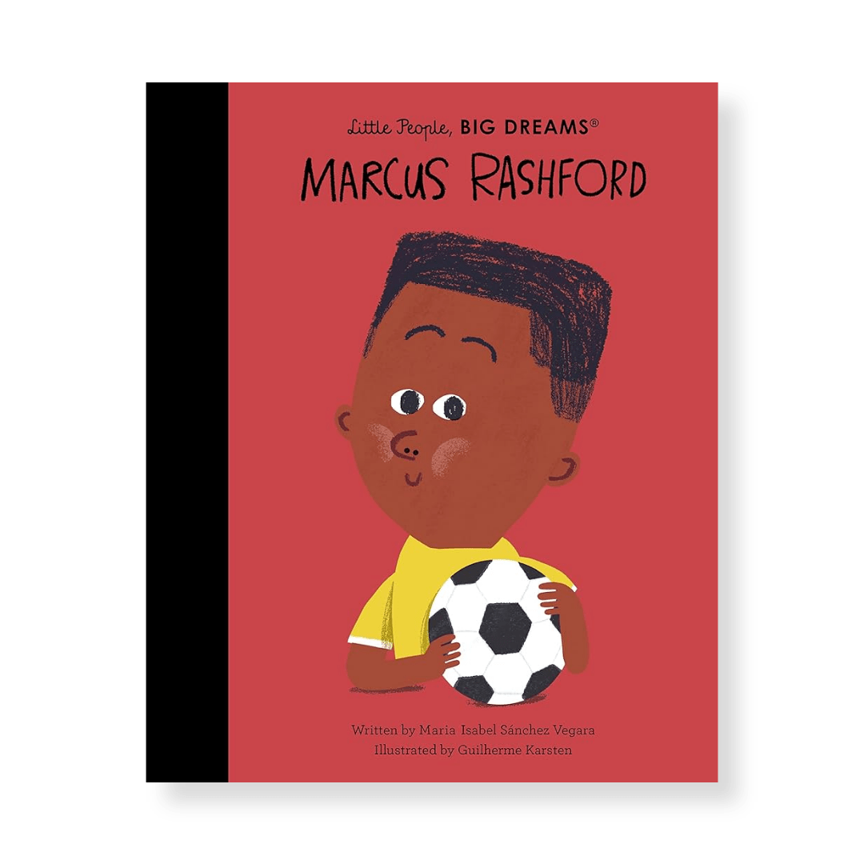  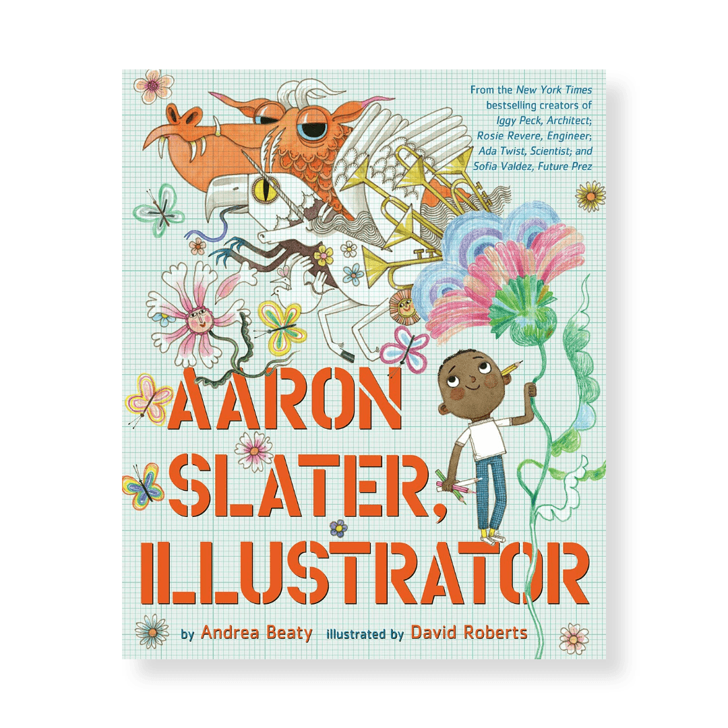  Story project - Aaron Slater Illustrator by Andrea Beaty | Story project - Little People Big Dreams: Marcus Rashford by Maria Isabel Sanchez Vegara | 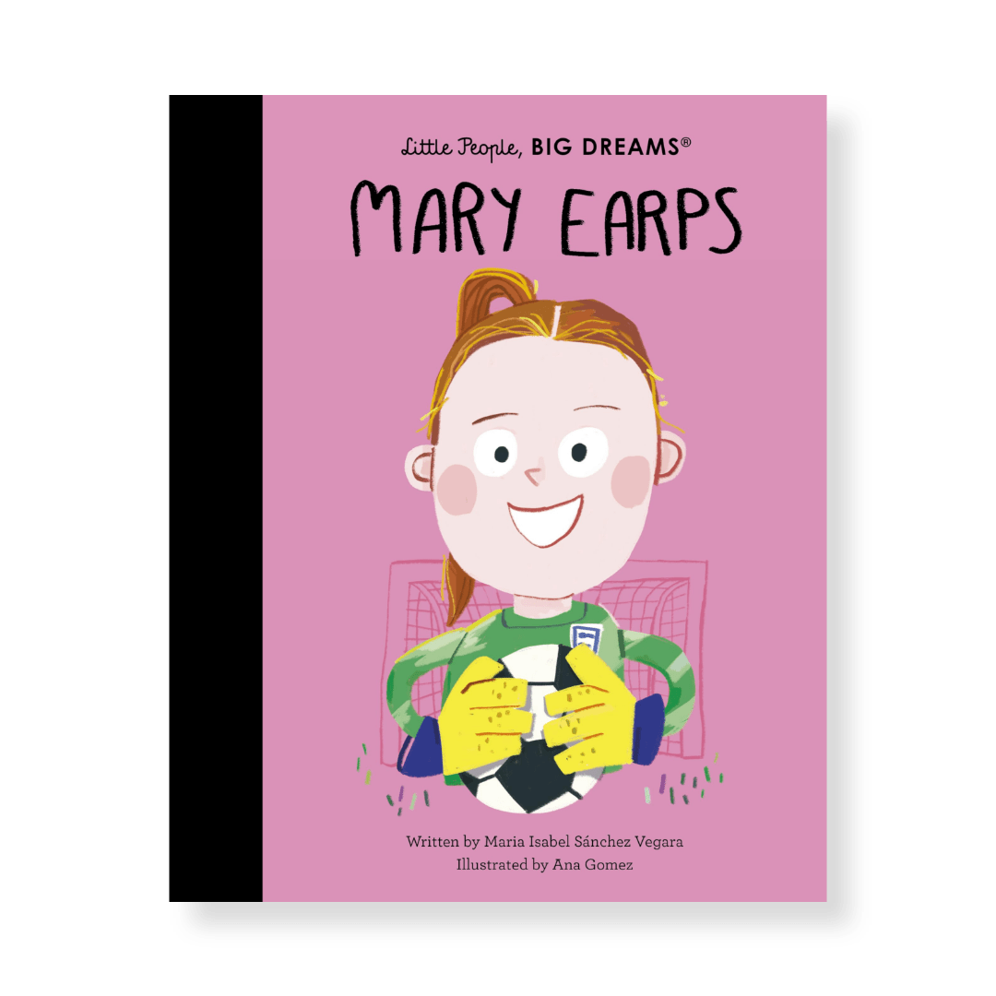  Story project - Little People Big Dreams: Mary Earps by Maria Isabel Sanchez Vegara  Story project - Sunny Side Up by Jennifer and Matthew Holm   |  | 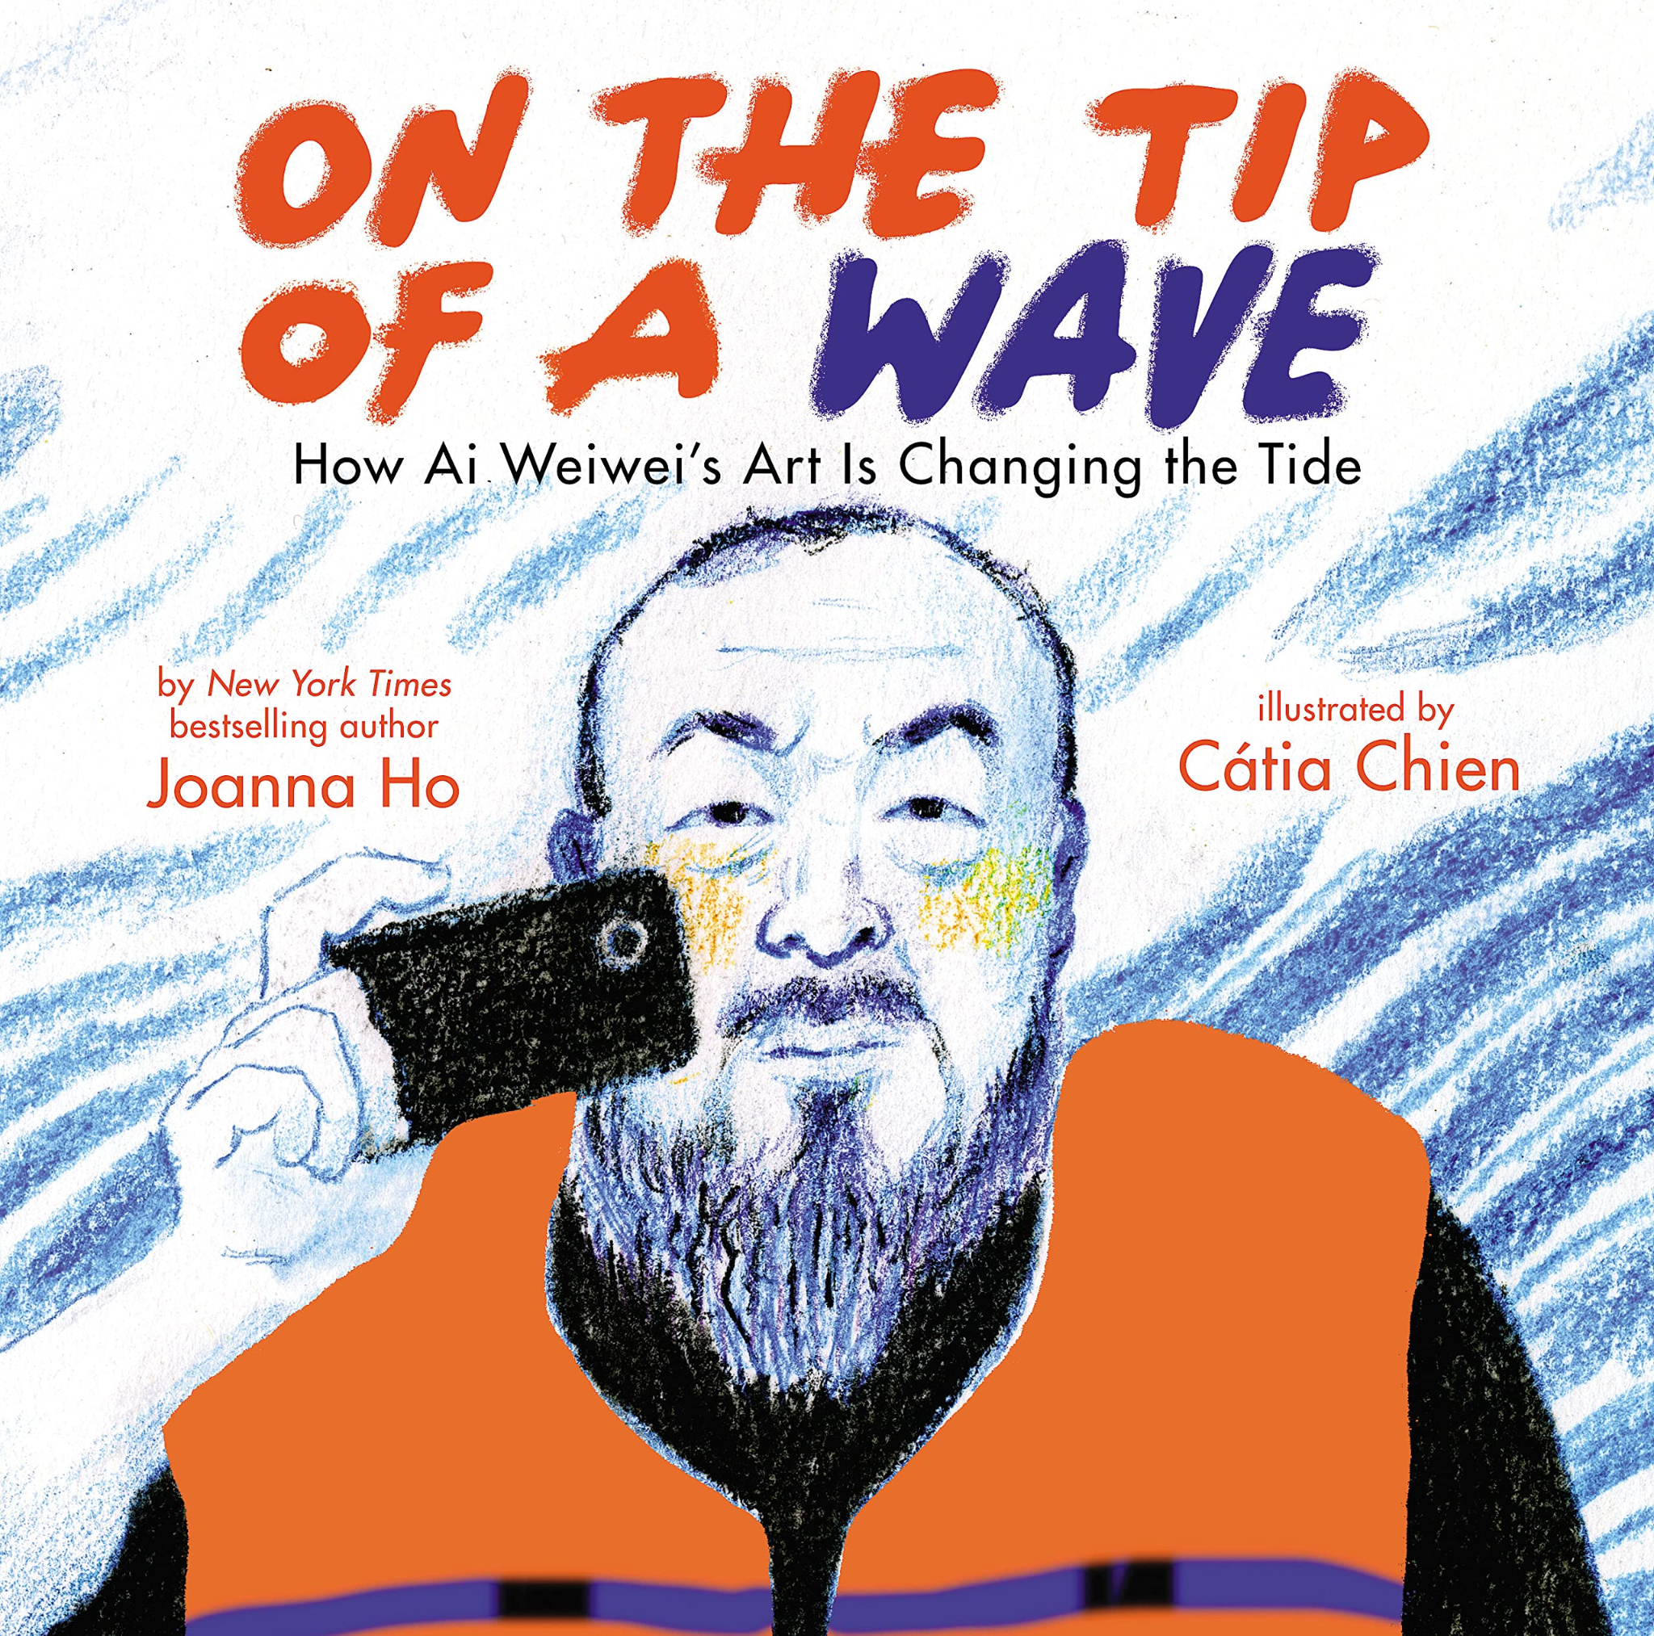  Story project - On the Tip of a Wave by Joanna Ho  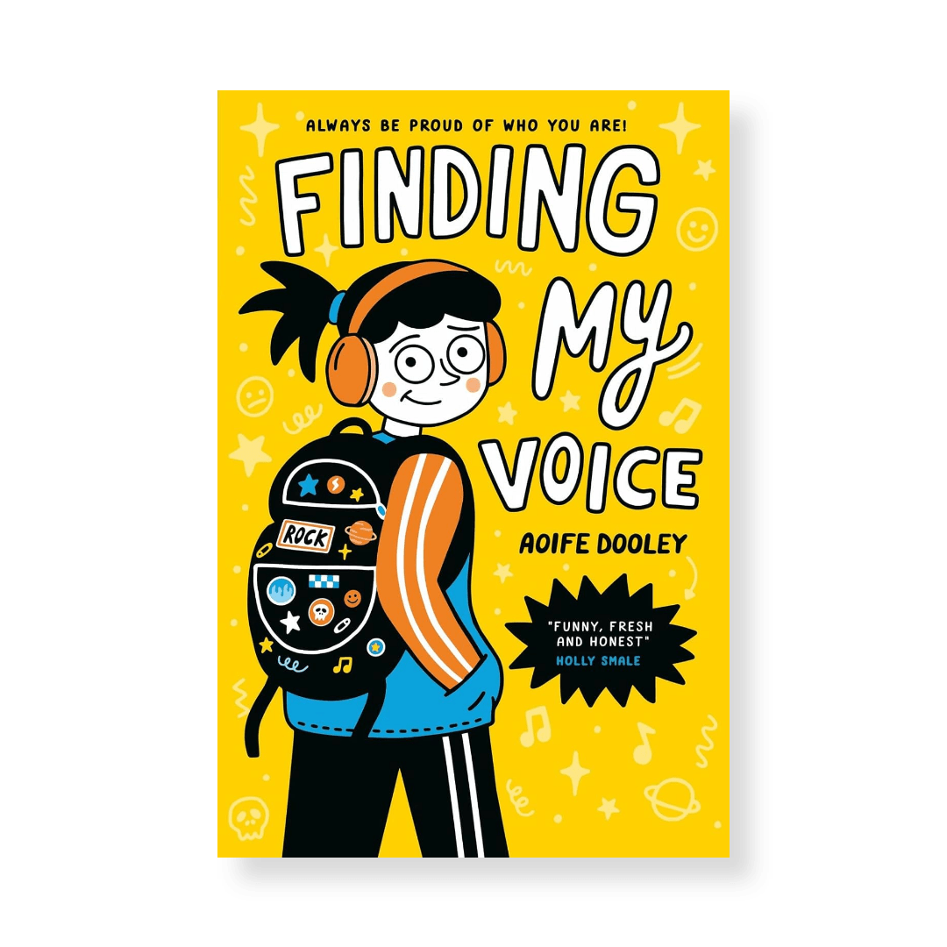  Story project - Finding My Voice Aoife Dooley
Music
Four-chord pop: Playing in a band | Songs that speak: Lyrics and messages | Bhangra beats: Global grooves | Music technology: Film soundtracks | Theme and variations: Developing melodies |  | Leavers: Our story in song
PE
Cricket  Football | Gymnastics  Basketball | Dance: WWII and freestyle  Circuit Training | Badminton  Handball | Outdoor & Adventurous  Athletics |  | Dodgeball  Rounders

