
Hollingwood Primary School Long Term Plan – Reception

The EYFS curriculum at Hollingwood Primary school is a reading inspired curriculum with stories and skills at the heart. Each half term we immerse our children in high quality books and staff use highly effective questioning and prompts based on the Blank Levels to support and extend students’ independent learning. We develop language and oracy through a language rich provision and role play areas to develop communication and language. There are high expectations for all pupils.
HT1 |  |  |  |  |  | HT2 |  |  |  |  |  | HT3 |  |  |  |  |  | HT4 |  |  |  |  |  | HT5 |  |  |  |  |  |  |  |  |  |  |  | HT6
Topic Texts
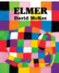  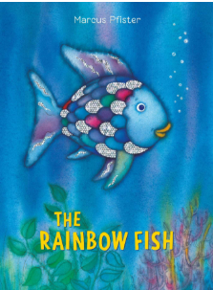  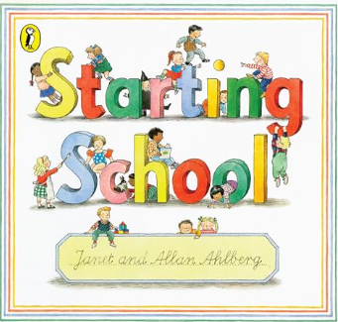 |  |  |  |  |  | 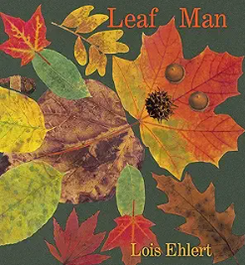  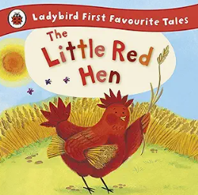  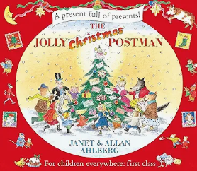 |  |  |  |  |  | 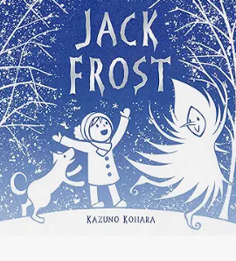  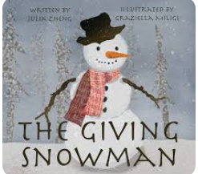  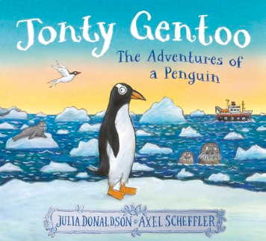 |  |  |  |  |  | 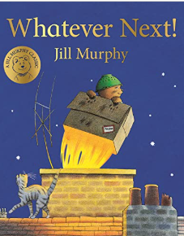  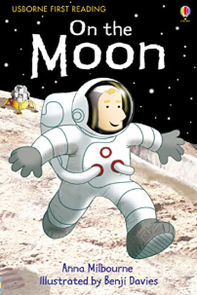  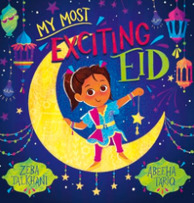 |  |  |  |  |  | 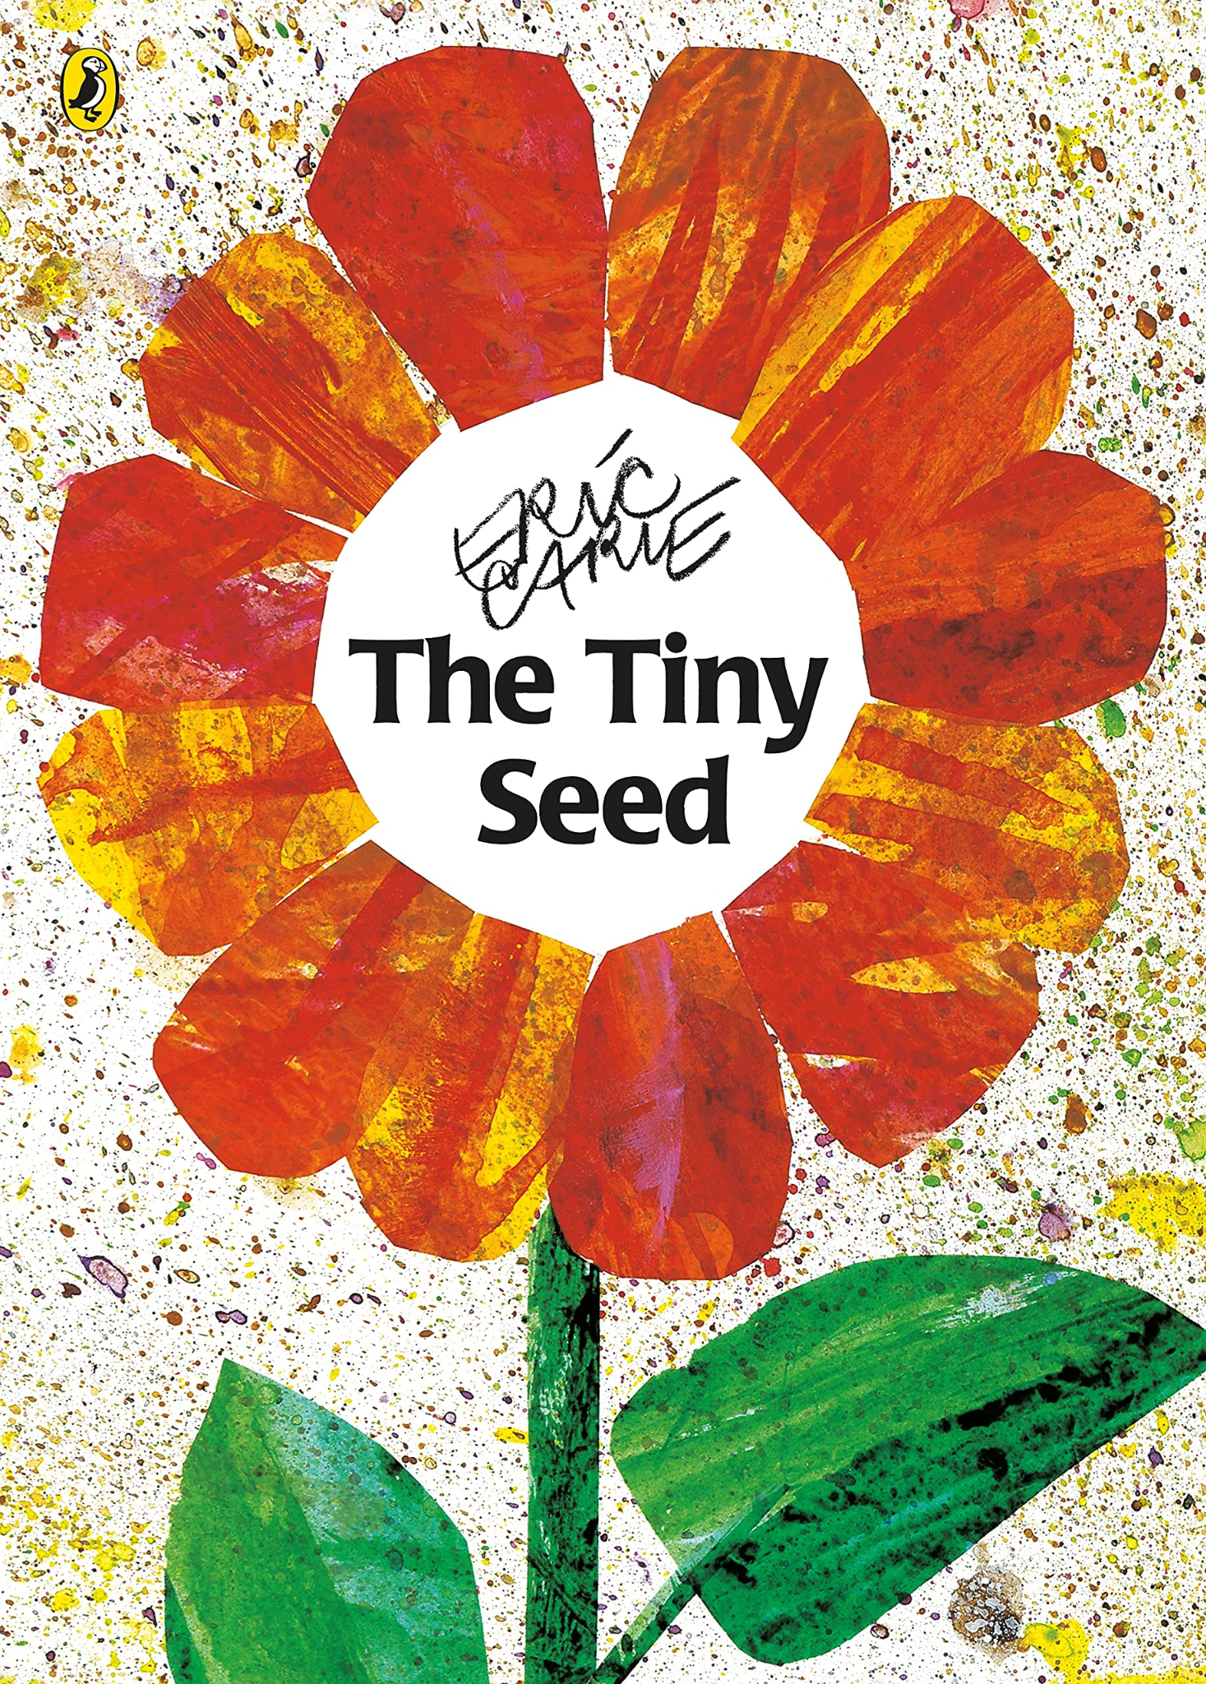  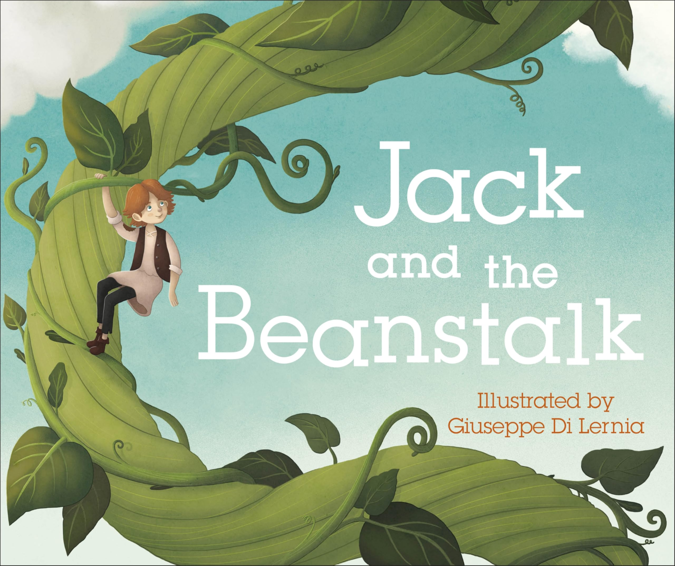  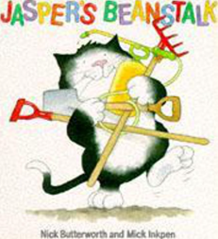 |  |  |  |  |  |  |  |  |  |  |  | 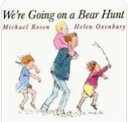  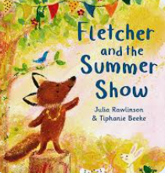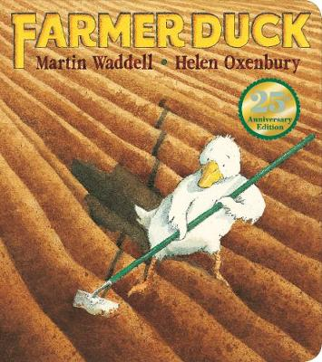
Story Project
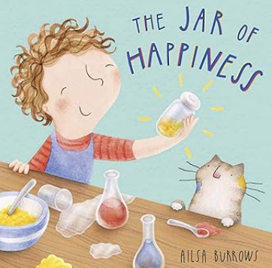 |  |  |  |  |  | 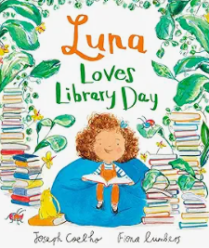 |  |  |  |  |  | 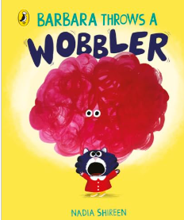 |  |  |  |  |  | 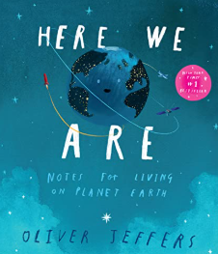 |  |  |  |  |  | 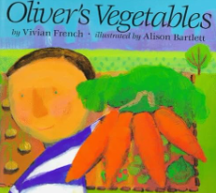 |  |  |  |  |  |  |  |  |  |  |  | 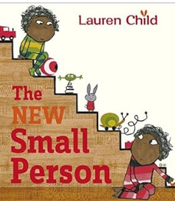
Key Theme
What makes a good friend? |  |  |  |  |  | Changes all around us |  |  |  |  |  | Winter Wonderland |  |  |  |  |  | We’re going on a journey… |  |  |  |  |  | How does your garden grow? |  |  |  |  |  |  |  |  |  |  |  | Animal Magic!
Literacy
Mark-Making: Gives meaning to their marks.  Writing: Write own name, beginning to form clearly identified letters. Uses some clearly identifiable letters to communicate meaning, representing some sounds correctly and in sequence. Introduction to linking sounds to letters. Writing initial sounds.  Reading: Read their own name and those of others. Join in with stories, rhymes and songs. |  |  |  |  |  | Mark-Making: Gives meaning to their marks.  Writing: Write own name, beginning to form clearly identified letters. Uses some clearly identifiable letters to communicate meaning, representing some sounds correctly and in sequence. Introduction to linking sounds to letters. Writing i/l, cvc words and phrases.  Reading: Read their own name and those of others. Join in with stories, rhymes and songs. Learn to continue a rhyming string. Describe main events in simple stories. |  |  |  |  |  | Mark-Making: Gives meaning to their marks. Some emerging letters.  Writing: Write own name with support and begin to attempt their surname. Begin to use phonic knowledge to write i/l, cvc words, simple words, phrases and attempts to write sentences in  meaningful contexts.  Reading: Begins to read words and sentences. Uses vocabulary and forms of speech that are increasingly influenced by their experiences of books. Explores and enjoys a range of fiction and non fiction books. |  |  |  |  |  | Mark-Making: Gives meaning to their marks. Some emerging letters.  Writing: Write own name independently and begin to attempt their surname. Begin to use phonic knowledge to write i/l, cvc words, simple words, phrases and attempts to write sentences in  meaningful contexts.  Reading: Begins to read words and sentences. Uses vocabulary and forms of speech that are increasingly influenced by their experiences of books. Explores and enjoys a range of fiction and non fiction books. |  |  |  |  |  | Writing: Use their phonic knowledge to write words that match their spoken sounds. Write some tricky words. Write simple sentences which can be read by themselves and others. Some words are spelt correctly and others are  phonetically plausible. Begin to have an awareness of the use of simple  punctuation i.e. finger spaces, capital letter, full stop and question marks.  Reading: Read and understand simple sentences. Use phonic knowledge to decode regular words and read them aloud accurately. Read some tricky words. Demonstrate understanding when talking with others about what they have read. |  |  |  |  |  |  |  |  |  |  |  | Writing: Use their phonic knowledge to write words that match their spoken sounds. Write some tricky words. Write simple sentences which can be read by themselves and others. Some words are spelt correctly and others are  phonetically plausible. Begin to have an awareness of the use of simple  punctuation i.e. finger spaces, capital letter, full stop and question marks.  Reading: Read and understand simple sentences. Use phonic knowledge to decode regular words and read them aloud accurately. Read some tricky words. Demonstrate understanding when talking with others about what they have read.
Phonics
Phase 2 graphemes  s a t p i n m d g o c k ck e u r h  b f l  Tricky Words  is I the |  |  |  |  |  | Phase 2 graphemes  ff ll ss j v w x y z qu ch sh th ng nk  Tricky Words  review: is I the  new: as and has his her go no to into she he of go |  |  |  |  |  | Phase 3 graphemes  ai ee igh oa oo oo ar or ur ow oi ear air er  • words with double letter  • longer words  Tricky Words  was you they my by all are sure pure |  |  |  |  |  | Phase 3 graphemes  Review Phase 3  • words with double letters, longer words, words with two or more digraphs, words ending in –ing, compound words • words with s /z/ in the middle • words with –s /s/ /z/ at the end • words with –es /z/ at the end  Tricky Words  Review all taught so far |  |  |  |  |  | Phase 4  Short vowels with adjacent consonants  • CVCC CCVC CCVCC CCCVC CCCVCC • longer words and compound words • words ending in suf-xes: –ing, –ed /t/, –ed /id/ /ed/, –est  Tricky Words  said so have like some come love do were here little says there when what one out today |  |  |  |  |  |  |  |  |  |  |  | Phase 4  Phase 3 long vowel graphemes with adjacent consonants  • CVCC CCVC CCCVC CCV CCVCC • words ending in suf-xes: –ing, –ed /t/, –ed /id/ /ed/, –ed /d/ –er, –est • longer words  Tricky Words  Review all taught so far
Mathematics
White Rose Maths Hub  Match, sort and compare  Talk about measure and patterns  explore 1, 2 and 3  NCTEM  identify when a set can be subitised and when counting is needed.  subitise different arrangements, both unstructured and structured, including using the Hungarian number frame.  make different arrangements of numbers within 5 and talk about what they can see, to develop their conceptual subitising skills  spot smaller numbers ‘hiding’ inside larger numbers |  |  |  |  |  | White Rose Maths Hub  Explore circle and triangles  Explore numbers 1 to 5  Explore shapes with 4 sides.  NCTEM  connect quantities and numbers to finger patterns and explore different ways of representing numbers on their fingers  hear and join in with the counting sequence, and connect this to the ‘staircase’ pattern of the counting numbers, seeing that each number is made of one more than the previous number  develop counting skills and knowledge, including: that the last number in the count tells us ‘how many’ (cardinality); to be accurate in counting, each thing must be counted once and once only and in any order; the need for 1:1 correspondence; understanding that anything can be counted, including actions and sounds  compare sets of objects by matching  begin to develop the language of ‘whole’ when talking about objects which have parts |  |  |  |  |  | White Rose Maths Hub  Alive in 5  Mass and Capacity  Exploring numbers 6, 7 and 8  NCTEM  continue to develop their subitising skills for numbers within and beyond 5, and increasingly connect quantities to numerals  begin to identify missing parts for numbers within 5  explore the structure of the numbers 6 and 7 as ‘5 and a bit’ and connect this to finger patterns and the Hungarian number frame  focus on equal and unequal groups when comparing numbers |  |  |  |  |  | White Rose Maths Hub  Length, height and time  Exploring numbers 9 and 10  Exploring 3D shapes  NCTEM  understand that two equal groups can be called a ‘double’ and connect this to finger patterns  sort odd and even numbers according to their ‘shape’  continue to develop their understanding of the counting sequence and link cardinality and ordinality through the ‘staircase’ pattern  order numbers and play track games  join in with verbal counts beyond 20, hearing the repeated pattern within the counting numbers. |  |  |  |  |  | White Rose Maths Hub  Exploring numbers beyond 20  Add and taking away  Manipulate, compose and decompose shapes  NCTEM  continue to develop their counting skills, counting larger sets as well as counting actions and sounds  explore a range of representations of numbers, including the 10-frame, and see how doubles can be arranged in a 10-frame  compare quantities and numbers, including sets of objects which have different attributes  continue to develop a sense of magnitude, e.g. knowing that 8 is quite a lot more than 2, but 4 is only a little bit more than 2 |  |  |  |  |  |  |  |  |  |  |  | White Rose Maths Hub  Sharing and grouping  Visualise, build and map repeated patterns  Consolidation  NCTEM  begin to generalise about ‘one more than’ and ‘one less than’ numbers within 10  continue to identify when sets can be subitised and when counting is necessary  develop conceptual subitising skills including when using a rekenrek
Understanding the world
Family and Friends  Ourselves  . |  |  |  |  |  | Signs of Autumn  Autumn Walk  Change  Festivals: Diwali, Bonfire night,  Christmas |  |  |  |  |  | Festivals: Chinese New Year, Shrove Tuesday  Looking at changes of ice/snow  Winter Walk  Camouflage/snowy animals -where they live, what they eat |  |  |  |  |  | Features of planets and space  Signs of spring  Spring Walk  Mother’s Day and Easter  Knowledge of Ramadan and Eid |  |  |  |  |  | Growth/new life  Eggs/butterfly cycle  Growing grass  Planting seeds and looking after them |  |  |  |  |  |  |  |  |  |  |  | Features of animals habitats, similarities and differences,  naming farm animals and their young  Signs of Summer  Summer Walk
Expressive Art and design
The development of children’s artistic and cultural awareness supports their imagination and creativity. It is important that children have regular opportunities to engage with the arts, enabling them to explore and play with a wide range of media and materials. The quality and variety of what children see, hear and participate in is crucial for developing their understanding, self-expression, vocabulary and ability to communicate through the arts. The frequency, repetition and depth of their experiences are fundamental to their progress in interpreting and appreciating what they hear, respond to and observe.

Artist Focus:  Wassily Kandinsky - Shapes and lines |  |  |  |  |  | Artist Focus:  Andy Goldsworthy - Natural art in forest |  |  |  |  |  | Artist Focus:  Yayoi Kusama - Polka dots |  |  |  |  |  | Artist Focus:  Georgia O’Keeffe - Flowers |  |  |  |  |  | Artist Focus:  Giuseppe Arcimboldo - Fruit and veg |  |  |  |  |  |  |  |  |  |  |  | Artist Focus:  L.S Lowry - People and buildings large collage
Painting/modelling – explore colour  Begin to use tools appropriately.  Music: Begins to  build a collection of nursery rhymes, number rhymes  Songs and dances  Exploring  Instruments  Harvest song and perform, |  |  |  |  |  | Firework pictures  Leaf art  Christmas crafts  Music: learn  Christmas songs and perform  Nursery rhymes |  |  |  |  |  | Music: exploring instruments:  louder/quieter,  faster/slower.  Habitats  Make an igloo, paint arctic animals, model penguins, polar bears.  Explore a variety of paints and tools. |  |  |  |  |  | Mother’s Day  art/song  Modelling  equipment to  make  rockets/aliens  Music: learn about rhythm and pulse in songs |  |  |  |  |  | Colour mixing  Observational  drawings of plants  Music: changing  sounds and singing songs linked to  topic |  |  |  |  |  |  |  |  |  |  |  | Father’s Day arts Paint, draw and  modelling of  animals and  Habitats, animal masks  Windmills, ice creams, sunshine  Music:  experimenting with sounds and  learning how to  play a variety of  instruments
Communication and Language

Listening skills/show interest in sounds.  Learning to speak with confidence when sharing ideas in discussion and talking to other children; expressing their pupil voice. |  |  |  |  |  | Developing accurate use of tenses in speech patterns.  Developing their own narrative skills.  Developing vocabulary associated to age related expectations/topics and themes. |  |  |  |  |  | Use language during play to imitate different roles.  Learn to listen to others with increasing attention and respond in appropriate ways; comments, questions or actions. |  |  |  |  |  | Use language during play to imitate different roles.  Learn to listen to others with increasing attention and respond in appropriate ways; comments, questions or actions. Following multiple-part instructions by listening to others. |  |  |  |  |  | Develop speaking skills; organise talk so it makes sense and sequence ideas.  Answering ‘how’ and ‘why’ questions about their experiences and in response to stories and events. |  |  |  |  |  |  |  |  |  |  |  | Develop speaking skills; organise talk so it makes sense and sequence ideas.  Answering ‘how’ and ‘why’ questions about their experiences and in response to stories and events.
Personal, Social and Emotional Development
Establish classroom routines,  expectations and the understanding of  how to use the classroom safely.  Support children making friends;  modelling behaviour amongst children. Exploring relationships i.e. friendships and family. Being a class family, how we can work together as a team to help one another.  Promote self-care – independent use of the toilet and modelling good hand washing.  Begin to regulate their behaviour accordingly. |  |  |  |  |  | How to deal with feelings, talk  positively about things that make us happy and sad.  Encourage and talk about healthy  eating.  Continue to promote self-care – especially with regards to hand washing and oral hygiene.  Safety around Bonfire Night.  Safety around using kitchen utensils.  Begin to regulate their behaviour accordingly. |  |  |  |  |  | Encourage independent learning.  Promoting our social skills with  regard to turn taking and sharing. Continue to build relationships  within the classroom and wider school family.  Use taught strategies to independently regulate their own behaviour |  |  |  |  |  | Continue to develop  independence within the  classroom, with regard to selecting and using resources.  To show empathy to our peers and communicate how others show feelings.  Use taught strategies to independently regulate their own behaviour |  |  |  |  |  | Give children opportunities to adjust their behaviour to different situations and take changes of routine in their stride.  Use taught strategies to independently regulate their own behaviour.  Revisit oral hygiene and the effects of different foods on teeth. |  |  |  |  |  |  |  |  |  |  |  | Exploring changes and transition to Year 1. Discuss changes in our lives – starting school, new class, moving house, new friends, family members (babies). Explore feelings and  emotions connected to this.  Use taught strategies to independently regulate their own behaviour
Physical Development
iexercise Animal Explorers or Dance 1 & 2 |  |  |  |  |  | imove Off to the Zoo or Gym 1 |  |  |  |  |  | ipractise Pirate Adventure or Gym 2 |  |  |  |  |  | icommunicate Fun at the Circus or Pilates |  |  |  |  |  | ithink Dino Movers or Dance 3 & 4 |  |  |  |  |  |  |  |  |  |  |  | icreate Space Cadets or Yoga

